  

Request for Proposal:

Database development:

**23rd July 2019**

# Table of contents

Table of contents 2

Introduction and background 3

Administrative 3

Guidelines for proposal preparation 5

Detailed response requirements 7

Evaluation factors for award 9

Terms of Reference 10

# Introduction and background

Concern Worldwide hereafter referred to as Concern is the lead agency in the Promoting Sustainable Partnerships for Empowered Resilience (PROSPER) INGO consortium.

PROSPER is a multi-stakeholder resilience programme supporting the Government of Malawi to reduce extreme poverty and end the recurrent cycle of crises and humanitarian assistance. Funded with UK aid from the UK government under the BRACC (Building Resilience and Adapting to Climate Change) programme, and over a 4,4 year period (Dec. 2018- March 2023), the programme will target 1.1 million vulnerable people in the districts of Balaka, Chikwawa, Phalombe and Mangochi.

Concern Worldwide is seeking expert assistance through a comprehensive proposal to design a monitoring and evaluation database to house and protect large amounts of beneficiary data, as well as manage data captured through programmes monitoring and evaluation, enabling all routine activity data to be stored and accessed by Consortium Partners as per the Terms of Reference on page 9.

The winning vendor will provide:

* the database solution;
* help-desk support during business hours;
* backup capacity;
* security controls and disaster recovery services from inception to end of March 2023; and
* Maintenance to end March 2023.

The overall goal of this RFP is to procure the

1. Database solution; and
2. Comprehensive, reliable and timely support.

## Consortium background

PROSPER aims at reducing the impact of climate shocks, responding to seasonal consumption needs, supporting the design of social safety nets, and generating evidence and knowledge to inform government policy. The programme is implemented by a joint INGO, private sector and UN consortium consisting of Concern Worldwide, FAO, GOAL, Kadale Consulting, the United Nations Resident Coordinator’s Office, UNDP, UNICEF, United Purpose, and World Food Programme.

# Administrative

## Contact details

Any questions concerning technical specifications, contractual terms or proposal format should be directed to:

|  |  |
| --- | --- |
| Name | Monitoring Information System Committee |
| Email | malawi.tender@concern.net |
| Email subject | PROSPER Database |

Any material information that is shared with one supplier, will be shared with all suppliers who received the RFP, or have expressed an interest in bidding.

## Proposal submission

Please submit electronic copy of your complete proposal, including all attachments, to:

|  |  |
| --- | --- |
| Name | Concern Worldwide Malawi |
| Email | [malawi.tender@concern.net](mailto:malawi.tender@concern.net) |
| Email subject | PROSPER Database proposal |

## Due dates

All proposals are due by 23:59 on **Monday 12th August**. Any proposal received after the specified time and date for receipt shall be considered late and non-responsive. Any late proposals will not be evaluated for award.

## Suppliers’ clarifications

Clarification questions from vendors will be accepted in writing, from the RFP distribution date to **midday on Wednesday 7th August 2019**. All material clarifications will be summarised and shared with all interested bidders periodically.

## Presentation / interview

Concern may ask a Proposer to attend[1] a presentation or interview. If this is requested, the proposed key project staff, as identified in the Proposal, must be in attendance. Remote bids are accepted, so attendance electronically is accepted.

## Schedule of events

|  |  |
| --- | --- |
| 1. RFP Distribution to Vendors | Wednesday 24th July 2019 |
| 2. Written questions from vendors | Accepted from RFP distribution to midday on Wednesday 7th August 2019 |
| 2. Proposal due date | 23:59 Monday 12th August 2019 |
| 3. Quote assessment | Two weeks - 26th August 2019 |
| 4. Clarification questions to vendors | 30th August 2019 |
| 5. Vendor selection | 6th September 2019 |
| 6. Anticipated commencement date of work | 9th September 2019 |

## Expected contract type

Concern expects that the contract signed with the vendor will cover:

1. Purchase and customization, or development of the solution
2. Ongoing maintenance and support to end March 2023

## Conduct

Concern Malawi strives to maintain the highest standards in the day-to-day conduct of their staff and work.  We are strongly against any form of discrimination, sexual exploitation, violence, intimidation or exploitation of any kind. Staff are not allowed to accept cash discounts or gifts; all discounts should be stated in invoices or quotes.

We seek to guarantee the transparency and accountability of this procurement process. All cases of commission and/or favours requested in relation to quote requests/tenders should be immediately reported using the following communication channels

* Phone number: 4848 (Toll free line) Ground line: +265 1 751 437/8
* Email: malawi.complaints@concern.net

# Guidelines for proposal preparation

## Proposal submission

## Award of the contract resulting from this RFP will be based upon the Vendor whose offer will be the most advantageous to Concern Worldwide in terms of value, functionality, ongoing support and development, and other factors as specified elsewhere in this RFP.

Concern reserves the right to:

* Reject any or all offers and discontinue this RFP process without obligation or liability to any potential Vendor;
* Accept other than the lowest priced offer;
* Award a contract on the basis of initial offers received, without discussions or requests for best and final offers; and
* Award more than one contract.

Vendor's proposal shall be submitted as set forth in the Terms of Reference. The Vendor will confine its submission to those matters sufficient to define its proposal and to provide an adequate basis for Concern’s evaluation of the Vendor’s proposal.

In order to address the needs of this procurement, Vendors may choose to work cooperatively to present a fully integrated solution. Vendor team arrangements may be desirable to enable the companies involved to complement each other's unique capabilities, while offering the best combination of performance, cost, and delivery for provision of both the management services component and the database maintenance component being provided under this RFP. Concern will recognize the integrity and validity of Vendor team arrangements provided that:

* The arrangements are identified and relationships are fully disclosed; and
* A prime Vendor is designated that will be fully responsible for all contract performance.

Vendor’s proposal in response to this RFP will be incorporated into the final agreement between Concern and the selected Vendor(s). The submitted proposals are suggested to include each of the following sections:

1. Executive summary
2. Approach and methodology
3. Management deliverables and reports does this include their work plan?
4. Detailed and itemized pricing
5. Appendix: References
6. Appendix: Project team staffing
7. Appendix: Company overview

The detailed requirements for each of the above-mentioned sections are outlined below.

# Detailed response requirements

## Executive summary

This section will present a high-level synopsis of the Vendor’s responses to the RFP. The Executive Summary should be a brief overview of the engagement, and should identify the main features and benefits of the proposed work.

## Approach and methodology

Proposer must respond to each task/deliverable in the Scope of Work section and include:

* The Proposer’s overall support strategy
* An overview of the data eco-system, hardware and software intended to be deployed and how they will interact, clearly stating whether it is:
  + Off the shelf
  + Off the shelf and customised
  + Fully bespoke
* The mains steps of the roll-out, and anticipated time taken for each step
* An acceptable performance testing that addresses common performance concerns (stress tests, load tests and capacity tests)
* Assumptions, i.e. requirements, risks, and expectations used to develop the proposal
* Brief information on how data will be protected and secured in line with GDPR[2] principles
* Outline of how the MEAL (Monitoring & Evaluation and Learning) Coordinator and IT officer will be trained.
* An explanation of the problem reporting and resolution process that describes the Proposer’s support plan, including tiers, reach-back capability, service levels, the person(s) authorized to close problem reports, etc.

## Management deliverables and reports

Include descriptions of any reports used to provide weekly updates to Concern outlining progress, issues, risk, assumptions and dependencies in relation to the design, build, test, implementation and roll-out phase of the project. Include sample reports as attachments to the proposal to provide an example of the types of reports that will be provided for this engagement.

## Detailed and itemised pricing

All quotes must be submitted in **US Dollars**. Include a fee breakdown based on your pricing model.

* What is the pricing model? Fixed fee, hourly rate, hybrid, other?
* What services are included in the pricing? Address specifically the following (and feel free to include anything not included in this list):
  + On-site time
  + Help-desk support
  + Response time/problem resolution time
  + Travel time
  + Vendor management
  + Training
  + Regular in-person business review
  + Regular reporting on system health in business terms
  + Response to major system problems or outages

Fees should be broken down into the following suggested categories. Information should include:

* Cost of system construction
* Cost of maintaining the system
* Cost of any third-party software required
* Cost of user support of the system
* Cost of generating special-request reports
* Cost of maintaining system documentation
* Cost of system modifications, based on on-going requests

Support and development costs, for example hourly/daily rates, should be valid until end March 2023.

## Appendix: References

Provide three corporate references within the last 2-years for which you performed similar work. At least one of the references should be for a humanitarian actor comparable to Concern in size and requirements. A reference from a humanitarian actor who is on DFID or UN funded programmes is an added advantage.

## Appendix: Staffing

Include biographies and relevant experience of key staff and management personnel. Describe the qualifications and relevant experience of the types of staff that would be assigned to this project by providing biographies for those staff members.

Ability to train and support staff to maintain and optimise data management and skills in use of Structured Query Language (SQL).

Concern requires background checks on any individuals who may routinely work on-site. We will collect information on whoever is assigned to our site, including finger-printing, and their information will be used for vetting. Vendor will not incur any costs other than their own staff time for this vetting process.

## Appendix: Company overview

Provide the following for your company:

* Official registered name (Corporate, D.B.A., Partnership, etc.), Dun & Bradstreet Number (if applicable), address, main telephone number, email and Skype.
* Key contact name, title and contact details
* Person authorized to contractually bind the organisation for any proposal against this RFP.
* Brief history, including year established and number of years your company has been offering managed services and/or applications support.

Disclosure of any actual or potential conflicts of interest and any pending lawsuits.

# Evaluation factors for award

## Criteria

Any award to be made pursuant to this RFP will be based upon the proposal, with appropriate consideration given to operational, technical, cost, and management requirements.

The following elements will be the primary considerations in evaluating all submitted proposals and in the selection of a Vendor or Vendors:

1. Completion of all required responses in the correct format.
2. A clear indication that the Vendor has understood Concern’s requirements and tailored their proposal to these requirements.
3. Clear process flow/functionality of the entire solution for the database and Management Information System
4. Proposed platform
5. The extent to which Vendor’s proposed solution fulfils Concern’s stated requirements as set out in this RFP
6. An assessment of the Vendor’s ability to deliver the indicated services in accordance with the specifications set out in this RFP.
7. The Vendor’s experience and record of past performance in delivering such services, particularly in the Humanitarian Sector.
8. An assessment of the Vendor’s likely stability in completing work up to end Mar 2023.
9. Availability of sufficient high quality Vendor personnel with the required skills and experience for the specific approach proposed.
10. Overall cost of Vendor’s proposal.

Concern may, at our discretion and without explanation to the prospective Vendors, at any time choose to discontinue this RFP without obligation to such prospective Vendors

# Terms of Reference

**1.1 Purpose of the Consultancy**:

The goal for implementation of the database is to streamline results-based management, monitoring, and evaluation (M&E) of Concern Worldwide led Consortium while adhering to recommended data protection protocols and ensuring all beneficiary data is effectively managed and protected. The system developed will help Concern Worldwide and its partners to easily capture, track, manage and report on interventions conducted, while supporting data quality, validity and reliability to deliver more impact to those in need.

It is expected that the system will contain a unified database of reporting forms (outcome monitoring forms, event evaluation form, complains and feedback form, etc.), to be used within monitoring and evaluation exercises. Baseline assessment results as well as targets for activities, envisaged outputs, outcomes and impacts to be uploaded to the system that significantly simplifies tracking progress toward those goals for program staff, and Concerns’ management which increases transparency and accountability.

The consultant(s) under the supervision of the Consortium Director will work in close collaboration with the Consortium MEAL Coordinator, and Concern IT department to perform the services outlined below:

**2.0 SPECIFIC OBJECTIVES:**

The objectives of this consultancy are to:

1) Develop and install a comprehensive and secure programme database system, with a corresponding dashboard which is consistent with pre-determined programme indicators and reporting requirements; and can adequately integrate information from different partners and programme areas

2) Integrate security and data protection features into the database, including defining authorisation levels and rights for different Consortium Partners as well as individual users.

4) Develop standard procedures and guidelines for using and maintaining the database, and the integrated system;

5) Build the competence, knowledge and skills of key PROSPER MEAL staff in relation to using and maintaining, the developed database and standards.

6) Provide support during a 3 months testing period following the establishment of the database, and ongoing support to the database operation as needed.

**2.1** **Scope of Work:**

Whereas Concern Worldwide has provided the general scope of work for this assignment below, the consultant is expected to propose a plausible approach for undertaking this assignment, covering the design/customisation of a MySQL web enabled beneficiary and programme activity database system.

* Develop a relevant, secure and cost-effective software solution; preferably on MySQL taking into account the decentralised locations of project personnel and enabling data upload and query functions;
* Align the database with the PROSPER programme’s Monitoring and Evaluation System including indicators and type of information to be gathered, data collection tools, timelines, data flow and reporting requirements;
* Assess the data flow system between Concern Worldwide and Consortium partners, and propose the effective approaches for information access; data sharing and protection including encryption of program data which should be in line with the recommended EU General Data Protection regulations.
* Ensure that the database effectively links registered individuals’ information with programme activity data and individual participation over time,
* Design robust data quality assurance/ control mechanisms, including flags and “rules” to minimise entry of incorrect data and prevent entry of duplicate data;
* Deliver a system for database back-up
* Ensure correct alignment of the unique identifiers for registered individuals i.e. every individual in the database must be correctly identified by their district, ward, village and household across time and across all interventions;
* Develop a user friendly interface for entry, management and analysis of beneficiary and programme data, and assigning unique identifiers to manage project beneficiary data, and addition of new beneficiaries over time.
* Ensure the database is able to link well with the digital data platforms of different consortium partners used for outcome monitoring including I Form Builder, ODK and Comcare
* Ensure the database is able to be accessed remotely from different project office locations for data entry and viewing of results, allowing offline and online usage.
* Ensure the database is compatible with the specifications of the national UBR database to enable upload of any beneficiary registration data updates
* Ensure that the database is able to run on a real time basis enabling data storage and information updates. The database should however also be operational/compatible with working in an offline mode and or desktop versions so that data can be captured offline and uploaded to the server when internet connection is available
* Ensure that the system is expandable to allow for inclusion of additional variables in the database when necessary
* Develop a comprehensive user guide for the database including, but not limited to a description of the back-up and other functions such as data exports, dashboards and queries
* Train key MEAL staff on the function of the developed database, including, but not limited to:
* how to import or export data into statistical programmes,
* troubleshooting, performing backups and restoration
* Review on how to add new fields or modify database tables and queries;
* Understand the management and flow of data
* Run basic and advanced queries
* Accurately enter data into the database
* Avail technical backup service to the database administrator (Consortium MEAL Coordinator) through an initial 3 months pilot / testing phase of the system to support implementation, maintenance, expansion and troubleshooting of the database.
* Avail longer term backstopping and support service for the initial year of implementation for the implementation, maintenance, and expansion and troubleshooting as they may arise.

**2.2 Direct Deliverables:**

* Consultation with key Concern and consortium staff on the data management needs for the database design;
* Design, develop and test the MEAL database
* Facilitate feedback and training workshop for MEAL staff on use of the database and basic modifications to report functions and indicator performance tracking tables.
* Facilitate inputs from key Consortium staff (including Consortium Director, Managers involved in program implementation, Program Officers) to feed into the final version of the database.
* Document standard procedures and guidelines for using and maintaining the database in a comprehensive user guide
* Conduct training on the final database with key MEAL personnel to build capacity in the maintenance, adjustment, expansion and troubleshooting of the system.
* 3 months testing support, and 1 year ongoing backstopping support as needed.
* Review of any other outstanding questions/ concerns.

**2.3 Concern Worldwide will provide the successful consultant with the following:**

* The detailed MEAL Framework including the programme Log frame
* A detailed list of required data collection tools, as well as the required levels of aggregation and disaggregation required for reporting.
* Sample report outlines to demonstrate what reports should be produced from the system and at what time intervals, to ensure that the database meets the needs of the Consortiums donor and stakeholders.
* Any other information required by the consultant as per their request.
* Regular meetings with MEAL and management staff to provide input and review of the database design, development and testing.

Below are brief graphical descriptions of the functionality and technical make-up expected to be carried out by the MEAL Information System Solution: The solution should be compatible with various ICT4D tools that include mobile devices, electronic data collection forms, and paper based forms collected by community volunteers linked to secure cloud based data storage and integrated digital reports and maps.

The solution architecture should consist of **five** technical components shown in Figure 1 below:

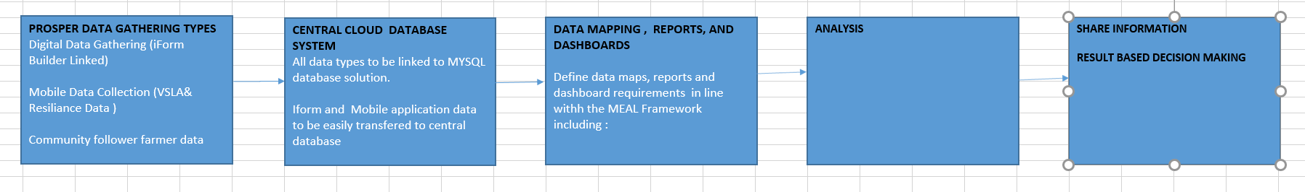

The solutions functionality and expected inputs and outputs as detailed in the Scope of Work (item 2.1), and use among consortium partners is depicted in the data flow map in Fig2 below:

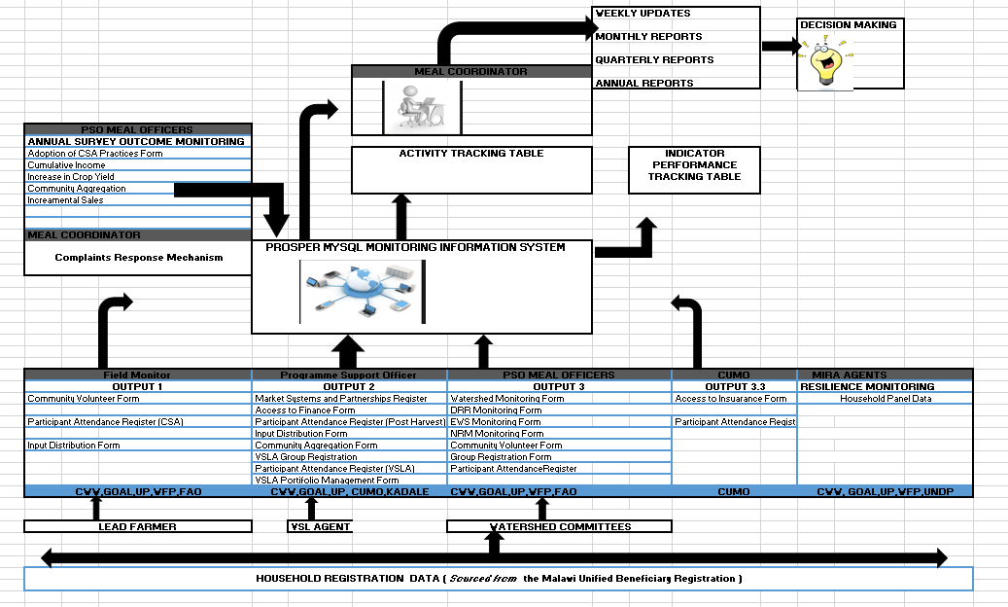

**3.0 EVALUATION OF PROPOSALS:**

Development of the monitoring system is expected to be done under tight timelines, however the Consultant is expected to propose a plausible duration, aligned to the scope and methodology for undertaking this assignment. This consultancy will be awarded to the consultant/s that offer a proposal that demonstrates the experience to develop a database to meet the programme’s needs at a competitive rate and within reasonable timelines.

The evaluation will determine the most technically compliant and competent bid addressing the scope of work outlined above, while also considering value for money and the proposed timeframe,, among the bids received. Concern Worldwide shall adopt a systematic evaluation process comprising of the following criteria:

a) Clear Process Flow/Functionality of the entire solution for the database and Management Information System

b) Platform proposed

c) Compliance with scope of work,

d) Compliance with Functional Requirements and Technical Requirements.

e) Qualifications of the Consultant and staff proposed for the assignment

f) Consultant/Firm’s experience and competency with data management and development of Management Information Systems.

g) Experience in the Development Sector and ability to provide a complete solution.

……………………………………………………………<END>…………………………………………………………

1. In-person or online
2. GDPR is the European Union’s Data Protection legislation. See <https://eugdpr.org/> for further details.