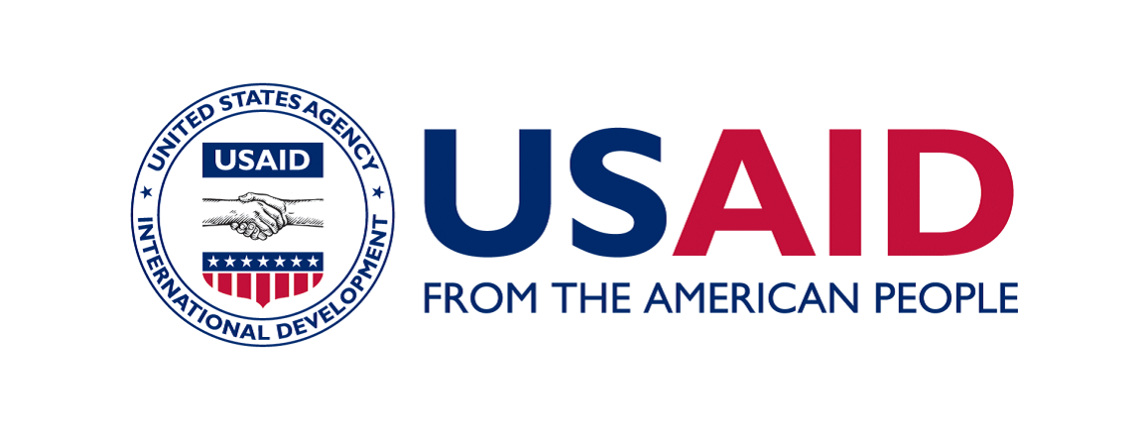
Call for Expression of Interest (EOI)
Humanitarian Response Capacity Building- NGOs
Concern Worldwide-RAPID

Call Reference No | ISB/Call EOI/21/03/0246
Issuance Date | March 30, 2021
Closing Date | April 15, 2021 17:00 hrs (05:00 pm)
- Introduction

Concern Worldwide is a non-governmental, international, humanitarian organization dedicated to the reduction of suffering and working towards the ultimate elimination of extreme poverty in the world’s poorest countries. Concern Worldwide is working in Pakistan since 2001. Concern is implementing the RAPID Fund (RAPID III) with the support of the United States Agency for International Development’s Bureau of Humanitarian Assistance (USAID/BHA). The program goal is to save lives, alleviate human suffering and reduce the social and economic impact of disaster and to nurture lasting national capacities in Pakistan. In close coordination with the Disaster Management Authorities (DMAs), relevant clusters, I/NGOs, target communities and working alongside existing humanitarian mechanism, the RAPID provides timely, flexible, effective, and needs-based sub-grants to national and international NGOs through a systematic short-term small grants mechanism.

In addition to sub-grants for disaster response, RAPID also includes targeted support activities for both national NGOs and DMAs to contribute in their disaster management capabilities.

- Background and Rationale

Pakistan has a history of major natural and man-made disasters. Local NGOs and the Disaster Management Authorities (DMAs) are most often the first responders to a disaster. However, they struggle to cope with the regular, multiple disasters due to both institutional as well as staff capacity constraints. Therefore, in addition to relief and recovery response through sub-grants, the second component of the RAPID provides capacity building support to local NGOs and DMAs. The basic objective is to invest in the local capacity as the country has a considerable national NGO base with strong potential to contribute towards timely and effective humanitarian preparedness and response. Similarly, with the establishment of National and Provincial Disaster Management Authorities (DMAs) the country now has an institutional structure to prepare for, and respond to, natural disasters.
RAPID capacity building support activities aim for improved humanitarian response capacities and include a multi-pronged strategy with focus on harnessing both the institutional and human resource capacities of targeted NGOs, as well as DMAs. After implementing first round of capacity building activities for NGOs and PDMA in Balochistan, RAPID is initiating the capacity building activities for NGOs in Sindh Province.

- Purpose of Call for Expression
The purpose of this Call for EOI is to invite eligible local/national NGOs based in Sindh Province with access/operational presence in disaster prone districts to submit their interest/proposal for RAPID capacity building component in accordance with the procedures and guidelines available on Concern’s RAPID Fund website and as per attached operational guidelines.

- Engagements/Activities with NGOs and selection Process
In response to the Call for EOI, the targeted NGOs will submit their proposal/interest; a panel will review and select eligible local/national NGOs for capacity building component. In the second step, selected NGOs will conduct self-capacity/needs assessment and sign MoUs. In Consultation with selected NGOs, RAPID will prepare and finalize the capacity building activities schedule. All planned activities shall be implemented as per the agreed schedule. Based on assessed needs, the activities will focus on institutional support such as development of organizational system, manuals and human resource skills development through trainings and practical simulations. NGOs will be linked with DMAs to assist them in conducting needs assessment in the immediate aftermath of any disaster and also support immediate rescue and relief efforts. For further details about RAPID mandate and potential activities, please refer to the attached operational guidelines. The selection process details for selection of local NGOs are given as given below;

Steps | Process | Timeline | Mode
Step 1 | Circulation of EOI | March 30, 2021 | NHN, UNOCHA, clusters, PDMA, PHF etc.
Step 2 | Submission of EOI | April 15,2021 | Electronic (email)
Step 3 | Administrative and Programmatic Reviews of EOIs | April 23, 2021 | Concern Internal
Step 4 | Final selection | April 30,2021 | Concern Internal
Step 5 | Communication to partners. | May 3, 2021 | Electronic
Step 6 | Signing Memorandum of Understanding (MOU) for capacity building partnership | May 10, 2021 | Electronic and postal service

- Evaluation Criteria
The key consideration for selection of NGOs to receive capacity-building support include:

- Organization must be registered as a legal entity in Pakistan only and local presence in Sindh Province.
- Organization with available human resource, established office in disaster prone districts in Sindh Province and demonstrated past experience of implementing humanitarian programs in disaster/conflict prone districts.
- Have clear governance structure (BoGs) and program management arrangements.
- Organization should be able to demonstrate their ability to secure and MoU with the EAD.
- NGO having at least 3-5 years of operational experience. Newly registered NGOs may not be considered unless otherwise they have proven institutional capacity and prospects for sustainability. Newly registered or NGOs with limited humanitarian response capacity may be considered if there are limited local NGOs in target area, limited previous humanitarian response and the area is vulnerable and susceptible to disasters.
- The Evaluation committee will conduct an initial analysis of prospects for success of capacity building support and from the past performance/experience evaluate the prospect for sustainability of assistance.
- Although it is not necessary that the organization interested for capacity building has substantial experience, however RAPID does not aim to start from scratch therefore RAPID will consider an organization’s previous experience in humanitarian program, disaster prone district(s) and humanitarian response sector(s). The criteria also considers NGOs that have previously implemented humanitarian response projects and have working experience with INGOs, UN or any other institutional donor. RAPID understands that in few disaster prone districts the small-scale, local NGOs have great potential to contribute but due to funding constraints they have limited previous experience. Therefore, RAPID will also consider target area’s vulnerability, NGO’s interest/commitment and potential for performance improvement.
- Organization demonstrates sufficient justifications (in EOI/Proposal) to receive capacity building support and sufficient justification that RAPID capacity building will support in organizational goals and improved humanitarian response.
- The challenges explained in the Expression of Interest (application) should be relevant to capacity gaps and within the scope of RAPID capacity building component. The impeding factors in addressing identified challenges are beyond organization’s own capacity and can be resolved through RAPID capacity building support. The expectations are in line with weakness/gaps identified by applicant and are within the scope of RAPID’s capacity building component.
- Commitment to performance improvement is a key consideration while selecting NGOs for capacity building support. This can be assessed by analyzing how well the organization has identified its own challenges, weaknesses, strengths and demonstrated a commitment for working on its areas of improvement, its own performance challenges and commitment to provide any resources or support such as staff time, office space and senior management time.
6. Mandatory Documents
Any local and national NGO meeting the above-mentioned requirements are encouraged to submit an Expression of Interest containing the following documents:
- Expression of Interest (on RAPID given standard template)
- Copy of latest MoU with the EAD
- Copy of Enlistment with PDMA, Sindh or copy of the application submitted to PDMA, Sindh for Enlistment.
- Please share last 02 years’ NOCs of at least two/three projects implemented by organization.
- Copies of the certificate of registration of the organization and any other documents demonstrating clearly that the organization is a recognized non-commercial/not-for-profit entity.
- Copy of NTN certificate.
- Please share the organogram of the organization.
- Latest audit reports for the last 2 years.

- EOI/Application Submission Guidelines and Deadline
The EOI/Application template and Capacity building operational guidelines attached with this Call for EOI should be read and understood by the Applicant. The EOI template standard RAPID document should be filled out as per the instructions/guidelines given for each section and the application should be submitted (in MS Word format) along with the other required documents (as listed above in section-5 ‘mandatory documents” ) via email to rapid.applications@concern.net. The total size of the email with attachments should not exceed eight (8) MB. The application must be legible and need not require magnification. Please keep all the attachments clear, concise, easy to follow, while also in complete compliance with the instructions herein and on our webpage.
This Call for Expression of Interest will remain open until 17:00 hrs (05:00 pm) on April 15, 2021. Only complete applications in compliance with the guidelines received within the deadline will be considered for further review process. It is the applicant’s responsibility to ensure that all required documents are submitted with the application on the email address provided below. Concern discourages the use of couriers as receipt of the application may be delayed.
In case of further queries, applicants can contact RAPID through the following email address or telephone number:
Email: rapid.applications@concern.net Phone: +92 (0) 51- 2310601-4 (Ext: 128)
Mobile: +92 (0) 301-8550812

Tharparkar, Umerkot, Sanghar, Dadu, Ghotki , Badin, Sajawal, Kashmore and Mirpurkhas

