Concern Worldwide
Republic of Ireland Gender Pay Gap Report 2025

- Introduction
One of Concern Worldwide’s core values is ‘We believe in equality’ - both within and for the communities with whom we work, and in our workplaces. In terms of gender, we are very conscious of the systemic inequality which women have experienced historically and experience today and so we continue to take action to address gender inequality through our programmes and throughout our offices.

In our workplaces we understand that position and pay are important metrics in assessing our progress in promoting gender equality. This Gender Pay Gap Report, looking at female and male staff employed through the Concern Republic of Ireland office, provides the opportunity for us to reflect on how we are doing in this regard in one of our countries of operation.

Employees Covered by This Report
The analysis within this report is based on those Concern employees who were employed on Irish contracts only. This includes our ‘International Staff’, and a number of specific employees based in countries outside of Ireland employed under the auspices of the head office in Dublin. It does not cover employees directly employed in any of our 22 programme country offices or employed by Concern UK or Concern South Korea.

The data used for profile and analysis in this report is from the period 29th June 2024 to 28th June 2025 inclusive. The data includes people who may have left the organisation within the reporting period due to resignation, end of contract, or retirement.

For this reporting period, the total number of employees included in the report is 512 people.

Pay
All Concern’s employees are aligned to transparent pay grades which provide for equal pay for equal work irrespective of gender.

The gender pay analysis and profile utilised in this report is based on annualised ordinary pay effective 28th June 2025 (ie it reflects pay for the preceding 12 month period).

- All Staff Gender Profile 2025
Of the 512 staff employed by Concern Republic of Ireland reported on in 2025, 45% (230) were female.
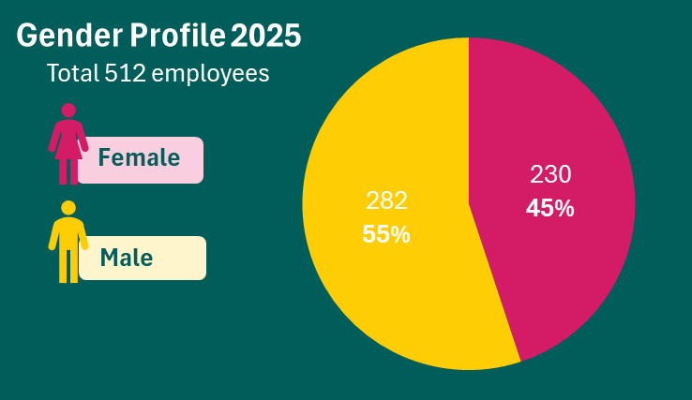

This represents a year-on-year decrease in the percentage of female staff from 50% in 2023, and then 47% in 2024.

- All Staff Gender Profile by Pay Quartile 2025
Pay quartiles are calculated by splitting all employees into four even groups according to their level of pay, with the lowest earning employees in the Lower Quartile and the highest earning employees in the Upper Quartile. Looking at the proportion of women and men in each quartile gives an indication of the gender representation at different levels of Concern Republic of Ireland.

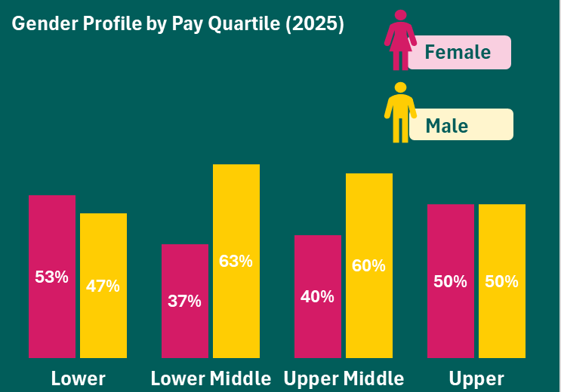

Quartile | Number of Employees | Female | Male | % Difference from 2024
 |  |  |  | Female | Male
Lower | 129 | 53% | 47% | -1% | 1%
Lower Middle | 128 | 37% | 63% | -7% | 7%
Upper Middle | 131 | 40% | 60% | -4% | 4%
Upper | 124 | 50% | 50% | 3% | -3%
All Staff | 512 | 45% | 55% | -2% | 2%

In 2025, 45% of staff in the Lower and Lower Middle quartiles combined were female, and similarly, 45% of staff in the Upper Middle and Upper quartiles combined were female. Given that 45% of the total staff in the reporting period were female, this represents a fairly representative spread across the lower and upper quartiles.

Comparing with figures for 2024 when 47% of employees reported on were female, we see that in 2025 there was a 3% increase in the percentage of female employees in the Upper quartile, but a decrease in the percentage of females across the other quartiles.

- All Staff Mean Hourly Renumeration 2025
The mean is the average. Mean pay by gender is calculated by adding the hourly rate for all female employees and dividing this by the number of female employees. The same calculation is carried out for male employees to allow us to identify the gap.

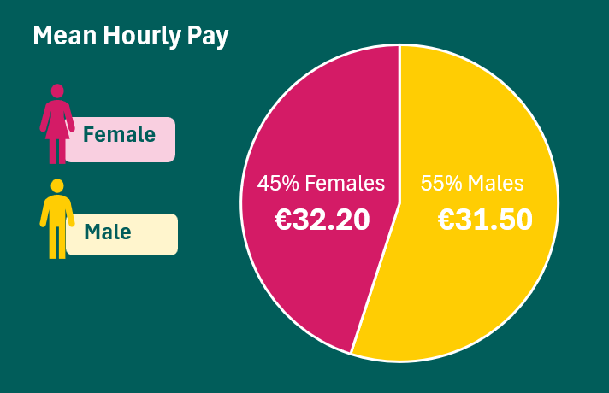

Year | Female | Male | Gap € | Gap %
2025 | €32.20 | €31.50 | 0.70 | 2.2%
2024 | €31.00 | €31.10 | - 0.10 | - 0.2%
2023 | €28.60 | €29.40 | - 0.80 | - 2.7%

In 2025, the mean hourly rate of pay for female staff reported on was 70 cent higher than for males, at €32.20 and €31.20 respectively. This meant the percentage gap in mean pay between female and male employees reported on was 2.2% in favour of female employees.

The 2025 percentage gap in mean hourly pay represents an increase of 2.4% in favour of female employees since 2024 when mean pay was 0.2% higher for male employees; and an increase of 4.9% on the 2023 figure which was 2.7% in favour of male employees.

- All Staff Median Hourly Renumeration 2025
Median pay is calculated by sorting hourly pay rates for female employees from low to high and taking the mid-point figure. The same calculation is carried out for male employees. The median gender pay gap compares the pay of the female in the middle of their line with the pay of the middle male.

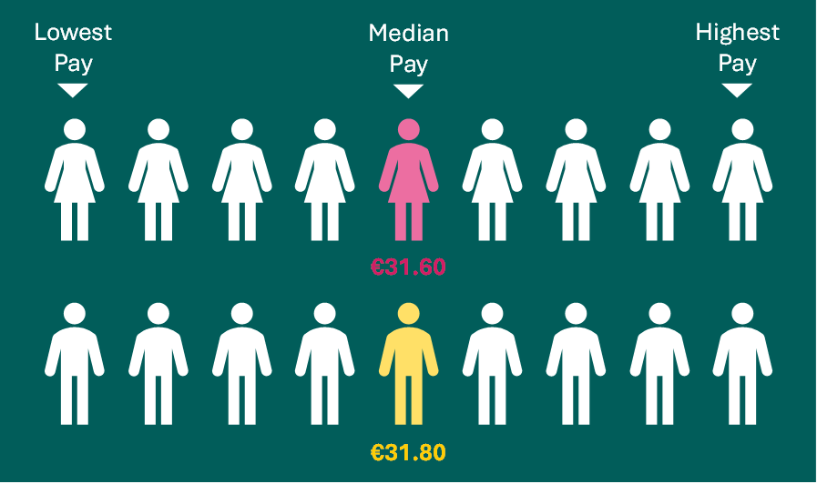

Year | Female | Male | Gap € | Gap %
2025 | €31.60 | €31.80 | - 0.20 | - 0.7%
2024 | €29.90 | €30.70 | - 0.80 | - 2.7%
2023 | €28.90 | €29.20 | - 0.30 | - 0.7%

The median hourly pay rate in 2025 was 20 cent less for female staff reported on than males, at €31.60 and €31.80 respectively. At 0.7% higher in favour of males, the 2025 figure is a reduction in the gap between females and males by 2% from 2024 when the median hourly rate of pay for males was 2.7% higher than females, and the same as 2023 when it was also 0.7% higher than for females.

- Part-time Employees
Of the 512 staff employed by Concern Republic of Ireland reported on in 2025, 19 (4%) were employed on a part-time basis.
- Our gender profile for these part-time employees was 84% female and 16% male (16 women and three men).
- The percentage gap in mean pay between part-time female and male employees was 79% in favour of female employees, with a mean hourly rate for females of €33.00 and for males, €18.40.
- The percentage gap in median pay between part-time female and part-time male employees was the same as the mean pay gap, at 79% in favour of female employees, the median hourly rate for females being €33.00 and for males €18.40.

The mean hourly pay rate and median hourly pay rate of €33.00 for the 19 part-time female staff, were higher than the mean and median hourly pay rates for all female staff of €32.20 and €31.60 respectively.

The mean hourly pay rate and median hourly pay rate for the three part-time male staff of €18.40, were considerably lower than the mean and median hourly rates for all male staff of €31.50 and €31.80 respectively, reflecting the fact that these three males were employed in lower paying jobs.

- Temporary Employees
Of the staff reported on in 2025, 247 (48%) of the total 512 were employed on temporary contracts such as fixed term or specific purpose contracts. This included people employed on international contracts, on project related contracts, and on leave cover.
- Our gender profile for temporary staff was 34% female and 66% male (85 women and 162 men).
- The percentage gap in mean pay between temporary female and temporary male employees was 5% in favour of male employees, with a mean hourly rate for females of €30.80 and for males €32.40.
- The percentage gap in median pay between temporary female and temporary male employees was 1.5% in favour of female employees, with a median hourly rate for females of €32.70 and for males of €32.20.

The mean hourly pay rate of €30.80 for the 85 temporary female staff was lower than the mean hourly pay rate for all female staff of €32.20; whilst the median for temporary female staff, at €32.70, was higher than the median hourly pay rate of €31.60 for all female staff.

The mean hourly pay rate of €32.40 for the 162 temporary male staff was higher than the mean hourly pay rate of for all male staff of €31.50; whilst the median for temporary male staff, at €32.20, was higher than the median hourly pay rate of €31.80 for all male staff.

- Bonus Renumeration
Concern operates a performance related pay structure for its Telemarketing Team and Street and Door to Door Fundraising Team. All Telemarketers and Street and Door to Door fundraisers receive a basic salary which can be increased each month if certain performance targets are met.

During the 2025 analysis period 35 such employees received performance related pay as a top-up to their salary.
- Out of the 35 employees, 13 (37%) were female and 22 (63%) were male.
- The mean bonus renumeration was €485 for females and €1,090 for males, representing a 55% gap in favour of male staff.
- The median bonus renumeration was €275 for females and €433 for males, representing a 36.4% gap in favour of male staff.

- Benefit in Kind
No benefit in kind was paid to any employee during the reporting period.

- Conclusion
Our gender profile of the 512 staff employed under the auspices of Concern Republic of Ireland in the 12 months to 28th June 2025, shows that 45% were female; 19 were part-time (84% of whom were female) and 247 were on temporary contracts (34% of whom were female). Notably, there has been a reduction in the percentage of female staff employed by 5% since 2023.

As regards levels of pay in 2025, 45% of the employees in the two lower pay quartiles combined were female, as were 45% of the employees in the two higher pay quartiles combined. This shows a fairly even representation of female staff across the pay quartiles.

Whilst the pay gap remains marginal for all staff, we have seen improvements in the percentage gap in the mean hourly pay rate for females, going from 2.7% in favour of males in 2023 to 2.2% in favour of women in 2025. Similarly, the median rate for females has recovered from a 2.7% gap in favour of males in 2024, back to the 2023 gap of 0.7% in favour of males.

Going forward, it will be important for us to remain cognisant of the reduction in the percentage of female staff employed through Concern Republic of Ireland in the past three years. In seeking to attract women into Concern and in order to maintain our marginal gender pay gap, we will continue to:
- Promote Concern as an organisation that values equality within our programmes and our offices.
- Highlight our working conditions – flexitime, hybrid working, part-time working, unpaid leave, and other terms and conditions.
- Embed an equality lens at every stage in the recruitment process, from role design, to interview, to on-boarding.
- Provide reasonable accommodation and specific supports to staff members who require these.
- Provide leadership development programmes and development opportunities for staff, with a particular focus on female participation in these.
- Equip our people managers to champion and role model our workplace equality, diversity and inclusion values.

Ordinary pay includes normal salary, allowances, overtime, shift premiums, pay for sick leave, salary top-up for statutory leave, pay for gardening leave and pay for piecework

