Sustainable & Equitable Wealth Creation in Amuria, Uganda 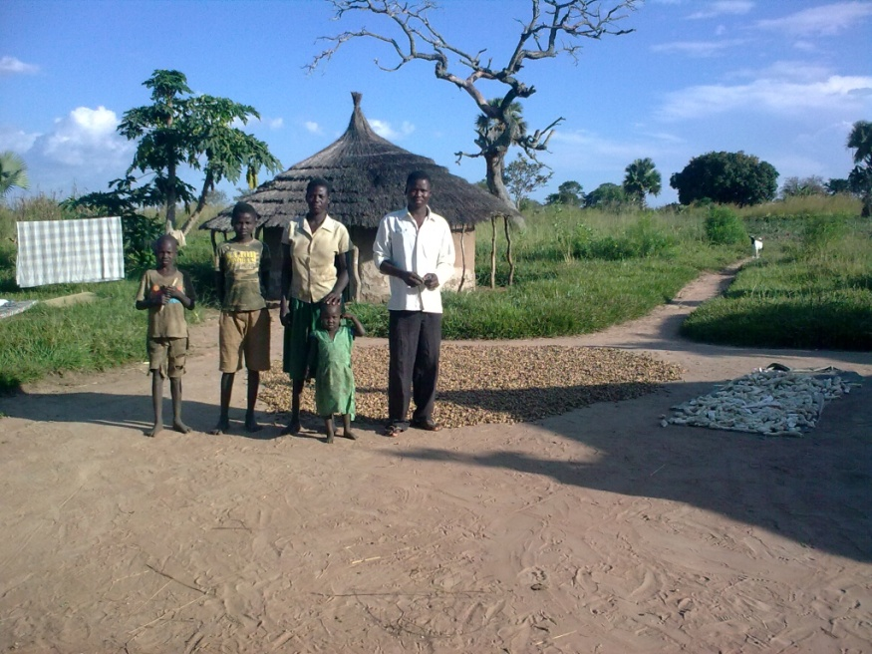

Final Evaluation

S J Truelove
Grant Code: GR002 A00018
September 2014

“This report reflects the opinions of the author alone and not those of CWW or their partners"

Contents
1 Executive Summary 5
2 Introduction, Project Background & Objectives 9
2.1 Overview of the Programme Intention: 9
2.2 What did a beneficiary or group typically receive? 9
2.3 Evaluation Objectives and Methodology 14
3 Did the Programme meet the outcomes set? 14
3.1 Did the Programme Meet its Target Number of Beneficiaries? 14
3.1.1 Did the Programme Include the Targeted Vulnerable Groups? 15
3.2 Were the Self Help, Marketing and VSLA Groups Formed Effective? 19
3.3 Were the Training Courses Effective? 21
3.4 Food Security, Nutrition and Agriculture Findings 22
3.5 Livestock and Poultry Findings 24
3.6 Disaster Risk Reduction Findings 27
3.7 Income Generation and Diversification Findings 27
3.8 Value Addition & Market Linkages Findings 32
3.9 Economic Findings 34
3.10 Advocacy and Influencing Decision Making Findings 37
3.11 Cross Cutting Findings 39
3.11.1 Conflict prevention 39
3.11.2 Value Added of Concern Worldwide 39
3.11.3 M&E and Progress since MTR 40
4 Recommendations and the way ahead 41
5 Learning 46
6 Conclusions 49
7 Annex 51
7.1 Terms of Reference 51
7.2 Evaluation Schedule 58
7.3 Detailed Evaluation Methodology 59
7.4 Beneficiary, Groups and FGD Question guidance tool 61
7.5 Key Stakeholders Consulted by Evaluation 66
7.6 Livestock and Poultry Data 66
7.6.1 Data from CIDI: 66
7.6.2 Data from VEDCO 67
7.7 Detailed Breakdown of Training Modules 67
7.8 Principal Advocacy Impacts 74
7.9 Bibliography 77
7.10 Logical Framework 78

Separate Technical Annex – SEWCA End line Survey Report 2014
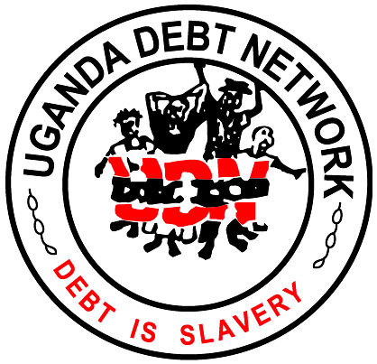
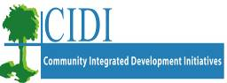
Report Status:
This report was commissioned by Concern Worldwide, and the agency are responsible for it. The views represented in the report are those of the author alone.
Acknowledgements:
Huge thanks to the Concern Worldwide, VEDCO, CIDI, and UDN SEWCA teams for Amuria; Laura Lalor, Finola Mohan, Emmanuel Ssegawa, Harriet Anyango, Ketty Nakirya, Emmanuel Eletu and Moses Okoed and a special mention for his tireless efforts acting as the evaluation interviewer and translator to Nelson Odeke.
Author:
Sharon Truelove
Independent Evaluation, Training and Technical Advice in Relief, Recovery, Cash Programming and Development: sjtruelove@hotmail.co.uk

Abbreviations
BF |  | Beneficiary
CB |  | Capacity Building
CBM |  | Community based monitors
CBO |  | Community based organisation
CHH |  | Child Headed Household
CIDI |  | Community Integrated Development Initiatives
CWW |  | Concern Worldwide
DFID |  | Department for International Development
FGD |  | Focus Group Discussion
FFS |  | Farmer Field School
FHH |  | Female headed household
HI |  | Heifer International – Uganda
IGA |  | Income generating activity
LH |  | Livelihood
LS & P |  | Livestock and Poultry
MA |  | Marketing associations
NAADS |  | National Agricultural Advisory Services
POG |  | Passing on the Gift
PWD |  | People with disabilities
PLWHA |  | People living with HIV/AIDS
SEWCA |  | Sustainable and Equitable Wealth Creation in Amuria
SMART |  | Specific, measurable, appropriate, realistic and timely
UDN |  | Uganda Debt Network
VSLA |  | Village Savings and loans Associations
TOT |  | Training of Trainers
VEDCO |  | Volunteer Efforts for Development Concerns

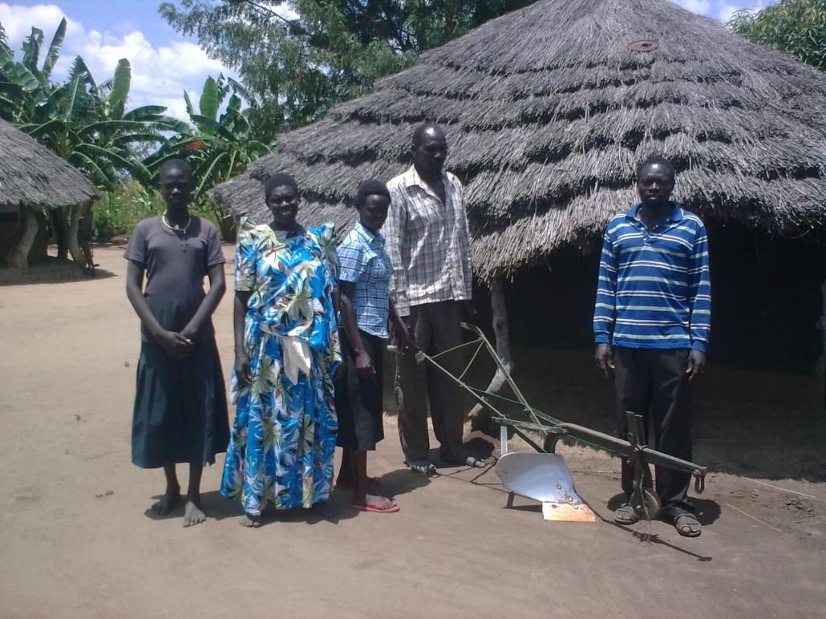
A vulnerable household with the plough they have been able to buy.

Executive Summary
This project has demonstrated a remarkable level of sustainable livelihoods in the post conflict and highly vulnerable households with which it has worked. It has also had remarkably strong positive knock on effects within many neighbouring households, who have spontaneously copied many of the improved agricultural and post harvest innovations disseminated. The advocacy and decision influencing approach is outstanding and donors and partners are urged to consider replicating this advocacy model globally.
This report and its detailed recommendations should be seen as small tweaks to an already successful approach, and should be read with these extremely positive overall statements in mind.
This report represents the final evaluation of a five year Comic Relief funded programme called the ‘Sustainable and Equitable Wealth Creation in Amuria’ (henceforth SEWCA) programme from January 2010 ending December 2014. This independent largely qualitative evaluation builds upon the extensive largely quantitative internal work contained within the programme baseline, mid-term review and the internal project monitoring data that is summarised and analysed in detail in the “SEWCA End line Survey” report contained within a separate technical annex.
The programme is principally; an agriculture project based on improved seeds and production techniques; a ‘passing on the gift’ livestock project with draught power and improved sheep, goat and chicken cross breeding components; a value added and improved and collective market practices and linkages aspect; and a village savings and loan (VSLA) component. This is supported by a wide ranging programme of training and capacity building measures; with disaster and climatic risk reduction elements and community mobilisation aspects, many of which relate to rights building initiatives’ and increasing beneficiary and women’s ability to influence local decision making. Though not described directly within its project documents as having climate change adaptation and mitigation aspects, the programme’s integrated agricultural, livestock and disaster risk reduction (DRR) strategy has broad ranging climate change adaptation practices principally: varied agricultural practices including drought resistant seeds (flood tolerant crops knowledge and varieties were not adequately disseminated), quick maturing vegetable garden seeds, nursery beds or ‘sack mounds’ and composting and manures advice; improved post harvest storage and processing techniques and technologies; fuel efficient stoves, with some limited tree planting and bee keeping aspects combined with awareness raising and advocacy work.

Overall, this combined agriculture, livestock, livelihoods and DRR programme has made remarkable and commendable impacts upon meeting the stated food security and income generation objectives of the programme. Project data indicates that the outcome indicators have now virtually all been met, with planned total beneficiary numbers at 4800 households or approximately 28,800 people. Achievements have occurred across all the aspects of the programme, and where challenges were identified in the mid-term review in November 2012, the project has implemented effective changes.

The programme was very successful in meeting its food security goals, with almost all households (except in the flood prone community) reporting having being able to ‘eat until satisfied at least three times a day’, and the majority of households were able to do this in all years, with only a small minority who now reported much shorter than previous ‘hungry’ periods in the months prior to harvest in poor years (floods and droughts). In contrast, many non beneficiaries reported still having longer periods within the year when they were not able to satisfactorily meet household food needs.
All groups reported considerable success in almost all of the agricultural aspects of the programme, most farmers reported a doubling or more of yields and a doubling of income from crop sales. This success is with the exception of the flood prone focus group discussions (FGD) beneficiaries who had lost almost all of their donated seed each year. A recommendation has been made to return to all flood prone communities and farms to investigate improved approaches, and attempt one final improved intervention prior to project closure if possible. There was a great deal of divergence in whether beneficiaries had managed to increase the area cultivated as a result of this project. Indications were that about half of HHs had increased the area cultivated, and about a quarter had managed to double the area cultivated. The Oxen and plough assets were fundamental to achieving this. Increased yield per area seems to have been a better indicator, with all farmers reporting having intensified production (increased yield per acre) and about half had also managed to extensify production (increased area cultivated). This is very positive from a climate change perspective. However, it is important to recognise, that as with the two focus group discussions (FGDs) with indirect and non-beneficiaries, that many in Uganda have also progressed, even without programme assistance. Non beneficiaries had also on occasions been able to double the area they had cultivated, though it was evident that many had not been able to increase the area cultivated by very much at all. Recommendations have been made regarding the inclusion of small non beneficiary control groups in future base line and end line studies to ensure that progress can be properly attributed to the programme.
Strongest gains in disaster risk reduction (DRR) were evident through the diversification of crops as well as the diversification of incomes through adoption of less weather dependent incomes as well as the reduced risk of disease from the water and sanitation aspects and the opportunity for riding out the ‘bad times’ presented by the VSLAs. The programme was aimed at increasing the diversity of crops grown (reducing risk of total crop failures), the nutritional diversity of those crops and the income from production. As can be seen in the detailed economic case study of Cuthbert in Section 3.9, many households were previously reliant on three staple crops (such as ground nut, millet and cassava). Almost all households now report growing nine or more different staple and vegetable crops (4 vegetable types on average), and a third now report growing small amounts of fruit crops. There was less evidence of crop diversity at household level in those cases where SHGs had grown all the vegetable and fruits on communal farms and thus it was uncertain whether the skills and nutritional benefits would eventually pass down to the individual household level, particularly in the most vulnerable of HHs who may tend to drop off or drop out of communal activities in the long term. It was felt that more could have been achieved to reduce risks and increase diversity and nutrition by specifically identifying nutritionally advantages crops, vegetables and fruits, and particularly targeting those for PLWHA, PWD, CHH and the elderly and through ensuring all new varieties are also grown at household level.

The programme was extremely successful in increasing the income generated by beneficiaries from the sale of crops surpluses, and very importantly the prevention of unnecessary wastage through reductions in storage losses (40-50% on average). About a third of farmers could now be said to be ‘commercial farmers’ and many more are on their way. The project has also achieved considerable value addition through improved drying, threshing and primary processing using largely SHG or Market Associations (MA) owned shelling and grinding machines. These communally run MAs are now functioning well and, for those farmers able to access Market Associations, have succeeded in not only increased the prices gained over farm gate middlemen by about 10%, but probably more importantly by further improving storage, better sacking-up in bulk and ensuring higher standards of raw material quality to ensure improved prices. Strong MAs represent a substantial success so early in the programme cycle and so soon after farmers have moved beyond purely subsistence production into commercial production. They now show the potential to increase their scope from assisting farmers through bulk purchasing of inputs to increasing the diversity of the crops that they deal in (cotton and more perishable fruits and vegetables) through adjustments in their strategy. Recommendations have been made to encourage MAs to begin setting ‘collection dates’ where the more bulky or perishable goods are communally collected and transported to more distant, high priced markets. Strategies need to be found to ensure that farms remote from the MA centres can benefit from these advantages. The project has established new market linkages with a small number of large seed and input suppliers who also purchase crops. Only small numbers of beneficiaries have gone on to gain new income through either new enterprise or adding value beyond the basic raw material stage through secondary processing such as cooking, preserving, packaging and selling to final consumers.
The majority of groups formed by the programme (SHG, VSLAs, MAs and CBMs) showed good signs of strong group formation, active members with well functioning leaders. All groups showed high levels of participation and empowerment of women and other vulnerable groups, even at a leadership level.

Other highly commendable aspects of the programme include; the little documented, fuel efficient stoves (FES) which have shown the greatest potential in terms of both labour saving for women and girls and DRR and climate change mitigation and adaptation benefits. FES are locally appropriate, sustainable and easily spontaneously adopted and have been shown to have the potential to cut domestic energy consumption by two thirds.

Some aspects of the programme are only just coming to fruition and will require a longer time frame and additional support to ensure that they can go on to be self sufficient and sustainable. Group managed oxen draught power and technologies have been critical to the food security and income gains made by Self Help Groups (SHGs). Though benefits from the livestock and poultry aspects of the programme are naturally slow to come to fruition, initial signs are that mortality rates are low. Recommendations have been made to ensure that the gains are equitably managed. The apiaries have proved problematic and many are not fully colonised or producing. Further specialist support, particularly on pests and diseases and the training courses in the lucrative bee product processing will require funding into the future before they can reach their potential and become sustainable. Other project aspects require some limited follow-on specialist advice to ensure that the full rewards can be reaped; some farmers have now reached commercial scales of production and require the ongoing backing of the specialist pest and diseases advice of staff to ensure that their bumper crops are not lost, and the expert advice on either storage, processing or accessing distant markets, if their crops are not to perish by the road side.

This programme with its community based monitors represents the only truly successful grassroots advocacy and influencing decision making approach that this evaluator has ever seen.
As the text box suggests, the approach of communities identifying individuals from within their communities to be trained in advocacy and decision influencing skills, and who are then grouped into CBM associations, has been an exceptionally effective one at both local, district, regional and national level. The evaluation did however identify areas where this successful CBM approach could be further strengthened, including; support to ensure all CBM associations have strong VSLAs and IGAs, increasing the ability of more remotely based CBMs to access meetings; promoting strategies to reduce CBM drop off/out rates particularly amongst women and twinning with neighbouring communities to allow skills and benefits to pass to other communities.

The project appears to have been well managed, and has shown its ability to respond to problems with the approach and learn from project challenges (MTR). There was sufficient anecdotal evidence during the evaluation that specific vulnerable groups were not being adequately monitored and were dropping off and out of programme activities and may begin to ‘miss out’ on advantages being received. The long term concern is that because the most vulnerable find it hardest to take part in the communal activities, that they will in the future be ‘missed out’ from the gains from, oxen, livestock and poultry etc.

The agricultural and marketing association aspects of the programme have in particular been extremely successful in turning around the fortunes of some very poor households. Not only have a wide range of households been able to increase food production, but they have been able to do so even in ‘drought’ years, and in good years have produced sufficient surpluses for sales that have allowed expenditures on education, health care and most crucially on investing in productive livelihood assets and other income generating activities

The project was also instrumental in improving working relationships and partnerships amongst the three implementing organisations which helped facilitate better linkages for local service delivery of Government programmes. The issues of the agricultural sector gained more profile and visibility at policy and budget decision-making forums, both at local Governments and national level. The Amuria intervention was reported to have contributed significantly to policy reports for agricultural financing, institutional reforms and mechanisms for delivery of agricultural extension services discourse in Uganda.

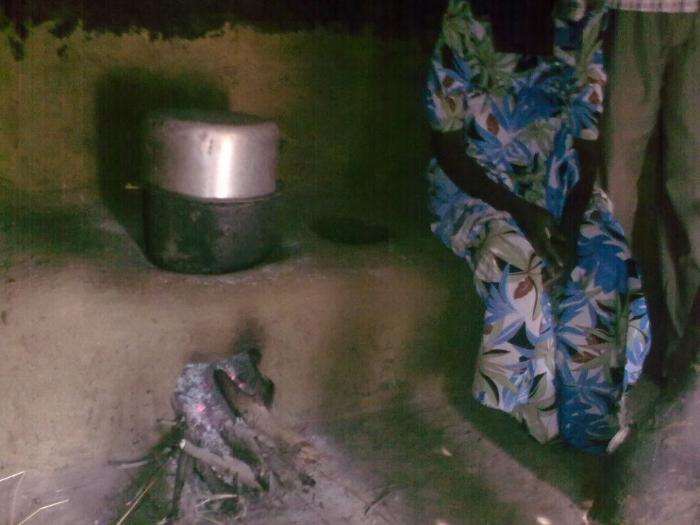
A handmade fuel efficient stove.
Recommendation: expand the concept of ‘pass on the gift’ to also include knowledge and spread benefits to neighbouring villages

Introduction, Project Background & Objectives
This report represent the final evaluation of a five year Comic Relief funded ‘Sustainable and Equitable Wealth Creation’ (henceforth SEWCA) programme from January 2010 ending December 2014 (GR002 A00018 GBP £1,564,288). This largely livelihoods recovery, market linkages and advocacy programme falls under the ‘People Affected by Conflict’ grant programme and is the first project in which the EIRE/UK based Concern Worldwide (henceforth CWW) has worked in a direct partnership consortium with the Uganda based Volunteer Efforts for Development Concerns (VEDCO), the Uganda Debt Network (UDN) and the second time CWW have worked with Community Integrated Development Initiatives (CIDI).
The ToR for this evaluation is contained in Annex 7.1 and the programme logical framework document is contained in Annex 7.10. These and the End line Survey in a separate technical Annex contains a full and detailed description of the background to the SEWCA programme and its objectives this is summarised here only to avoid repetition:

Overview of the Programme Intention:

Programme Goal: Sustainable and equitable wealth creation in four sub-counties of Amuria District which will contribute significantly to sustainable development in the region and contribute to MDGs 1 & 8

Programme Purpose: Producers benefit from increased food security through the diversification and increase in household agricultural production and income from surplus trade through increased access to local and national markets.

Programme Coverage: Four sub counties in Amuria District, Uganda (Obalanga, Kapelebyong, Acowa and Morungatuny)

Programme Implementation Strategy: The programme is being implemented by Concern Worldwide Uganda in partnership with Volunteer Efforts for Development Concerns (VEDCO), Community Integrated Development Initiatives (CIDI) and Uganda Debt network (UDN)

Target: A total of 240 Groups (60 groups per sub-county) representing approximately 4,800 households The programme targets at least two members of each participating household so a total of 9,600 individuals will participate directly, benefiting a total of approximately 28,800 individuals.

What did a beneficiary or group typically receive?
The tables below summarise what a typical beneficiary household might have received during the course of the programme. For simplicities sake, the information provided below is listed for VEDCO and CIDI in separate tables. There were some small differences in the packages given by VEDCO and CIDI, and it is recommended that the partners discuss the pros and cons of the different approaches in detail to ensure learning is captured by the end of project.

What did a typical Household receive? |  | A typical CIDI beneficiary received | Remarks
Tools: |  | Hand hoe. | To each of the beneficiaries.
Livestock & Poultry |  | Listed in Annex
Year 1 Seeds: | Ground Nuts  Sorghum  g/grams  cassava cuttings  citrus seedlings | 0  10kgs  5kgs  8 bags  50 seedlings | Citrus given to a household hosting demo site in selected group/household
 | Vegetable Seeds:  Tomato  eggplants  onions | 50gms  50gms  50gms
Year 2 Seeds: | Ground Nuts  Sorghum  Upland rice  Simsim  Greengrams  sunflower  Maize  Soya beans  Citrus seedlings  Pine seedlings | 2 bags/1bag  5kgs  11 kgs  2.5kgs  5kgs  5kgs  10kgs  20kgs  72 seedlings  200 seedlings | Citrus & pine seedlings was given to a household hosting a demo site in selected group/household
 | Vegetable Seeds:  Tomato  Eggplants  Carrots  Water melon  onions | 50gms  50gms  50gms  50gms,  50gms
Year 3 seeds: | g/nuts  pineapple suckers  passion fruits  paw paws seedlings | 1bag revolving seeds  500  50  50 | Ground nuts to all beneficiaries.  Fruits to selected PLWHIV
Year 4 seeds: | Eucalyptus seedling | 50 seedlings | each host household given the seedlings

There were slight differences in approach and what a household received between the partners, with CIDI adopting more of a ‘breeding centre approach to animals and poultry and VEDCO adopting a different approach to ‘commercial farmers’ from ‘subsistence farmers’:

What did a typical Household receive? |  | A typical VEDCO  Beneficiary HH received | Remarks
Tools: | Hand hoes | 1/HH | 1,208 in total given
Livestock & Poultry | Listed in full in Annex 7.6:
Agricultural Inputs
Year 1 Seeds: | Gnuts  Cassava cuttings  Sorghum  Green gram | 12000kg  4800 bags  475kg  2400kg | Commercial household got:  - Groundnuts (shelled) 35kgs  - Green gram 8kgs  Food security households  - Groundnuts 8kgs(shelled)  - Sorghum 3 kgs  - Cassava stems 4 bags
Vegetable seeds | Tomatoes  Onions  Grain Amaranth | 2000gms  2000gms | Household level  Tomatoes 25grams  Onions 25grams  Grain Amaranth 0.5kgs
Year 2 Seeds: | Ground Nuts  Soya  Green grams  Sim sim (Sesame)  OFSP Vines  Citrus seedlings  Sun flower  Rice | 10500kgs  1000kg  2000kgs  500kgs  121 bags  1000 seedlings  100kg  1000kg | Commercial Farmer household  - Groundnuts (shelled) 35kgs  - Soya 8kgs  - Green gram 8kgs  Food security households:  - Groundnuts 8kgs(shelled)  - Simsim 2kgs  - Citrus seedlings 25
Groups |  |  | Group Demonstrations  Rice  Sunflower 5kgs  OFSP Vines 1 bag
Vegetables | Tomatoes  Egg plant |  | 4 FFS
Year 3 Seeds: | Neem tree  Citrus seedlings  Soya | 250  500  1040kg | Neem Tree seedlings – 12  Citrus seedlings 25  Soya Individual hh – 7.5kgs
group | Soya |  | Soya 15 kgs
vegetables | Carrots  Egg plants  Tomatoes  Cabbages |  | 12 FFS  Carrots….  Egg plants  Tomatoes  Cabbages
Year 4 seeds | Gnuts  Cassava cuttings MMH96/427 variety  Namsoy | 20 bags Given to only farmer field schools  4 bags  400kg Given to vulnerable households | 20 FFS:  Groundnuts 1 bag per FFS  Cassava cuttings MMH96/4271variety -4 bags to 1 FFS  Soya 8 kgs per household
Year 5 seeds | Epurpur sorghum | 7500 kgs
Vegetable seeds | Tomatoes  Onions  Collards  Egg plants | 4300gms  4300 gms  4300gms  4300gms
The table below indicates what a typical Self help group (of typically 20HHs) received:
A Typical Self Help Group Received: | CIDI  Planned/actual | Remarks
2 Oxen, plough, chains | Oxen 240/240  Ox-ploughs 120 /120  Chains 120/120 | All the 120 groups were supported
Wheel barrows | 60/60 | 60 given to pre-existing groups
bicycles | 120/120 | Given to all the groups
Hand hoes | 120/120 | Given to first groups
Bee hives | 10/10 | 10 modern beehives given, 5 in Obalanga & 5 in Acowa
Small grants worth 633,100 | 10/10 | 6,331,000 were given for produce buying (cassava chips, millet grain, groundnuts etc.), sale of fuel etc.
Wire mesh for constructing raised racks | 60/60 | Distributed to cassava and maize commercial farmers. 30 per sub-county
Tarpaulins | 60/60 | Distributed to commercial farmers
Improved Granary | 10/10 | Ten farmers were supported with 10 modern granaries one demonstration per parish targeting the elderly.

The Table below indicates the depth and breadth of training and capacity building that a typical group or household would have received during the programme:

What Training did a Typical Household Receive?
Group dynamics:
- Group formation & governance/constitution/records
- Group savings/credit & mgmt
- Conflict resolution
- Gender
- Group leadership
- Monitoring and monitoring with government authorities
- Collective marketing
- Extension support
- Farmer Field school.
Agronomy Areas/topics covered:
- Seed selection
- Land preparation &site selection
- Timely planting & soil/water conservation
- FFS approaches – seasonal long calendar/AESA sheet usage
- Weed & pest mgmt -IPPM
- Post harvest handling/marketing
- Nutrition
- Vegetable production
- Post harvest handling & management
- Epuripri seed growing
- Sunflower growing
- Farm records/types and importance
- Farming as a business(FAAB)
- Farm planning & mgmt
- DRR- coping mechanisms, energy saving stoves, agro-forestry
Livestock management:
- Small animal mgmt, feeding, poultry breeding
- Ox en & Ploughing
- Tick borne & disease identification &control –de-worming, spraying
Business skills development:
- Start-ups
- Customer care
- Business plan development
- Business records
- Financial records & mgmt
- Value chain development
Gender roles & daily activity calendar
Hygeine & sanitation
Other capacity Building methods used:
Exposure visits - to places Research Institutions, marketing associations
Exchange visits – to effective groups or associations that included. Kaberamaido FFS, Serere Sweet potatoes growers and Processors association
Cross learning visits - 5 done between VEDCO and CIDI
Exposure visits for marketing associations -4 done
Market information dissemination

Evaluation Objectives and Methodology
This evaluation report concentrates on reviewing the programme progress against:
- The stated outcome indicators in the project logical framework using internal project collated data (baseline, mid-term and end line) and triangulated against the more qualitative findings of the final independent evaluation.
- The standard DAC criteria (conclusions)
- The Comic relief key evaluation questions where most relevant.
The report concentrates on the changes and impacts identified in the lives of the beneficiaries and communities and local and government institutional structures that they live within. Qualitative information was collected principally through a small number of well attended focus group discussions and triangulated with individual beneficiary case study interviews and key informant interviews with principal stakeholders. The evaluation was unable to collate qualitative data evidence due to the very short time available in the field. Where qualitative data has been used in the report it is given as a guide only and is in no way considered to be significant statistically.
A more detailed description of the methodologies used within this evaluation is contained in Annex 7.3 and the principal tool used is copied in Annex 7.4.

Did the Programme meet the outcomes set?
It is important to point out, that this evaluation is based on the information gathered from a good number of stakeholders and a relatively small number of beneficiaries in focus group discussions (approximately 130 beneficiaries and 15 indirect and non beneficiaries) and through an individual household case study interviews (10 beneficiaries). Thus, though it is backed by the evidence of an internally produced baseline, mid-term and end-line surveys this report is not based on a statistically significant survey. Findings should be considered as a guide only.

This report summarises evaluation findings in brief and concentrates on detailed actionable recommendations in order to inform future programming and proposal applications. A great deal of analysis relevant to this evaluation has been outlined in detail in the internally produced “SEWCA Survey” (2014) contained in a separate technical Annex. This evaluation report has sought to draw upon the most important findings from the end line survey reports analysis of the baseline, mid-term and end line data, and does not attempt to repeat these important findings wholesale. The “SEWCA End line Survey” report is essential background reading for a complete understanding of the progress of this programme.

Did the Programme Meet its Target Number of Beneficiaries?
The table below indicates that the programme has achieved all of it targets (identified in the programme logical framework in Annex 7.10) both in terms of the total numbers of beneficiaries and groups established, as well as exceeding its target numbers of beneficiaries from specific vulnerable groups. Et not attained was that for the numbers of Community Based Monitors (CBMs) due to a specific difficulty encountered with failure by group leaders to keep satisfactory financial records in one sub county (Kapelbyong).

 | Planned | Actual achieved  VEDCO/CIDI | Comment & percentage of BFs falling into this category.
Number of Households | 4800 HH | 4808
Men (see note)  Women  PWD  PLWHA  Elderly  Widows  CHH  YOUTH | Targets for VEDCO:60% women, 40% men: CIDI 50% women, 30% men and 20% youth | 1000/1328  1408/1072  31/202  191/422  133/465  119/0  0/8  795/988 | Total – 2328 (48%)  Total – 2480 (52%)  Total – 233 ( 5%) (nationally PWD 19%)  Total – 613 (13%)  Total – 598 (12%)  Total – 119 ( 3%)  Total – 8 ( 0.2%)  Total – 1783 ( 37%)
Number of Self Help Groups | 240 | 241
Number of VSLAs | 240 | 241 | Two groups carry out VSLA as one group
Number of IGAs | No target set | 2400 | On average 11 members per group having IGAs
Number of Marketing associations | 8 | 8 | Achieved all planned for 2 in each s/county
Number of Bulking stores | 8 | 8 | Achieved all planned for and four marketing associations have four stores, 2 in each s/county
HIV/gender focal persons | 240 | 241 | All achieved
Community monitors (UDN output) | 120 | 90 | Achieved in all sub counties accept one (Kapelebyong)

Did the Programme Include the Targeted Vulnerable Groups?
VULNERABLE GROUP INCLUSION - ACHIEVED - Documents indicate that the programme would target the specific vulnerability groups of women (widows and female headed households in particular), People with Disabilities (PWD), People Living with HIV/Aids (PLWHA), the elderly and Child Headed households (CHH). Project data in the table above indicates the project successfully met and in some cases surpassed its inclusion targets. A recommendation has been made to ensure inclusion targets are recorded in project logical framework documents. Project documents indicate the programme appears to have low percentages of PWD (5%) in relation to the national average (19%, which would be expected to be higher in a post conflict region like Amuria than in the nation as a whole). Programmes are recommended to set realistic but challenging targets and not to forget to target FHH and recognise the additional challenges faced by female headed households (FHH) and to particularly adapt their programmes for the restricted labour available to these HHs.
The end line survey has a detailed section on the findings of the base, mid and end line surveys on HIV and AIDS (no baseline stats). The evaluation concluded that PLWHA had been strongly targeted, but it did have some concerns over the methods that may have been used on occasions to identify, select, and possibly verify HIV status. These concerns were discussed with the relevant senior staff member and recommendations were made for Concern to produce short clear guidelines for partners on PLWHA beneficiary identification, selection and maintaining client confidentiality.
UDN were also involved in partnership with local government staff (Community Development Officers) in ensuring that PLWHAs and other vulnerable persons are identified and included for training in advocacy strategies and links in respect to Rights holders, citizen roles and responsibility and Duty bearers
The Youth (defined as 18-30 in line with GoU) were not specifically selected for the agriculture and livestock aspects of the programme, but high rates of inclusion were reported. Given the donors emphasis on ‘youth inclusion’ it is surprising that more was not done to include young persons, that might have involved selecting a younger age group than the GoU definition, particularly given the specific loss of education and livelihood training that occurred for this group during the conflict. UDN have indicated that though youths were deliberately targeted, the drop off/out rates of Youths was high because youths often leave the area or frequently move for marriage or work purposes as well as the lack of ‘quick tangible benefits’ (UDN). UDN should be tasked with coming up with innovative recommendations for how to address this for future programmes.
The initial Concern Worldwide programme proposal also indicated an intention to work with men who were ‘under productive’ and this too appears to have been widely achieved, with many men seemingly reinvigorated by their productive roles. During beneficiary selection, the project staff worked very hard to aim to ensure that the SHGs and marketing associations included as high a proportion as possible of the targeted vulnerability groups. In some cases this was achieved by literally scouring the local communities to identify sufficient CHHs, for example, to ensure that the project targets would be met. This is an unusual approach, but does in some cases seem to have ensured that some HHs who would have otherwise been forgotten about, as they were very marginalised, were not excluded. The project also worked very hard to influence SHG and MAs to as far as possible include specific target groups within leadership roles. In many cases this has been a very successful approach, but in a number of individual cases, vulnerable beneficiaries have not really met the leadership needs (literacy and numeracy as well as confidence) or had the spare time to properly fulfil these roles. The attempt was admirable, and where attempts have been made to address the causes for the failure of individuals to fulfil leadership roles, then groups should now be allowed to select other candidates.
There was sufficient anecdotal evidence that specific vulnerable groups were dropping off and out and were beginning to ‘miss out’ on advantages being received such as tarpaulins and vegetable seeds and the long term concern is that because the most vulnerable find it hardest to take part in the communal activities, that they will in the future be ‘missed out’ from the gains from, oxen, livestock and poultry etc.
Though the project has been very successful and initially targeting vulnerable groups, drop off and drop-out rates have not been routinely monitored. This would have been a useful way of addressing the inevitable tendency for the weakest to be lost from programmes (CHH in particular), and this should constitute a key area of learning for all partners and Comic Relief. The evaluation did not have sufficient time to adequately explore which groups were most adversely affected, but CHH, the infirm elderly and HHs with limited able bodied labour such as PWD and the chronically sick requiring considerable care, are more likely. The categories of PWD and PLWHA can be problematic as they include a wide variety of HHs some with limited restrictions on labour, and it is often primarily the restriction on labour that contribute most to the HHs vulnerability. This is a key learning point, and partners should develop strategies related to this for future programming.
There was a strong emphasis within the programme upon the inclusion of PLWHA, and a great deal was achieved in particular in increasing community understanding and reducing stigma. Though the programme interventions fitted the specific needs of PLWHA well, particularly through the inclusion of a water and sanitation component, it would also have been beneficial for there to have been a more wide ranging deliberate strategy of targeting PLWHA with agricultural and livestock and poultry assistance that was more deliberately linked to their nutritional and additional income needs. For example, specific fruit, vegetable and livestock products such as specific vitamin and mineral rich fruit and vegetables, milk and eggs for example.

Indirect and non beneficiaries indicated that though they were often poor and some of whom were representative of vulnerable groups targeted for the programme, that they were not members of SHGs or MAs as they were late returnees from the camps. Future programmes would be recommended to have systems in place to ensure the capture and inclusion of these late returnees, who do tend to be, by their very nature, the most vulnerable. This should represent a key learning point for Concern and Comic Relief in Post conflict camp setting environments.

In addition, baseline results are believed to have been too late to inform geographic and poverty targeting. Recommendations to ensure M&E is light and practically based enough to be quickly useable to improve project delivery and allow adaptations in approach, have been made.

Inclusion and Participation of Women – ACHIEVED. There was not sufficient time to evaluate the GBV aspects of the programme, though a detailed analysis is included within the end line survey report. Across the project the targets for the partners and the degree to which these were attained are as indicated in the table below:
Inclusion | Target | Actual
VEDCO:  Men  Women | 40%  60% | 41%  59%
CIDI:  Men  Women  Youth | 50%  30%  20% | 55%  45%  41%
It is important to point out that the target for the inclusion of women in a programme that indicates it wishes to promote womens inclusion should at least be set in line with the prevailing local or regional rate of women present within the region. In an area where there are large numbers of FHHs and HHs with absent males through male migration, the prevailing rate of women would be expected to be much higher than 50%. Thus targets that wish to promote the inclusion of women should have been set over and above this rate. It is unclear why it was decided that within CIDI the number of women targeted would be reduced in order to incorporate Youths, and it is recommended that this is not repeated. It seems that overall the project only achieved a 52% female inclusion rate, which is not considered to be satisfactory for a programme of this nature in this region. Within SHGs however, women’s inclusion rates have been good and in the leadership of SHGs, CBM and marketing associations. In addition 94% of beneficiaries in the end line survey said that women felt confident to express their opinions at meetings, which was clearly witnessed by the evaluation team. When asked if the roles and responsibilities of women in the household had changed as a result of this project, 97.6% agreed that they had.
It is less clear whether women have been as advantaged in gaining the advantages of livestock and poultry and other project benefits as project M&E data has not always been disaggregated by gender or vulnerability group, which should be an important lesson learnt. The evaluation did have some concerns that the method of identifying a primary and secondary beneficiary within each HH may have contributed to; 1) potentially reducing the spread of the benefits of the programme, by reducing the numbers of individual beneficiaries within groups and receiving project benefits; 2) inadvertently allow the men in some households to capture more of the benefits (particularly livestock and poultry) of the programme than was originally intended. The partners are recommended to research this more fully and ensure that lessons learned are disseminated.
Almost ten detailed case studies were undertaken. A detailed economic case study of ‘Cuthbert’ has been included in Section 3.9 on Economic findings, and this case study is provided here as a way of demonstrating some of the concerns related to the ease with which vulnerable beneficiaries can tend to easily drop off from or drop out of programme activities and benefits if not closely monitored:
Case Study 2 - Poor Child headed Household at risk of dropping out of project activities.
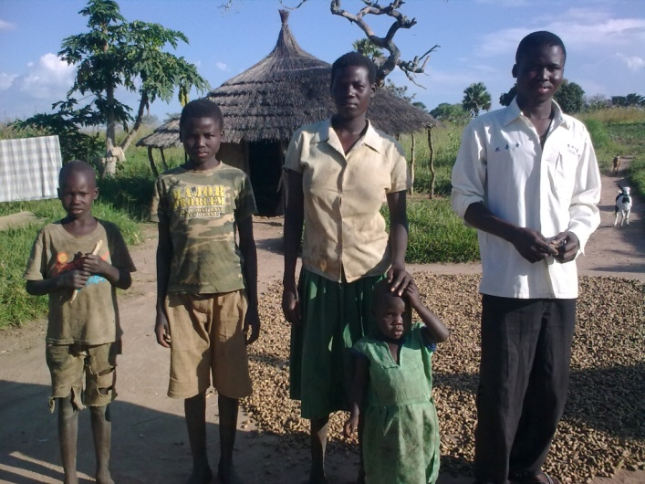
Patrick Ochin and his family was selected to take part in the programme as a representative of a specific vulnerability group of ‘Child headed households’. He was about 15 or 16 at the start of the project and was looking after his twin brother, two younger brothers (14 and 10) and a four year old cousin, after their mother was killed by rebels and their father died of TB. He and his brother started work on clearing the overgrown land and planting the new drought tolerant staple crops of ground nut and cassava (the vegetable seeds went to the elderly and people living with HIV/AIDs households) with the new hoe he was also given. They also worked from time to time on the self help groups communal plot growing the sesame, green gram, sorghum and Orange trees that CIDI and CWW gave the group, but the boys found they did not have much time as the other group members because of all the jobs to do looking after the other children and the house. Fortunately Patricks young girlfriend Betty (aged 15) came to live with them in 2011 so she was able to help with collecting the fuel wood which takes about an hour a day (they had not managed to build their own fuel efficient stove) and water (another one or two hours a day) for their washing and laundry. Patrick and Betty now have a three year old daughter. Betty is extremely busy and does not want to leave the washing to talk to us, as she is also busy bringing in the grain which she has been drying on the earth floor outside (they did not get a tarpaulin, as these went to the more commercial farmers). The family have been able to get much greater yields from the new drought tolerant seeds. They grow 2 bags of ground nut, and pass two bags on to neighbours, as CIDI asked them to, and have grown 10 sacks of cassava for household consumption and have managed to sell 10 sacks to the local middleman who comes to collect it from the farm gate. They often lose quite a lot of the seed they store (50-60%) as they have not been able to improve their grain store, and do not get a very good price for the crop as it dried on the earth and they live too far from the CIDI marketing association that could offer them a better price. They were never really able to make regular contributions to the VSLA, and their savings group has now closed down. Despite this, a great deal has changed for the children; They get much better yields by planting in rows and using the new seed, and with the hoe and occasional access to the groups draught oxen have managed to increase the area they plant from one to one and a half acres. They used to get one meal a day or sometimes less, but now they manage to have 2 meals almost all year round. They have also managed to dig a pit latrine, though they haven’t been able to cover it to keep it safe and give them some privacy, but they hope it means they will not get sick so often.
Pertinent points;
- Drought tolerant seeds and oxen permit increased yields and increased area cultivated allowing improvements in food security. Hunger periods do still remain for some specific vulnerability groups.
- Inability of the CHH to fully contribute to communal group tasks and such aspects as the VSLAs may mean that they are less likely to be considered as long term members deserving of the benefits from the programme such as crops from the communal fields and livestock and poultry from the breeding centres.
- The targeting of some benefits to specific vulnerability groups (like vegetable seeds) may mean that other equally vulnerable groups miss out (CHHs).
- The failure to monitor take up of key project aspects such as grain stores and improved grain drying techniques has allowed a key vulnerable HH to slip through the net and fail to benefit from programme potential.
- Long distances to Marketing Association Bulking stores precludes their use and reduces price benefits.
- The importance of FES to women and as a way of reducing labour time that can then be spent on more productive programme tasks.
- The very positive CIDI approach of encouraging BFs to pass on seed to their neighbours, should be limited to those HHs who have already begun to fully meet HH consumption.

Were the Self Help, Marketing and VSLA Groups Formed Effective?
ACHIEVED – the majority of groups (SHG, VSLAs, MAs and CBMs) interviewed showed good signs of strong group formation, active members with well functioning leaders. All groups showed high levels of participation and empowerment of women and other vulnerable groups, even at a leadership level.
Self help groups and VSLAs - The evaluation interviewed both newly formed SHGs and some groups who had either been a part of previous CWW projects or had been in existence, usually as women’s groups, prior to the programme. As a result of the recommendations of the mid-term review, all the SHGs now appear to have some form of VSLA, although the functioning of a small number still remains weak. In addition partners reported a small number of cases where savings have been mismanaged or taken without permission.
The comparative ‘strength’ of these SHGs did not necessarily seem to be linked to whether they had been in existence previously, but seemed to be more related to the abilities of both the group leaders and their members. Some of the SHGs and associated VSLAs visited still showed signs of general weaknesses, and these should be followed up prior to project closure. VSLA weaknesses identified include; difficulties finding safe means of storing cash as accounts are unrealistically costly and distant; some VSLAs resorting to ensuring that all monies are always distributed as loans to minimise security risks; failure amongst some groups to maintain safe reserves for welfare or use during ‘bad times’ (DDR goal), and the setting of minimum savings levels that some of the most vulnerable were unable to meet.
The evaluation found that average annual money reportedly gained from IGAs started through VSLA loans was about 735,000UGX or about £173GBP (ranges from 250,000 -1,500,000UGX). This represents good results at such and early stage. Though the importance of VSLAs to stimulate alternative incomes had clearly been understood, savings are known to be an important resiliency and DRR adaptation strategy during shocks or more extreme weather events.
Of 24 people interviewed in two separate FGDs: most (10 out of 24) had spent loans on trade (buying and selling agricultural and non-agricultural goods), 9/24 on small non-agricultural businesses (shops, repairs, timber/carpentry etc), 7/24 had invested in livestock and poultry (or veterinary services), 6/24 on inputs and seeds, 5/24 on hiring labour to help with key agricultural tasks and one person to pay for milling or processing their raw material. No beneficiaries had examples of ‘failed enterprises’.
In some groups all monies appeared to be loaned out at all times, with no reserves being kept. In others, and this requires further investigation, members appeared to immediately loan back at 10% interest the money given. Recommendations have been made to encourage the introduction, after some time, of the concept of welfare and disaster fund reserves.
Project records appeared to indicate some SHG leadership related issues in Ogolai parish where group assets such as livestock had been sold by chairpersons. Staff reported financial management group leadership problems in Kapelebyong CBM association, and that all efforts to recover this group had so far failed.
Marketing Association formation and leadership – Two MAs were interviewed to purposively demonstrate the strengths and weaknesses of the groups. Staff were clearly monitoring for leadership weaknesses and when efforts to rectify problems with individuals, leadership re-elections had been undertaken and strong support was evident to these more recently formed leadership groups.
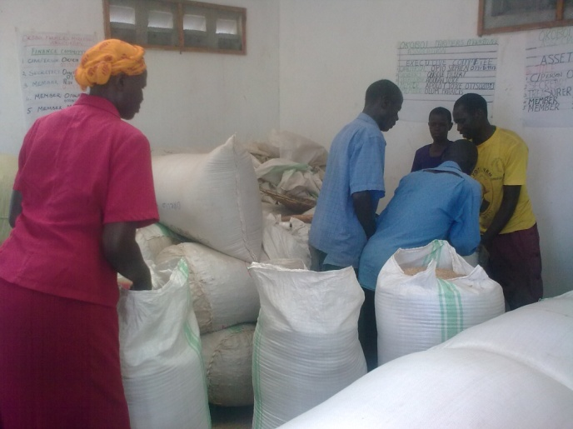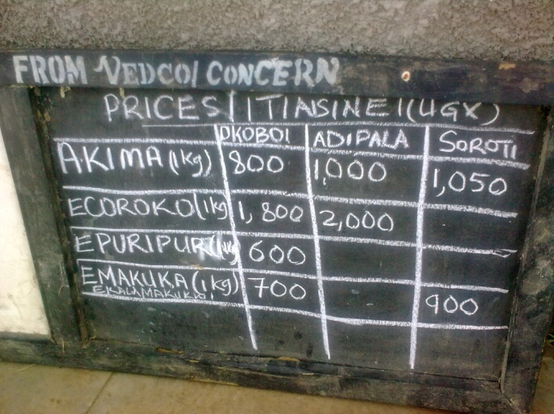
On the whole, the marketing associations appeared to be very well run enterprises, though they did appear to have a very large number of leaders (emanating from some of the new subcommittees established by the groups themselves), though this may well be contributing to the strength of the organisation by spreading the many time consuming tasks required. The marketing associations, and SHGs and CBM associations, that had group activities that earned the group regular incomes (largely draught oxen and processing machines) look set to be the most sustainable in the long term. In order to protect this positive progress, groups should be urged to begin to set aside some earnings for maintenance and eventual asset replacement. The participating groups, have improved their leadership competencies and civic engagement. It also brought aspects of rights based programming to the fore within the communities.
Recommendations: Ensuring that when any substantial group is set up, that some form of group income generating opportunity be supported in order to provide ongoing group earnings and compensations to group leaders; More emphasis on savings for ‘bad times’; Tracking of those individuals dropping out of SHG and regular savings, to be sure that it is not the most vulnerable with valid additional difficulties that are dropping out; Encouraging setting of gradually increasing minimum ‘recommended’ rather that absolute minimum contributions; Ensure there is a strategy ready and in place to support vulnerable people struggling to participate in groups.

Learning: Importance of income generation activities for all groups to offset ongoing costs and compensate leaders. Importance of savings and loans for promoting and diversifying alternative incomes (outside of agriculture) that are less weather dependent to increase DRR and climate change adaptation.

Were the Training Courses Effective?
Just about all of the gains achieved by this programme, come about through a hugely extensive programme of detailed trainings. All 4800 beneficiary HHs have received wide ranging trainings either individually or through their groups as indicated in the table in Section 3.3 ‘What did a beneficiary or group typically receive?’ but summarised briefly below:
Principal Categories of Training:
Households: Vegetable Growing, , Nutrition, Gender, hygiene and sanitation,
Groups: VSLAs, group dynamics business planning, , value chains, extension support, Oxen plough, farmer field school training
The table indicates that a great deal of training has been invested in project beneficiaries, in order to help to address the loss of skills caused by the long period of conflict. Though the evaluation was not able to assess the effectiveness of each of the trainings, or have sufficient time to review training modules it is evident that practices have been updated and improved and this has certainly had strong impacts in terms of sustainability There was not much evidence of the production and distribution of colourful posters, leaflets etc in project homes but the group and household interviews show that most of the key messages of the project have been understood and many also acted upon. Interestingly one of the most important and effective trainings was that on Fuel efficient stoves (FES). It was essential in terms of ensuring women and female headed households and girls in particular had reduced labour constraints and essential in ensuring women had more time to be involved in the productive tasks of the programme. It also had knock on economic savings, health benefits and reduced health costs of BFs also. FES are highly recommended at the very start of future programmes.

Food Security, Nutrition and Agriculture Findings
Virtually all farmers reported now being able to fully meet their household food security needs, even in the worst of years, and almost all indicated considerable income gains (doubled) from sales of crop surpluses. Improved storage (reduced losses by 40-50%), drying and processing were fundamental in contributing to the food security and income goals.

Outcome 1: 240 target groups increase and diversify food production for sale and home consumption, by 60% based on domestic household requirements and market demand to improve livelihoods options and increase food security by the end of programme.
Indicators for Outcome 1:
Indicator 1: 80% of households increase agricultural production by 50% through growing at least three drought resistant crops (acre cropped/yield per acre). Evaluation Finding = ACHIEVED
Indicator 2: 100% of households accessing at least 4 improved seed varieties by year 3. ACHIEVED 99%
Indicator 3: 75% of households maintain healthy livestock through demonstrating effective livestock management practices (see following section on livestock)
Indicator 4: 75% of households increase domestic vegetable gardening by 20% growing at least three varieties. Evaluation Finding = ACHIEVED

Summary Analysis:
- Endline survey indicates an almost 1 acre increase in average area cultivated since the baseline. Evaluation concluded that yield increases were more due to intensification than extensification. Base, mid and endline survey data inconclusive regarding increased production, but evaluation indicates that Hhs on average doubled yields per acre.
- Evaluation found that access to sufficient labour within the household or to hire was limiting the ability to increase area cultivated, but this enabled farmers to leave land fallow which has environmental and climate change benefits.
- Endline survey found that 65% of BFs are growing 3 or more vegetables, and the evaluation found that farmers were growing on average 3 to 4 additional varieties of vegetables and fruits than before.
- The additional benefits from improved storage and drying practices that reduce losses and increased quality and price gained were as important in reaching food security and income goals as increased yields.

All groups reported to have performed well in almost all of the agricultural aspects of the programme, most farmers reported a doubling or more of yields and a doubling of income from crop sales. This success is with the exception of the flood prone FGD which had lost almost all of their seed each year. A recommendation has been made to return to all flood prone communities and farms to investigate improved approaches, and attempt one final intervention prior to project closure.
There was a great deal of divergence in whether beneficiaries had managed to increase the area cultivated as a result of this project. Indications were that about half of HHs had increased the area cultivated, and about a quarter had managed to double the area cultivated. The Oxen and plough assets were fundamental to achieving this. The two FGD with indirect and non beneficiaries did however indicate that some of these households had also been able to increase and on occasions double the area they had cultivated, though it was evident that many had not been able to increase the area cultivated by very much at all.
Increased yield per area seems to have been a better indicator, with farmers largely having intensified rather than extensified production.
The programme was successful in meeting its food security goals, with almost all households (except in the flood prone community) reporting having being able to ‘eat until satisfied at least three times a day’, and the majority of households were able to do this in all years, with only a small minority who now reported much shorter than previously ‘hungry’ periods in the months prior to harvest in poor years (floods and droughts). The programme was also highly successful in increasing the diversity of crops grown (reducing risk of total crop failures) and the nutritional diversity of those crops. As can be seen in the detailed economic case study of Cuthbert in Section 3.9 many households were previously reliant on three staple crops (such as ground nut, millet and cassava). Almost all households now report growing nine or more different staple and vegetable crops (4 vegetable types on average), and less than half now report growing small amounts of fruit crops. There was less evidence of crop diversity in those cases where SHGs had grown all the vegetable and fruits on communal farms and thus it was uncertain whether the skills and nutritional benefits would eventually pass down to the individual household level, particularly in the most vulnerable of HHs who may tend to drop out of communal activities in the long term. It was felt that more could have been achieved to reduce risks and increase nutrition, particularly for PLWHA, CHH and the elderly through a greater emphasis on fruit crops, and through ensuring all new varieties are grown at household level.
Flood tolerance findings indicated that: rice, citrus (not if water very long standing), mango, pineapple, paw paw, banana egg plant, green leaf and cabbage were reported to withstand floods well, though this requires further investigation. Post flood quick crops possibilities that were suggested by BFs include; Sorghum, green gram, toms, egg plant, cabbage and onion. The project has rather emphasised the drought advice and drought tolerant varieties rather than flood matters.
Some farmers reported that some of the seeds and varieties given had not resulted in the improved yields or incomes expected. These included chilli pepper, green gram, sesame and in some years the variety of tomato seeds given. Sunflower variety given was liked except that it required farmers to re-purchase seed each year. Farmers appreciated the wide range of egg plant varieties given and stressed that it allowed them to select which suited their conditions and tastes better. The approach of giving diversity, in order to permit selection and suitability is an important lesson for the project.
Farmer field schools (FFS) were very popular and had been instrumental in encouraging uptake of new varieties and techniques such as row planting. Some of the more specialised new approaches and soil and water conservation techniques had not had as strong an uptake as would have been expected, with few examples of nursery sack mounds, organic manures and pesticides and improved composting being applied. In some cases, all of the new vegetable seeds had been planted communally in SHG gardens. It is recommended that in future programmes fruits and vegetables are encouraged for take up in all HH gardens, to ensure that all HHs, even if they drop off/out of communal activities gain.
The evidence from the dietary survey at base, mid and end line (see separate technical annex) is inconclusive and considered . that this level of detailed nutrition surveying of this nature was beyond the needs of this programme. Beneficiaries were asked how disaggregated information on how many meals were consumed within their household each day at mid and end term, and 67% stated that food ‘normally’ lasts from one harvest to the next (52% at mid-term) and these findings corroborated the evaluations findings that beneficiary HHs were able to ‘fill their stomachs until satisfied’ three times a day. A small number of households indicated that in poor years there were still pre-harvest times when they were not fully satisfied, and very occasionally had to reduce to 2 times per day. Cross checks with small control groups of indirect and non beneficiaries indicated that they had not gained similarly Selecting appropriate nutritional monitoring questions for this level of food security programme would be a useful area for programme learning, as well as a detailed discussion on the benefits or otherwise of promoting cooking three times per day, from a labour gender perspective as well as a climate change perspective.
There are considered to have been strong nutritional gains from the inclusion of more varied and nutritional basic staples (especially ground nut and sesame), as well as the increased vegetable consumption created, however it was felt more could have been gained from wider and specific selection of particularly rich nutritional varieties (like red sweet potato and pumpkin rather than white fleshed for its Vitamin A content etc.) vulnerable groups such as PLWHA, PWD and CHH etc.

Livestock and Poultry Findings
Oxen were critical to the food security and income gains made in agriculture. Though benefits from the livestock and poultry aspects of the programme are naturally slow to come to fruition, signs are that the gains, if equitably managed will be forthcoming.
Annex 7.6 lists the findings gathered by partners for the evaluation on livestock and poultry mortality/survival rates, which were not thought to have been routinely monitored by the programme, nor were reasons for mortality or morbidity at birth being checked. This represents an important learning point to allow project interventions to be adapted and improved.
Outcome 1 - Indicator 3: 75% of households maintain healthy livestock through demonstrating effective livestock management practices
Endline Report: Breakdown of animals owned at baseline, mid-term and end line
(NOTE: NOT NECESSARILY AS A RESULT OF THE PROGRAMME):
Animal | Percentage owning at Baseline | Percentage owning at Mid-term | Percentage owning at endline* |  | Percentage Men (Endline) | Percentage Women (Endline)
Chicken | 75 | 94 | 89% |  | 54.7 | 45.3
Goats | 66 | 68 | 67% |  | 53.1 | 46.9
Oxen/ Bulls | 45 | 65 | 66% |  | 58.6 | 41.4
Sheep | 25 | 24 | 38% |  | 55.5 | 44.5
Pigs | 13 | 14 | 23% |  | 57.3 | 42.7
 | *multiple choices allowed so total exceeds 100%
The evidence given in the base, mid and end line surveys as indicated above is inconclusive and does not refer solely to the maintenance of the animals provided by the programme. It does however act as an indicator of increasing asset accumulation, some of which has occurred as a result of the programme. It does indicate a remarkably small increase in goat ownership (1%) and low ownership of poultry by women, who are traditionally poultry keepers. The evaluation had concerns that the breeding centre and ‘caretaker’ approach used in some groups, has impacted upon the ability of the programme to target (and empower) women and the most vulnerable HHs with these valuable livestock and poultry assets. Close analysis of programme data indicates that the livestock and poultry assets are largely in the hands of a small number of men. Recommendations have been made to ensure that further sensitisation and monitoring and control measures be researched and put in place to ensure that in the long term ALL targeted individuals (irrespective of whether they have been able to maintain a high attendance or strong group presence) go on to gain livestock and poultry assets.
Livestock management practices at end line | Baseline | Percentage of respondents who carry out this practice at end line*
Regular spraying against ticks to control East Coast Fever (ECF) | 60 | 86.4
Treatment against livestock diseases | 72 | 81.7
Regular de-worming to control worms | 60 | 78.6
Vaccination of livestock | # | 27.8
Supplementary feeding (cut and carry feeds) | # | 1.1
Provision of salt lick | # | 11.9
Planting of extra plants for grazing | # | 1.0
Construction of a crush | 5 | 3.1
Supplementary feeding for poultry | 0 | 1.9
Poultry vaccination | # | 24.2
Construction of a kraal/ pen/ housing unit | # | 12.5
# - question not asked at baseline |  | *multiple choices allowed
Despite problems with the survey data, the evidence on increasing use of improved animal husbandry practices does however seem to show both an increase in take up and an increase in the diversity of methods used. The evaluation does however have concerns that the breeding centre and ‘caretaker’ approach, that does have other reported advantages, may concentrate the knowledge on improved animal husbandry in the hands of the few and reduce its spread and uptake to all HHs. Initial analysis of the differing mortality rates of the goats (see Annex 7.6) kept under the two different approaches does seem to indicate that mortality is higher with the group approach, however sample sizes are small. It is recommended that the programme seeks the specialist technical help of its neighbouring agency Heifer International Uganda in a detailed discussion of the pro’s and con’s of all aspects of the rearing approaches.
It is still early days to be able to evaluate the full benefits of the livestock and poultry aspects of the programme. This has been exacerbated by the lack of programme monitoring data related to livestock and poultry available. A recommendation has been made to increase monitoring for mortality rates and type as well as whether and the reasons for animal being sold as well as the gender and vulnerability group to whom the assets are being distributed in order to allow early interventions. Initial indications are that mortality rates of animals given are low, though it has not been monitored for, and it is not possible to indicate whether there have been problems related to birthing of the improved cross breeds.
Beneficiaries are very positive when questioned about both livestock and poultry and seem confident that those currently raising the animals will eventually ‘pass on the gift’. Many of the SHGs also reported good initial progress with the draught animals, other livestock and poultry. CIDI and VEDCO had both adopted very different livestock strategies, with CIDI emphasising a breeding centre or ‘livestock caretaker’ approach. In addition to this, different SHGs had modified these two ‘individual’ and ‘communal’ rearing approaches further. It was therefore very difficult, in the absence of well defined and disaggregated data to identify the strengths and weaknesses of the varied approaches. The evaluation has concerns regarding a number of matters related to the differing approaches adopted and recommends further analysis; what are the disease implications, particularly of communal poultry rearing? whether the selection of ‘caretakers’ or breeders was gender or vulnerability appropriate and whether in the long term, the majority of men (77% men for Oxen, 89% for piglets, 78% for boar goats but with a reverse of 63% of local goats going to women) going to individuals that project data indicate have been selected for caretaker/breeding centre roles, will continue to hand on progeny equitably.
Mortality rates and reasons or failure to be effectively operated reasons are not being routinely monitored for. VEDCO were able to produce some of this information for the evaluation; of the 114 oxen, four have died (3.5%) and six (5.3%) have been sold-off or acquisitioned or kept by individuals (1). These were all in the parish of Okoboi, and monitoring should have been picking this information up and acting upon it. Pigs had a mortality rate of 8.2%. Of the VEDCO boar goats 3.3% died and 6.7% were sold off by three chairpersons (all in Ogolai parish again). VEDCO local goat data indicates 4.5% mortality rates and further detailed investigation of the data 5% being sold off (Kapelebyong and Amaseniko). No data was available from CIDI and neither partner provided poultry data. In general programme monitoring data was insufficient. Specialist advice should be sought on what other matters should be monitored for such as birthing difficulties, miscarriage (especially when introducing large improved breeds into small local breed populations and disease rates should be monitored to improve programming decision making, intervention and improve learning.

Disaster Risk Reduction Findings
Strongest gains in DRR were evident through the diversification of crops as well as the diversification of incomes through adoption of less weather dependent incomes as well as the reduced risk of disease from the water and sanitation aspects and the opportunity for riding out the ‘bad times’ presented by the VSLAs.
The end line survey indicated that drought was the most commonly experienced risk (97% of HH), followed by crop disease (60%) and finally floods (41%). The programme interventions concentrated on drought tolerance rather than flood tolerance. Interviews with beneficiaries indicated that though droughts affected many, they were less devastating than the floods and more occasional hail storms which affected comparatively few. This is key information which should be used to inform future programme formulation.
This aspect of the project did not appear to have been widely understood by the beneficiaries (the end line indicated 18% had taken no DRR or mitigation measures other than drought tolerant crop varieties), and perhaps the approach taken was not one of deliberately sensitising SHGs to DRR in general, but more on concentrating on ensuring that the approaches being adopted were grounded in a DRR perspective. The evaluation concluded that good gains had been achieved in DRR, though, it was felt that more could have been done particularly by adopting more of a climate change emphasise and through increased emphasis on flood prevention and mitigation approaches.
Recommendation: investigating the possibility of combining the advocacy and decision influencing of government aspects of the programme with the possibilities of communal self help working groups to bring government works and communities together to clear up the siltation of traditional flood prevention dams and structures.

Income Generation and Diversification Findings
The programme was extremely successful in increasing the income generated by beneficiaries from the sale of crops surpluses, and very importantly the prevention of unnecessary wastage through reductions in storage losses (40-50% on average). About a third of farmers could now be said to be ‘commercial farmers’ and many more are on their way. The project has also achieved considerable value addition through improved drying, threshing and primary processing using largely SHG or market association owned shelling and grinding machines. For those farmers able to access Market Associations, these communally run MAs have succeeded in not only increased the prices gained over farm gate middlemen by about 10%, but probably more importantly by further improving storage, better sacking up in bulk and ensuring higher standards of raw material quality to ensure improved prices. Strategies need to be found to ensure that farms remote from the MA centres can benefit from these advantages. The project has established new market linkages with a small number of large seed and input suppliers who also purchase crops. Only small numbers of beneficiaries have gone on to gain new income through either new enterprise or adding value beyond the basic raw material stage through secondary processing such as cooking, preserving, packaging and selling to final consumers.
Income Generation and Diversification which is a major contributor to DRR and climate change mitigation, has been achieved largely through utilization of; more varied staple crops, vegetable and in a small number of cases; fruit crop types. As is common amongst livestock projects, it is still early days to confirm whether diversification into livestock and poultry production will be widespread or sustainable, but there are some initial good signs, once equitable distribution is embedded. Only small numbers of HHs have achieved diversification into new enterprises. Recommendations have been made to ensure that secondary processing and new enterprise diversification is central to any programme second phase.
The project has made the majority of gains in improving links with service providers and market linkages through the establishment of ‘bulking stores’ or Marketing Associations (Leadership matters are covered in details in Section 3.2 above). Where marketing associations are considered accessible to communities they are increasingly becoming widely used for the storage and marketing of a small number of the most important staple crops. This has had considerable indirect benefits to neighbouring HHs, which is likely to have had further community cohesion gains. Farmers do not get a particularly large improvement in the potential price gained. Typically farmers are getting a 10% increase of the 100% increase in price that the MAs can gain. Though prices can of course vary and losses can also be made by MAs. This is because the leadership are necessarily being initially cautious and ensuring repayments are met for set up and running costs. It will be essential that at project closure, the MA leadership and communities as a whole are sensitised that in time, they should start to receive a greater gain in the profits of communal selling arrangements, but that they understand that on occasions, there may also be losses to deal with. Any second phase programme should ensure support to MAs with improved national weather and price forecasting information. Additional recommendations to encourage MAs to start to consider a wider range of crops and to find solutions for the communal sale of some of the more difficult storage crops. This should include highly valuable yet perishable crops such as fruits and vegetables and cotton which is traditionally used to pay school fees and is too bulky for the stores. A recommendation has been made to trial communal transport to market dates, with less emphasis on the need to store within the ‘bulking stores’. Further recommendations for any second stage programme include encouraging both group and individual BF activities that add value to members goods through processing, preservation, packaging and sale to final consumers (group or individual trainings and apprenticeships in low and high value products enterprises that reach the final consumer e.g. tomato paste, relish and jam sales and school tuck shop sales of nutritional juices, cakes etc, butcheries, bakeries and leather goods etc).
Outcome 2 - 190 target groups have at least two diversified sources of income which are able to improve household livelihoods from on-farm and off-farm activities through expanded agricultural production, processing and marketing activities by the end of programme.

Recommendation and Important Institutional Learning Note: Outcomes 2 and 3 both relate to extremely similar objectives, that of; ‘diversified and increased incomes’. Outcome 2 has 7 indicators, and outcome three has five indicators. The lead agency and more importantly, the donor, should review programme logical frameworks and outcomes and indicators to ensure quality and that they are practically possible and realistically achievable. It is recommended that outcomes should have no more than three indicators. It is also recommended that indicators should avoid having the unnecessarily complicated and impractical proportion of household aspect. For example. ‘50% of households save 20% of their income’ could be more realistically monitored as ‘On average, households save 20% of their income’ or preferably be improved entirely to ensure that the vulnerable groups or worst impacted are included in the statistic. So the indicator might become ‘‘all households are able to save 10% of their income’. A lower overall target that ensures the project focus on ensuring that ALL households gain, even the most vulnerable. This represents an important learning point for Concern and Comic Relief in particular, who have received recommendations in the past on improving their capacity to act as a quality control intermediary in terms of logical frameworks and outcome and indicator setting in particular.

Because outcomes 2 and 3 both relate to the similar objective of ‘increased incomes’ partly through diversification and partly through value addition and improved market linkages, they are very difficult to evaluate separately. The evaluation has chosen to rather artificially separate findings into two sections (‘diversification’ and ‘value addition & market linkages’) that relate to the two outcomes and has dealt with the indicators in order. Thus the evaluation findings do not always fall clearly under specific indicators, and to prevent some repetition, omissions may occur if only one section is read.

Indicators for Outcome 2:
Indicator 1: 80% of SHGs operate at least 4 different income generating activities.
Evaluation Finding – Not realistically achievable. Most groups operate one (usually processing raw materials) or sometimes two new enterprises in addition to their communal agricultural and livestock activities. The evaluation was satisfied that sufficient income generation activities were occurring within the majority of groups to give them an adequate chance of being self sustaining groups. There were some concerns related to the weakest groups interviewed and recommendations have been made to ensure that staff return to strengthen these groups prior to programme closure and that across the programme groups are advised to ensure that savings are reserved for maintenance and replacement of group assets.

Indicator 2: 50% of households generate 50% of their income through off-farm activities by project end
Evaluation Finding – Indicator not realistically achievable. PROGRAMME HAS ACHIEVED INCREASES IN INCOME, BUT NOT OFF FARM. In the mid-term evaluation it was suggested that this indicator be changed to ‘80% of farmers operating one IGA’. The end line survey found:
- 25% of BFs reported earning 50% or more of their total income through off-farm means in the last 12 months.
- 93% of respondents (51% men and 49% women) reported that they had an IGA.
- Of all the beneficiaries surveyed, 26% did not report any income from off-farm sources in the past 12 months, but for those that did report earning income from off-farm sources (74%), the average amount earned in the past 12 months was 437,335 UGX.
The table below shows the kinds of IGAs carried out (Endline Survey,2014 Annex 1);
IGA types at Endline | Total Number | Number Women | Number men | Percentage respondents
Sale of own agricultural produce | 40 | 14 | 26 | 10.7
Sale of own livestock and livestock produce | 14 | 6 | 8 | 3.7
Petty trading | 109 | 60 | 49 | 29.1
Beer brewing | 42 | 32 | 10 | 11.2
Hire out labour | 21 | 12 | 9 | 5.6
Cassava processing/ milling | 10 | 3 | 7 | 2.7
Run a kiosk/ small shop | 9 | 1 | 8 | 2.4
Construction work | 9 | 2 | 7 | 2.4
Beekeeping | 7 | 1 | 6 | 1.9
Agricultural produce buying and selling | 7 | 1 | 6 | 1.9
The most common new IGAs were similar for both men and women being; petty trading and beer brewing. Child headed households in particular were shown by the end line survey to be lagging behind all other groups and failing to begin new on-farm or off-farm IGAs. Elderly HHs performed well in on-farm activities, but were lower than average at starting off farm activities. Recommendations have been made to ensure improved monitoring of these vulnerable groups and encourage more focus on their IGA work. This, alongside the findings of the final evaluation demonstrates that in reality, beneficiaries have largely increased the first stage processing of their agricultural products but have not largely begun to process goods much beyond first stage processing to the sale of value added processed, preserved or packaged products, and very seldom to final consumers, where the majority of profit lies. The income generation types are not really new enterprises that could be properly classified as ‘off farm’ or ‘non agriculture related’ incomes. It is recommended that future projects aim more deliberately to focus on encouraging diversification to new IGAs that are less weather dependant and thus agriculture related (livestock, poultry and new enterprises and services) or are related to diversification into agricultural activities that are more tolerant of climatic extremes wherever possible. It was correct in the first phase to focus on improved storage and primary processing of raw materials. The second phase of the programme should move more towards secondary processing of agriculture and livestock and poultry products into high value, preserved, processed, packaged and end of value chain services that directly connect the producer with the consumer (fruits & vegetables processed into packaged products or school snack shops, cafe’s or restaurants, bakeries and butcheries, leatherwork shops etc). This evaluation, like the two previous evaluations for Comic Relief as the donor, has concluded an important Institutional learning point that it is unrealistic for programmes and donors to expect projects in post conflict societies in particular, to move to meet more than food security and basic improvements in storage, drying and processing in the first phase (3 to 4 year programmes). A recommendation has been made that the majority of progress in off farm income diversification, value added and market linkages is more likely to sit within a second project phase (from year 3 to 4 onwards).

Indicator 3 – SUCCESSFULLY ACHIEVED: 80% of target men and women add value through processing their agricultural produce
The end line survey showed that 93.3% of respondents processed their agricultural produce in some way. The qualitative findings of the evaluation that in many ways one of the greatest successes of the programme has been to reduce the unnecessary wastage of existing yields through improved post harvest storage and practices (improved grain stores and drying on raised racks or tarpaulins in particular). Most BFs report loosing up to 70% of their produce prior to the project which has declined to less than 10% now. This represents a huge achievement which does not require either intensification or the increased area cultivated which have knock on environmental and climate change consequences. Recommendations have been suggested to increase the take up of rat guards on grain stores by switching to the less costly more locally available plastic homemade rat guards, as well as ensuring all CHH and other vulnerable HHs have received tarpaulins and constructed improved grain stores and FES.
Indicator 4 – UNCLEAR INDICATOR; SHGS – ACHIEVED; INDIVIDUAL HOUSEHOLDS – NOT FULLY ACHIEVED: 50% of SHGs mobilise group savings for small enterprise investment in year 3
It is unclear whether this indicator relates to group IGAs or individual BF IGAs. At endline, 74% of BFs said that they had an IGA in their SHG. All SHGs visited had at least one form of group IGA, which was considered adequate by the evaluator for sustainability purposes. On questioning of individual beneficiaries, it was evident that all had started some form of new, though largely agriculture and processing related, income generation activity. Some BENEFICIRIES (women in particular) had made use of the food snack production training and were cooking, packaging and selling basic snacks (fried soya beans, sesame, ground nut and dough cakes or ‘mandazi’) to add value and make additional incomes particularly for investment in livestock and poultry and to pay school fees. Recommendations have been made to increase the diversity of the cooking and food preservation trainings and income generation skills trainings for women.

Indicator 5: NOT REALISTICALLY ACHIEVABLE 80% of households are members of SACCOs and 50% of households access microfinance loans by project end.
At baseline in 2009, 15% of respondents accessed financial services and only 9% of households were active members of SACCO with only 1 SHG reported links with MFIs and none reported any links to SACCOs. This had not changed by the end line.
78% of respondents at the end line did say that they saved in their SHG or VSLA. 54% save 20% of their income or more and 21% save 50 % of their income or more. 57% saved cash in the home and only 4% saved in a bank or microfinance institution.
Evaluation Finding –– The SHG are very small and include fewer than 20 households, making them far too small to be able to access very distant financial institutions that are not highly trusted within the communities and that have high minimum contributions, entrance and ongoing fees. Recommendations have been made that partners explore the possibilities of SHGs grouping together with the larger marketing associations to attempt to find more secure ways of storing their funds.
Indicator 6: ADEQUATE PROGRESS ACHIEVED. 75% of women demonstrate an equal control over IGA proceeds
The evaluation is unable to make use of the statistics from the base, mid and end line surveys related to this issue as FHH data is included within the data sets (a common mistake) regarding joint decision making within the household, when in FHH it is by definition, not possible for decisions to be made jointly. However, when questioned on the increased control of the financial gains of IGAs, both women and men were in agreement that decisions were now being made increasingly jointly, and that where women were undertaking sole enterprise, such as animal raising or snack making, they were wholly responsible for financial decision making.

Indicator 7: UNREALISTICALLY HIGH INDICATOR THAT WAS ADEQUATELY ACHIEVED. 60% of households save 20% of their income per month.
The end line survey interpreted this indicator as being related only to the income from IGAs, and not necessarily the whole household income, finding that; 54% of respondents who saved save at least 20% of their income from IGAs per month.
Evaluation Finding – This was an unrealistically high indicator, but was ADEQUATELY ACHIEVED. In the space of four years, almost all households have moved from being food deficit heavily indebted households, to being food secure virtually all year round (irrespective of climate extremes) with surplus production for sale in two (not the previous one) seasons of virtually every year. Virtually all households report being able to meet the minimum contributions to savings of 1,000 UGX/week and many households report being able to save 3 to 4 times the minimum despite currently being in a phase of production and business expansion which requires investment in production.

Value Addition & Market Linkages Findings
The majority of findings related to this outcome (which is similar in objective to outcome 2 on increased incomes and diversification) and five indicators have already been referred to in previous sections and thus summaries only are provided here:
Outcome three: 150 target groups benefit from effective linkages with market supply and value chains, with increased access to market information, increased capacity to meet market demand through improved access to buyers, agricultural and technical support and inputs by the end of project.
Evaluation Finding – UNREALISTIC OUTCOME THAT HAS BEEN ADEQUATELY ACHIEVED.
Those self help groups (SHGs) that are within a reasonable distance of a local market or a marketing association or ‘bulking store’ have made exceptionally good gains in first stage value addition (drying, household and communal storage in particular) and through improved market linkages. Those SHGs who are either too distant from markets or MAs or who have been unable to produce adequate surpluses, such as those in flood prone areas in particular, have yet to make gains in this area.

Indicators for Outcome 3:
Indicator 1: 100% of male and female farmers plant crops based on market price information - NOT ACHIEVED. Very few beneficiaries reported crop selection based on price information or having gained advanced information, prior to planting of crops. The end line survey shows approximately 10% of farmers were motivated by ‘good market price’ at both base and end line and thus no change related to market price information. Farmers were switching decisions on which crops to grow away from HH food security towards potential income gains (FS motivation at baseline 86%, end line 54% switched to 29% for ‘increased income’ at end line with no statistic at baseline). Farmers in reach of MAs were however able to view market prices offered at local markets after harvest. The proper objective of this ‘first stage’ post conflict programme was initially to increase production to meet HH food security. During this stage, crop choice objectives are best linked to nutritional outcomes. Only when farmers begin to produce surpluses (or where crops that require many years to bare results e.g. apiaries, fruits, timber etc.) in the ‘second stage’ should programmes introduce crop selection based on market prices.

Indicator 2: 80% male and female farmers bulking produce for market at cereal banks and bulking centres – SUCCESSFULLY ACHIEVED BY FARMERS LIVING CLOSE TO MA OR BULKING STORES, NOT ACHIEVED BY REMOTE FARMERS OR THOSE NOT ABLE TO PRODUCE ADEQUATE SURPLUSES, such as flood prone. The results from the mid and end line surveys shows only a small (from 6 at mid to 18% at end) increase in the percentages of BFs stating that they ‘sold produce collectively as a group’. This was not considered a true reflection by the evaluator.

Indicator 3: 80% of men and women adopting value addition technologies and practices including improved post-harvest handling techniques – SUCCESSFULLY ACHIEVED IN TERMS OF IMPROVED POST HARVEST HANDLING TECHNIQUES BUT NOT ADEQUATELY ACHIEVED IN TERMS OF SECOND STAGE VALUE ADDITION. This is discussed further in Indicator 3 under Outcome 2 above.

Indicator 4: 80% of households sell 80% of their produce as surplus – UNREALISTICALLY HIGH INDICATOR CONSIDERED ADEQUATELY ACHIEVED. The evaluation considers that for a first stage programme, that it was adequate for the target to have been; for ‘ALL household to meet their household food consumption needs’, with a small proportion going on to produce surpluses for sale. Some of the most vulnerable households (e.g: CHH) and those in flood prone areas are yet to increase production substantially beyond meeting HH food consumption. The end line survey reports:
- That 81% of HHs reported selling ‘at least some produce’, however, it is likely that ‘some produce’ may also have been sold prior to the project.
- That 3% of farmers (12) reported selling 80% or more, and 15% selling between 50 and 80% and 63% selling less than 50% of their crops in the 12 months preceding the survey.
Indicator 5: 40% of household’s access regional and international markets directly –ADEQUATELY ACHIEVED. The evaluation found high levels of selling through MA where they were close enough to farmers, and these MAs were all largely selling at regional markets. The data from the end line survey (only 89% at local and 11% selling at regional markets) is not considered a good reflection of the projects achievements. The programme did not make gains related to sales internationally, which are explained in the survey in a separate technical annex, related to regional conflict and poor harvests in 2013.

Economic Findings
This section attempts to indicate some of the household economic security gains from the programme. Assessing income gained is notoriously difficult, complex and time consuming and accurate figures are beyond the remit of this evaluation, however a great deal of information can be used as a guide. Savings can be used as a proxy indicator of the amount of surplus income that beneficiaries are able to store and invest. The evaluation found that average annual money gained purely from the loans from VSLAs was reported at 735,000UGX or about £173 GBP (ranges from 250,000 -1,500,000UGX). The detailed economic case study of Cuthbert, at the end of this section indicates the increased income that this typical vulnerable beneficiary has been able to produce through purely crop production, as a result of this programme (1,076200 UGX or about £250/year more than prior to the project). Programme M&E data indicates that during the course of the programme VSLAs ‘average total current savings were 211,468 UGX at the time of the end line survey. The average savings from the last 30 days preceding the survey were 36,883 UGX. All these figures show very positive economic benefits indeed.
The table below indicates a summary of a small number of some of the other qualitative economic impacts that are considered likely to have occurred as a result or as indirect benefits of this programme. Some of the information contained within the table comes from the assessment of the programme by VEDCO and its partners APTUK and Heifer International Uganda in the neighbouring Pader District. It is reasonable to believe that similar potential economic gains are likely to have been gained through this similar programme approach:
 | Principal Quantitative Findings from SEWCA or similar project in Pader. | Annual ‘monies gained’ in Amuria
Reduced Expenditure  (only to those HHs who were previously purchasing) | Beneficiaries on average saved money on:  Fertilisers - 51,250 UGX (£12)/year on Fertiliser by producing their own organic manures (Pader). Only a small number of HHs adopted this practice in Amuria.  Fuel – 864,000 UGX (£206)/year on fuel wood and charcoal purchases as a result of efficient stoves and biomass briquettes (Pader). Good numbers of BFs using FES, but no briquettes adopted in Amuria.  Water - 84,200 UGX(£20)/year for those families who no longer purchase water as a result of being able to harvest rainwater (Pader). No RWH adopted in Amuria.  Health – reduced expenditures on medicines due to improved water and sanitation and increased productivity gains also from lack of illness. Not quantified, but reported by BFs | 864,000 UGX
Increased incomes | Beneficiaries on average gained increased income of:  Drought Tolerant seeds - 700,000 UGX(£167)/year from crops (Pader)  Quick maturing/Vegetable seeds - 150,250 UGX(£36)/year from vegetable gardening (Pader)  Apiaries - 166,878 UGX(£38)/year from honey and other bee products (Pader). This aspect of SEWCA project was not very successful in Amuria, but statistic indicates potential for the future should further technical support be given.  Average annual incomes from Off farm IGA’s - 437,335 UGX (SEWCA End line survey data)  Alternative Incomes started from VSLA loans - Average annual money gained from loans from VSLAs was reported at 735,000UGX or about £173 GBP (ranges from 250,000 -1,500,000UGX) (SEWCA – Amuria). | 700,000 UGX  150,250 UGX  437,335 UGX  735,000UGX
Increased savings | Beneficiary households saved on average a total of:  489,000 UGX(£116)/year and many also purchased; oxen, plough, cows, bikes or paid school fees etc (Pader). | 489,000UGX
 | These figures should be used as a general guide only. See Footnote below | TOTAL=
Not all families are making savings or having increased incomes in all areas, but the figures do give an indication of the kinds of economic benefits that are increasingly beginning to accrue from these types of Comic Relief funded projects in Uganda.
The table below summarises some of the reported economic gains from some of the new varieties and new types of crops grown, so that the programme may assess which crops are most affective for income generation purposes (rather than food security or nutritional):
New or Improved crop grown | Reported Annual Income gained after HH consumption (UGX) | New or Improved crop grown | Reported Annual Income gained after HH consumption (UGX)
Staples :  Maize  Sesame  Cassava  Ground Nuts  Soya  Sorghum  Millet  Green Gram | 600,000 - 2,700,000  74,000  300,000 -1,500,000  240,000 - 560,000  1,000  162,500  100,000  315,000 | Vegetables :  Onion  Tomatoes  Egg Plant  Cabbage  Fruits :  Pineapple | 80,000 – 800,000  50,000-125,000  20,000 - 50,000  500,000
The table below summarises some of the reported gains from two income generation activities, as a way of demonstrating the type of cost benefit analysis that partners could be undertaking that would facilitate an understanding of which are most economically rewarding for BFs. It is important to point out that enumerators need to calculate profit carefully. In addition to the incomes listed below, the BFs were also able to have bought other assets such as pigs, cows or oxen:

Income Generation Activities | Reported annual income gained (UGX)
Brick production | 400,000UGX (profit calculated by evaluator)
Fuel purchasing and sale | 400,000UGX (profit calculated by evaluator)
The case study below represents the gains that just one, non exceptional or ‘typical’ example of a beneficiary from a specific vulnerability group, has managed to achieve:
Case Study Example on Economic Gains – Cuthbert the millionaire!
Cuthbert is the 65 year old secretary of the local marketing association (or ‘bulking store’). He is the grandfather of the household that includes his wife, son and daughter in law and five grandchildren aged from 2 to 12. He talked to the evaluation team in detail about the crops he used to grow and the increased benefits he had gained as a result of the programme. He only grew three basic staples prior to the start of the project, which were not very nutritionally diverse. He now grows nine crops of which four are vegetables with the micronutrients that his growing family needs, and is over a million shillings (or £250) better off. He has gained a great deal from the project; he now loses 40% less crop during storage and gets a better price for his crops because they are higher quality, and well dried on tarpaulins on a raised rack and he gets a better price. If he sold through local middle men, he might get 55,000UGX for a sack of ground nuts, but with the marketing association he can get 60,000UGX/sack (the marketing association makes a further 40-60,000UGX/sack on top of this, depending on the price they are able to get when they sell in bulk. The MA use this money to pay for their costs and overheads.).
BEFORE INTERVENTION | Number of sacks | Sacks kept for replanting | Sacks kept for food | Sacks sold | Money gained (UGX) | Comments
Ground Nuts | 12 | 2 | 2 | 8 | 240,000
Millet | 3 | 1 | 0 | 2 | 100,000
Cassava | 5 | 0 | 5 |  |  | All eaten
Other crops | 0 |  |  |  |  | None
TOTAL BEFORE |  |  |  |  | 340,000 | (note inflation factors)
AFTER INTERVENTION | Number of sacks | Sacks kept for replanting | Sacks kept for food | Sacks sold | Money gained (UGX) | Comments
Ground Nuts | 18 | 5 | 3 | 10 | 100,000 | There is no sheller close by so low price
Millet |  |  |  |  |  | No longer grows, prefers other crops
Cassava | 33 | 0 | 16 | 17 | 540,000 | Growing 6x more. Uses MA grinder and sells cooperatively so gets good price
Maize | 5 |  |  | 5 | 600,000 | Sells all of above through marketing association
Sorghum | 2.5 |  |  | 2.5 | 162,500 | Sells all of above through marketing association
Green Gram | 1.5 |  |  | 1.5 | 315,000
Tomato |  |  | yes | Yes | 125,000
Onion |  |  | yes | Yes | 80,000
Egg plant |  |  | yes | Yes | 20,000
cabbage |  |  | yes | Yes |  | Not yet ready
TOTAL |  |  |  |  | 1,416,200 UGX | (£330 GBP)
DIFFERENCE |  |  |  |  | 1,076200 UGX | (£250)

Advocacy and Influencing Decision Making Findings
This programme with its community based monitors represents the only truly successful grassroots advocacy and influencing decision making approaches that this evaluator has ever seen.
Outcome 4: Four sub-county Community Based Monitoring Groups (CBMGs) are better engaged with national level advocacy networks and Concern Worldwide’s UK based campaign. In this way, poor farmers will input into and benefit from national level policy debates and advocacy with the British Government to achieve measureable improvements in their own competitiveness and access to markets.
EVALUATION FINDING – SUCCESSFULLY ACHIEVED (though not UK aspects). Interviews with partners and one local NGO and district officials (the evaluation had insufficient time to cover regional or national level government or private & NGO stakeholders) indicate that the project staff have strong working relationships with government, and are at the forefront of lobbying for a wide range of issues related to livelihoods, improved market linkages, DRR, education, health and local service provision.
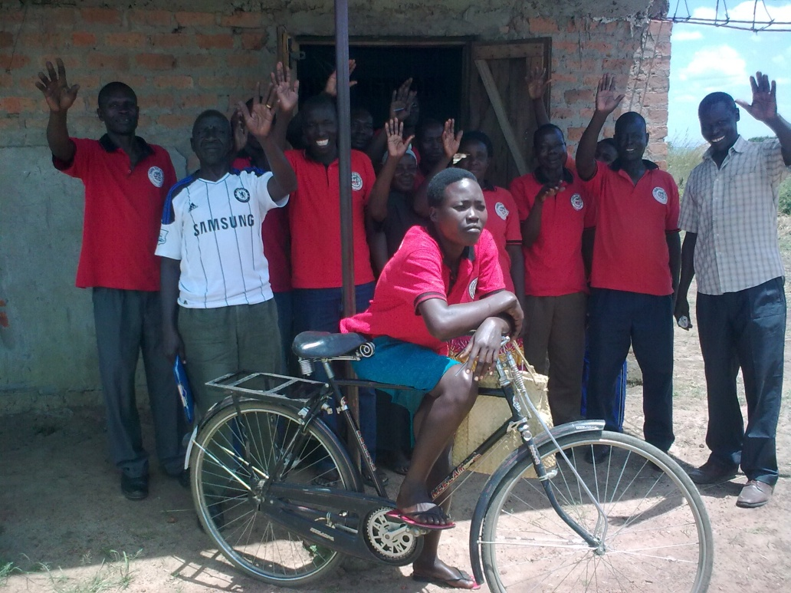
The importance of bicycles to allow CBMs to access meetings sustainably.
As the text box suggests, the approach of communities identifying individuals from within their communities to be trained in advocacy and decision influencing skills, and who are then grouped into CBM associations, has been an exceptionally effective one at both local, district, regional and national level. The table in Annex 7.8 lists the wide ranging sectors across which CBMs have had positive effects and gives approximate success rates for interventions as estimated by UDN. The evaluation identified an individual CBM success rate of about 60%. Successes have been notable at all levels and include such nationally important issues as the cancellation of taxes on key commodities such as domestic Paraffin (almost 20%) and agricultural inputs (18%). The end line survey results corroborate and support those of the final evaluation, reporting strong results in the area of influencing decision making. That 68% of BFs said they had CBMGs in their communities and that 49% had raised issues with them related to: service delivery (40%), rejection of sub-standard material/ inputs provided by the government (17%), challenging service providers to adhere to guidelines (12%), community ownership of projects supplied by government (15%) and holding local leaders to account (12%).
The evaluation did however identify areas where this successful CBM approach could be further strengthened. This included recommendations related to; support to ensure all CBM associations have strong VSLAs (and are maximising the use and potential of travelling to meetings to generate income through cooperating around transport of goods and communal selling), increasing the ability of more remotely based CBMs to access meetings; monitoring for and promoting strategies to reduce CBM drop off/out rates particularly amongst women (30% for men and 50% for women), such as adult literacy and numeracy, job shares, on the job training and mentoring (especially for women of child bearing and rearing age) and twinning of neighbouring communities to allow skills and benefits to pass to other communities.

Indicators for Outcome 4:
Indicator 1: Three submissions a year from community monitoring groups to national platforms. TARGET SURPASSED. See above and Annex 7.8.

Indicator 2: Local Government service delivery/ development plans indicate strategies to address the needs of women, elderly, child headed households. SOME PROGRESS BUT NOT ADEQUATELY ACHIEVED. There was insufficient time within the evaluation to consider this adequately, however government officials did report trainings and some progress in better integrating the issues of women in PLWHA in particular within their activities. The end line survey (more detailed analysis of results in a separate technical annex) corroborated this with 50% of BFs agreeing that local government is meeting the needs of PWD, 57% of women, and 84% felt they were meeting the needs of PLWHA (though conversely few or 18% of the chronically sick, 26% for widows and 36% for CHHs). It is important to note this is people’s perceptions rather than that government is meeting their needs.

Indicator 3: 75% of households report that agricultural extension services e.g. NAADS is effective and appropriate.
It was felt that although the programme could influence extension provision it was not realist for it to be able to responsible for improvements in effectiveness. Baseline against end line data analysis indicates insignificant changes in perceptions of NAADS effectiveness or in the percentage of BFs accessing extension services from NAADS.

Indicator 4: Two submissions to Concern Worldwide UK based campaign. NOT ACHIEVED. Project staff have indicated that the campaign areas for Concern Worldwide have shifted more towards resilience and this is not considered to have been a strong aspect of this programme.

Cross Cutting Findings

Conflict prevention
Outcome 5: Communities in four sub-counties of Amuria district have skills to undertake conflict prevention and peace building through inter parish/ sub-county based dialogues and are aware of their rights to engage and benefit from development activities by the end of the project.

Outcome 5 was achieved in 2012 and removed from the programme. As such, no questions related to Outcome 5 were asked in the end line survey or the evaluation. However the evaluation felt that the SHG, MAs and in particular CNM associations were excellent conduits for conflict resolution and that in future programmes this opportunity should not be overlooked. It was further recommended that had more of a large community group approach been used that targeted certain benefits at the most vulnerable that more community cohesion gains could have been made.

Value Added of Concern Worldwide
The table below briefly summarises the most important roles that Comic Relief expect Grant holders to fulfil, and the degree to which it has achieved them on this occasion:
Summarised Roles | Summarised Achievements and Challenges
Project Oversight and Reporting and M&E | Good ongoing support and management gained through the presence of a senior manager at field level and through regular and good quality field visits from head office support staff. Good levels of high quality reporting. Poor initial setting of outcomes and indicators that failed to be picked up and acted upon by either CWW or Comic Relief resulting in excessive M&E workloads for staff.
Technical training, capacity building and mentoring. | Exceptionally strong role played in this area overall. Concern staff have been involved in delivering wide ranging trainings to partner staff and government and other stakeholders on; Farmer Field School approach, DRR, gender mainstreaming, HIV AIDS awareness. Some evidence that more of an enterprise development approach could have been implemented and that more work was required to ensure the value chains training was transformed into action with BFs. In general it was felt that CWW were able to increase the quality and best practice of partner work, most especially in areas such as HIV awareness and marketing and value chains aspects.
Facilitating reflection and partner learning and promoting the sharing of this experience between and beyond its partners. | There is evidence of partner learning and adaptation of approaches as a result of ongoing learning workshops and as a result of the MTR.

Below are photos of field support to Teete Women’s FFS Nyada in Kapelebyong
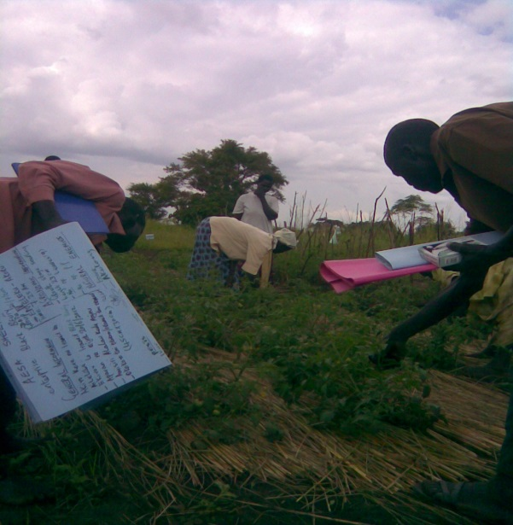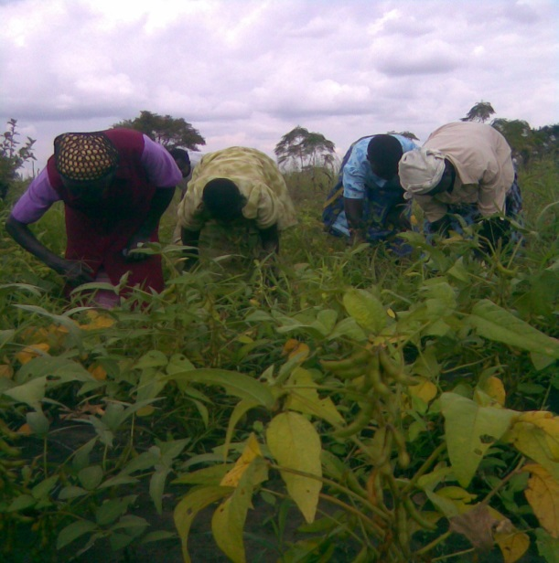

To a large extent, much of the value added that CWW has created is somewhat hidden but never the less essential. Overall, CWW has been seen to have achieved a good level of added value to the programme, but may have fallen behind in the area of overseeing of quality project logical frameworks and light, t robust and practical monitoring and evaluation systems.
Their role in training and capacity building in HIV/AIDs and ensuring appropriate interactions related to selection, identification and vital protection and privacy issues should by no means be underestimated, however some cross checks are advised to ensure good practice continues to occur and that lessons are learnt where weaknesses are identified.

M&E and Progress since MTR
It is understood that M&E is a relatively new area for many agencies, and that although a great deal of hard work and effort has clearly been put in by M&E staff, the design of the initial logical framework was poor. The programme had two very similar outcomes and most of the outcomes had far too many indicators. A number of indicators were not well phrased and some were not realistically achievable. Although CWW should be commended for having attempted to get a baseline, this could have been a much more basic and practical baseline that concentrated on a smaller number of more practically applicable indicators. In general, a lighter baseline and ongoing M&E that particularly focuses on ensuring that managers are able to guage the progress of their programme, usually results in less detailed but clearer and faster results. It is important that programme monitoring is light enough to feedback quickly to allow changes and adaptations to be made to the programme interventions. The baseline was thus not achieved quickly enough to inform early programme design or BF selection etc.
The use of the time consuming and complex nutritional survey tool of HDDS was considered excessive for the needs of this programme, and was not undertaken adequately, simpler methods of monitoring food security and nutrition could have been used.
In general the programme would be advised to improve the nature of the indicators selected and ensure that they are used identically at base, mid and end line. A good tip is to try to phrase them in the way you would need to use to ask the question of a BF. Be sure that by the end, you have monitored actual change attributable to the project itself (as a result of) and this may need to entail at least some basic level of M&E of a small control group of non beneficiaries. It is also possible to ask questions that have been missed out at baseline by asking before and after questions, so that actual change can be measured.
It was evident however, that the programme had learnt from and gone on to implement a great deal of the changes identified in the MTR including; Increasing FFS from 8 to 24; extending VSLAs to all SHG and CBM associations; Increase in market association linkages and more value chain analysis and linkages developed (e.g sorghum to breweries, more milling and other processing), more fruit and other tree planting, more focus was put on improving livestock management practices, and on animal husbandry and management. Further recommendations have been made to increase training in new enterprise development particularly related to adding value to products through food processing, preservation and cooking.

Recommendations and the way ahead
The evaluation has identified an exceptionally strong and sustainable integrated approach with comparatively few weaknesses in the programme approach. This is an important statement and should be born in mind when reviewing the seemingly long list of recommendations given below. This evaluation has been undertaken with the intention of highlighting areas that could be slightly adapted to improve programme outcomes as well as to inform any further phases of the programme and proposals that are compiled to seek further funding from wide ranging donor types. Thus it has concentrated on outlining potential future strategies to inform a ‘second phase’ of the programme, and thus full, wide ranging, detailed and actionable recommendations have been identified. A small number of recommendations from the full list have been highlighted for consideration for action in the remaining three months until programme closure.
Recommendations for consideration for actions prior to end of project (December 2014):
- Establish SHG community based monitoring for drop off and drop out of households from SHG activities and VSLAs, as well as monitoring that the most vulnerable have received all intended benefits individually and acted upon key vital components (vegetable planting, improved drying, FES & W&S etc). Sensitise groups to the importance of supporting involvement of the most vulnerable.
- Ensure that where SHGs have planted all their vegetable and fruit seeds communally that they are sensitized to ensure HHs take up individually as well. Supply one last round of a small number of a wider range of fruit and vegetable seeds to households who have not yet planted.
- Research and analyse impact of floods on those communities who have suffered ‘double’ floods this year and use to design appropriate strategy for future phase ‘flood’ approach. Consider whether a diversification away from agriculture towards livestock, poultry, tree crop or other IGAs would be most appropriate in the most flood prone areas. If funds allow, ensure more flood tolerant variety seeds are distributed in these communities. Monitor well and adapt strategy.
- Establish CBM association community based monitoring for drop off and drop out of CBM from meetings and activities. Develop a strategy to address that includes tackling transport issues for the most remote. Ensure all CBM groups have VSLAs and sensitise regarding potential income generation and enterprise activities.
- Further support and sensitisation of weakest VSLAs in particular and small number of struggling MAs
- Analysis of which livestock and poultry approach has worked best and monitoring and sensitisation to ensure birds and animals are fairly passed on to all intended beneficiaries (including those who are dropping off/out).
- Technical support to the apiary sites
- Sensitise SHG, CBM & marketing associations to the importance of investing now in fruit growing, and if funds remain train groups in tree nursery skills and distribute appropriate fast growing fruit seed varieties such as passion fruit and pineapple to all HHs or PWD, PLWHA, elderly and CHH in particular for nutrition and IGA.
- Sensitisation of groups who have been given or purchased group assets of the need to establish funds for maintenance and replacement of the asset at the end of its productive life (from oxen to processing machines etc).
The table below contains the full summary of potential recommendations for how to adapt the existing approach so that it both improves upon the current approaches areas of weakness and builds an approach for any future phases of the programme. In essence, these recommendations should inform proposals that both repeat the existing approach but in new communities and add a further ‘second phase’ approach that concentrates on embedding gains in commercial production and adding value to products though post raw material processing, value addition and enterprise creation to ensure gains remain at HH and community level:

Summary of Recommendations and Way Ahead for future Phase
Agricultural Production, Livestock and Poultry:
- Increase spread and sustainability of project aspects by explaining exit dates to BFs right at the start. Working with BFs to ensure that by the end of the project they are able to maintain and replace any project inputs by their own efforts or through savings for replacement. Principally this involve ensuring all BFs understand the obligation to hand on any knowledge gained to none beneficiaries, duplicate any inputs received through such things as seed replication and dissemination to neighbours or should include passing on of livestock and poultry outputs as well as saving for maintenance and replacement of oxen, ploughs and other assets.
- Improved livestock fodder species and organic manure and manure and crop residue composting advice for livestock caretakers.
- Consider whether in small groups where only a small number of animals can be given, whether giving male improved animals and a cross breeding programme might not be more cost efficient and effective.
- Consult specialist experts with regard to the advantages and disadvantages of communal rearing of animals and poultry. Be sure to consider the increased risks of poultry disease spread in particular.
- Ensure partners budget for replacement seeds in subsequent years for complete crop loss due to floods and severe drought, pest or diseases.
- Encourage dissemination of small quantities of very varied seed types, to allow farmers to test and select those most suited, and prevent some larger scale losses.
- Encourage community meetings at project start to discuss which crops are most flood and drought tolerant specific to certain small areas and source these seeds plus small amounts of new recommended varieties by research, other agencies, FAO etc
- Wider range of fruit and vegetable varieties available and ensure good quality seed.
- Where some groups have chosen to grow fruit and vegetables communally, ensure that small amounts of seeds are distributed to ensure all members try new crops at home.
- Extension visits after exceptional floods to affected villages, monitor whether HHs are considering eating improved seeds and develop strategies to avoid.
- Increasing emphasis on understanding the reasons why all farmers should have small nursery beds/sacks to maximise early planting, concentrate watering and fertilising and gain early crops to access higher prices.
- Drought – soil and water conservation strategies, mulching, improved composting and manures straining etc.
- Consider recommending intensive plots that can be watered during droughts
- Mixed cropping and Inter cropping – this was a fairly widespread practice before, but some knowledge as to specific companion crops is still in its infancy. (for fertility and pest prevention purposes.
- Organic manures, mulches, composting, crop residues as drought avoidance strategy
- More identification of flood prone areas and dissemination of advice and flood tolerant varieties.
- Weather forecasting and early warning - Most farmers have not gained any specific early warning or weather forecasting information from the project other than what they have heard on the radio. Develop a strategy that gets simple, localised weather, pests, diseases and price information to farmers, through radio, texting and extension officers to group leaders.
- CIDI had a highly commendable community seed replication and distribution system in place. It is much better if improved seed can be sold for seed rather than for food purposes after a programme of this nature. It is essential however, that farmers are permitted to make sufficient gains for their own food consumption before ‘passing on the seed gift’ to their neighbours. The evaluation identified some farmers who had had to give all their surplus seed away and others who had lost their seed and then had to purchase seed to give to neighbours.
- In general NGOs should be moving away from seed distributions in the development phase and moving more to enabling seed replication in communities and facilitating the capacity within local government and private seed suppliers to sell wide ranging and good quality improved seed varieties.
Self Help Groups & VSLAs & CBMs:
- Fees and minimums can promote drop off/out. Graduated increases in recommended minimum VSLA payments. Avoid high up front member registration fees, encourage flexibility in amounts people able to save each month, ensure that the importance of savings to be kept to cover bad times rather than just to fund IGAs, and that if possible loans should try to be taken for productive rather than consumptive purposes
- All groups should have strategies and safe places for money storage such as concreted lock boxes and wherever feasible for large amounts, access to bank accounts. Partners to explore partner sub accounts and group insurance
- In some, but not all cases, increased basic cost benefit analysis of group and individual IGAs would be beneficial with increased advice from partner staff. For example, explaining to groups and individuals that purchasing several goats/sheep rather than one valuable cow reduces risks and ensures benefits can spread more quickly.
- Advise groups to allow oxen to go to weakest groups members first (CHH, elderly etc) to give them a slight advantage.
- Consider purchasing carts for those remote and poor SHGs with oxen to use to get to bulking stores and as an income source in the non-ploughing season.
- Consider part-purchasing bicycles for the use of the most remote community monitors and as compensatory income source.
- Develop sustainability strategies to reduce the impact of drop outs/offs amongst women in particular who have group leadership roles. In the community mobilisation groups drop outs have been around 50% for women.
- Increase the spread and influence of each community monitor by increasing the number of villages they cover/represent.
- Where radio coverage is low, develop other communication strategies for communication of community monitoring issues in remote areas.
- More stress on investment in alternative IGAs. Tracking of those individuals dropping out of youth and savings groups, to be sure that it is not the most vulnerable with valid additional difficulties that are dropping out. Ensure there is a strategy ready and in place to support vulnerable people struggling to participate in groups.

Income generation, diversification, value addition and market linkages:
- Increase the diversity of trainings in value adding food processing and preservation IGAs
- Consider involving children in helping to raise funds for their own school fees through projects such as pigeon keeping (being used in some families to pay school fees and ongoing school costs).
- Ensure SHGs that are distant from bulking stores/marketing associations are joined together into neighbouring groups so that collection dates can be arranged for crops. Consider facilitating this with an oxen cart sharing scheme.
- Improve communications between marketing associations and traders as well as with SHGs through mobile notifications.
- Consider apiaries as income generation source for marketing associations whose waste flour from grinding mills provide a food source to stimulate bee colonies.
- Better help getting price forecasting information and alerts
- Increased advice on fair share out procedures and ensure that FHH or CHH do not miss out.
- Recommend in house improved grain stores/barrels in homes prone to raids and floods.
- Ensure a clear message goes out to beneficiaries that having alternative incomes outside of agriculture, that are not as dependent on the weather, is a vital way of overcoming the bad times associated with changes in the climate and extreme and variable weather patterns. Increase training in this area. Develop a project ‘slogan’ or ‘mantra’ or song around this important concept and communicate it by varied means (text, radio, drama, school competitions etc.) consider implementing small alternative income generating approaches through value adding by processing crops or small IGAs ideas that emanate from innovative farmers (doves, turkeys, ducks etc).
- Distribution of briquette making moulds (perhaps as income generation source for groups or CBMs) or training local craftsmen to make and sell them so that briquettes can be sold at scale. Disseminate this technology to other NGOs and partners.

DRR
- Increased direct emphasise on the sensitisation of BFs to principle climate change mitigation strategies (savings, flood tolerance, income diversification, reduced fuel wood consumption etc)
- Identification of better appropriate strategies at specific farm level for flood prone farms in consultation with national research and extension services and international agencies (including FAO)
- Consider adopting a different strategy specific to the needs of flood prone farms, which may include a shift towards more emphasis on livestock and poultry production
- FES & briquettes as an IGA
- Ensure clear simple messages around seedling nurseries that allow early and staggered planting in order to spread risks and capture the best of the season’s rains. Develop a slogan or mantra around early and staggered planting as a way of accessing the high prices at the start of the season.
- Ensure VSLAs seen as a source of help in bad times and encourage reserve funds for after extreme events.

Training and Creating Change:
- It is clear that some groups and certain farmers are now meeting commercial scales of production and require a second phase of project support and specialist advice

Influencing Decision Making and Advocacy:
- Remoteness, lateness fees and VSLA minimums can contribute to drop off/out. Monitor for CBM drop off and drop-out rates and design strategy to promote increased attendance.
- Consider part purchasing of bicycles for most remote CBMs and permit hire out for IGA and sustainability purposes.
- Ensure CBM groups begin VSLAs and have group and individual business and enterprise training in the earlier phases in order to encourage attendance and compensate for efforts and expenses. Research and consider ‘traders’ concept of CBM cooperating over purchasing, transporting and selling in readiness for phase out.
- For sustainability could CBM groups share use MA buildings post project when nearby?

Cross Cutting
- Taking care with the issue of inadvertently increasing women’s workloads
- Ensure project discussion and learning around having selected two BFs per HH? What are the advantages and disadvantages of the approach?
- Ensure baselines and ongoing M&E are more light and relevant and thus quicker to undertake and report back and are thus more likely to be able to be used to inform project design and adapt strategies and activities.
- Monitoring of disaggregated beneficiary drop out reasons and rates and Livestock and poultry mortality figures to allow staff to respond within the life of the project. Drop out/off rates amongst community monitors in Obalanga for example show that male drop off/out rates are 30% whilst women is 50%.
- Monitoring take up of training and other project advice, and returning to re-sensitise if necessary. Examples include relatively poor take up of sack mounds and improved manures and composts etc.
- Inclusion of ‘chronically sick’ inclusion category which can include PLWHA and can help with privacy issues.
- More care regarding privacy and protection of beneficiary information particularly related to disclosure of HIV/AIDS status.
- Targeting of integrated water and sanitation and nutrition training and associated planting advice to PLWHA.
- Inclusion of basic literacy and numeracy training for selected individuals in order to ensure meaningful participation of specific vulnerability groups (women, elderly and PWD particularly) and contribute to the inclusion of the vulnerable.
- Develop innovative strategies for increasing the proportion of women as leaders (particularly of marketing associations 48M/28W and community monitors50m/20w)

Learning
The following table summarises some of the key learnings identified in more detail within the report;
Learning Summary
- Sustainability and exit - In general, when forming groups it is advisable that they have access to an income generation strategy in order to compensate or cover the costs of the leadership and management of the group. Those marketing associations, self help groups and community monitors groups who moved quickly to acquiring small businesses, processing machines or transport devices look set to prove more sustainable.
- Consider whether in DRR and climate change related programmes that interventions need to be tailored to the individual HH at farm level. Thus it may be preferable to have alternative approaches for ‘flood prone’ or drought prone households, or a mix. A selection criteria for the programme could thus become ‘flood prone’ for example.
- The approach of giving diversity (seed types and more?), in order to permit selection and suitability is an important lesson for the project.
- Building in a nutrition element through the crop, fruit and vegetable varieties and IGAs selected and targeting these at nutritionally vulnerable groups
- Labour saving aspects at start to release labour time for project activities.
- Identifying specific programme aspects to increase productivity and underactivity of men and avoid overburdening women (particularly in post conflict settings)
- Labour saving aspects at start to release labour time for project activities.
- Nutrition as foundation for PLWHA
- Aim for more of a ‘community group’ aspect in future, targeting specific aspects and gains at the most vulnerable. Approach has added community cohesion benefits also.
- Partners report learning the value of higher extension officer per beneficiary ratios and could consider taking on experienced and less experienced extension officers side by side and then doing on the job training, mentoring and capacity building, to ensure more staff in the long run.
- Need to consider more small IGA or livelihood cash grants
- Specific approaches for CHH and PLWHA, elderly and PWD.
- HDDS not required

Concern Worldwide:
- Consider internally produced baselines with HO technical support. Aim for light but robust baseline that is rapid enough to inform geographic and vulnerability targeting.
- Monitoring for the impact of trainings and whether actions taken as a result and including sufficient time in evaluations to establish the degree to which Knowledge, Attitude and Practice (KAP) have changed.
- Ensuring that partners are trained and procedures regarding how to target and select PLWHA and ensure their confidence is protected are achieved early and monitored for continued best practice.
- Taking care that by introducing men to what were existing women’s groups that these do not then go on to capture benefits. Additional care when adopting a ‘caretaker’ approach to livestock and poultry that men do not overly capture benefits
- Institutional reflection as to whether; it was the right decision to continue work with the existing groups or whether the project would have been better to spread the benefits to new groups in new communities; whether bigger groups with one principle beneficiary would have spread the benefits wider and reduced risks of men capturing benefits intended for women.
- Bi-annual learning workshops that look in detail at the differing partner approaches, challenges faced and assessing what can be done to improve delivery/implementation methods.
- Ensure all programmes have strategies to maximise the spread of benefits to non-beneficiaries.

Comic Relief:
- Comic Relief to simplify application procedures so that intermediary organisations are not essential to application success. Simplification and review of final evaluation key questions.
- Recognition by agencies and donors that in long term post conflict situations, projects need much longer time frames. First phase programmes of 3 or 4 years should concentrate on strong group formation and DRR and food security outcomes with second phase programmes building on success with value addition, income generation, marketing cooperation and linkages.
- Programme analysis and wider communication and dissemination of learnings on the need for and best way of organising draught power in post conflict settings (perhaps across CR agencies)
- Further research and analysis of climate change mitigation issues related to the importance of fallow farming and the degree to which programmes should encourage intensification rather than opening up of new or fallow land (particularly post conflict)
- Further investigations into Livestock and poultry programmes that involve communal or caretaking of group assets may contribute to the low take up of improved animal husbandry practices unless accompanied by special measures (community based animal husbandry providers etc).
- In regions where communities are recovering from long term cattle raiding, communal raising of animals may increase the risk rather than spread the risk.
- Develop a strategy for cooperative marketing of cotton. Cotton growing pays for school fees and bulking stores are not equipped to deal with this product.
- Ensuring that community monitoring groups have VSLAs attached from the start and IGA training in order to act as a compensation for time, efforts and expenditures.
- As beneficiary levels of production and household incomes begin to rise, the demand for fuel to cook 2 or 3 times a day also increases. It is therefore essential that energy saving techniques and technologies are established and in place at the very earliest stage of community involvement, to reduce harmful tree felling.
- Ensuring aims to disseminate the benefits to the wider community and cascading to neighbouring communities as widely as possible through ‘passing on the gift’ be that knowledge or improved technologies.
- The knock on benefits of integrating a climate change project with a project aimed at increasing production.
- Ensure all programmes to have strategies to maximise the spread of benefits to non-beneficiaries. Encourage community groups with targeting specific aspects at vulnerable groups. Especially in conflict environments.
- Improve M&E advice and support. Particularly ensure that drop off/out rates and monitoring of take up rates, mortality rates to allow adaptation in approach.
- Two phases needed

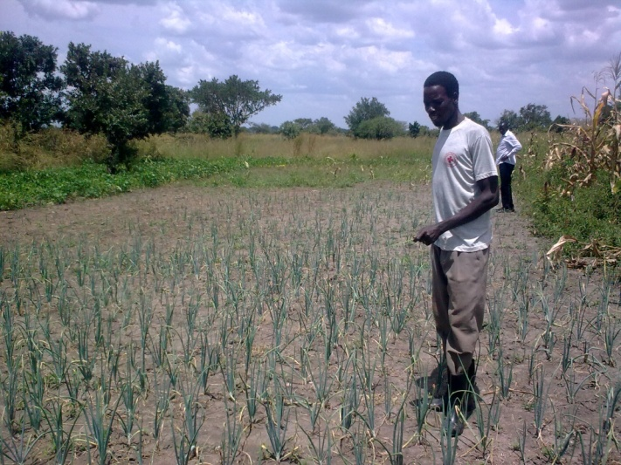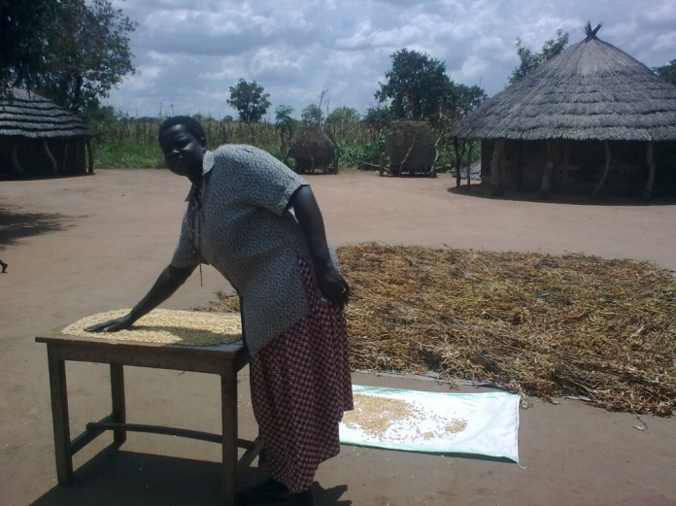
Farmers meeting household subsistence through improved storage and drying and moving on to commercial levels of production.
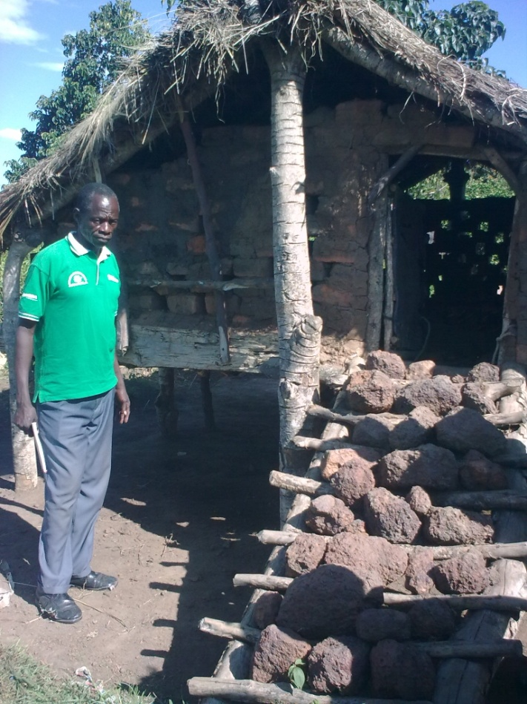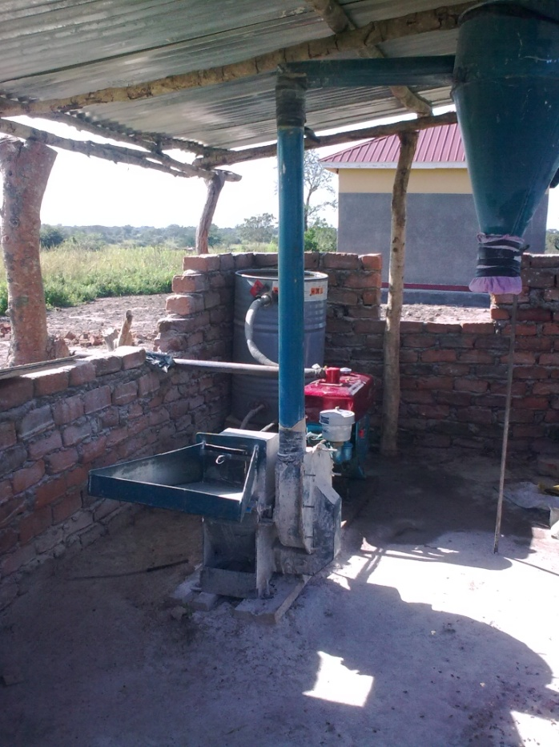
Breeding centres and passing on of livestock assets. Value addition through processing at bulking stores.

Conclusions
The evaluation ToR (Annex 7.1) requested that the programme be evaluated against the DAC criteria:
DAC Criteria
Relevance  The extent to which the objectives of a development intervention are consistent with participants’ requirements, country needs, district needs, Concern and partners policies. | Fully ACHIEVED - This programme was well aligned to Concern policies and deemed highly relevant to the needs of vulnerable Ugandans in Amuria, and was particularly effective in ensuring their needs were being met by government through the programmes strong advocacy and decision influencing aspect.
Effectiveness  The extent to which the development intervention’s objectives were achieved, or are expected to be achieved, taking into account their relative importance. | Fully ACHIEVED - The programme was effective in meeting its food security and income generation objectives, however there remain areas where income generation could occur through value addition that should more appropriately occur in a second stage programme. CWW and their partners have shown considerable improvements in capacity. Beneficiaries, other than those in flood prone areas have developed sustainable subsistence livelihoods strategies and many are well on their way to reaching commercial levels of production.  The grassroots advocacy and decision influencing aspects of the programme were the most effective ever seen by this evaluator.
Efficiency  A measure of how economically resources/inputs (funds, expertise, time etc) are converted to results | ACHIEVED - The fuel efficient stoves, water and sanitation and fruit, vegetable and crop seed aspects of the programme have shown the greatest levels of efficiency in terms of their cost in relation to their benefits, particularly in relation to the advantages gained by women both nutritionally and through labour saving and control of financial gains.
Impact  Positive and negative, primary and secondary long term effects produced by a development intervention, directly or indirectly, intended or unintended. | ACHIEVED - The evaluation has demonstrated that there have been wide ranging positive impacts to both beneficiaries and their neighbours that go above and beyond the general improvements in conditions in rural areas that have also seen improvements for non beneficiaries. No major negative direct or indirect impacts were identified and change is considered likely to be sustainable in the long term. There were some concerns that tighter more practical monitoring of things like livestock mortality rates and drop-out rates could improve the long term inclusion of the most vulnerable for future programming.  Women have gained alongside the men within their HHs, and FHH have similarly gained. FES have reduced HH labour tasks and improved health conditions for women and given them more time to work on the project tasks than they would otherwise have had. Household decision making has become more equal and women were clearly able to speak out and participate widely within meetings and with officials.
Sustainability  The continuation of benefits from a development intervention after major development assistance has been completed. The probability of continued long-term benefits. The resilience to risk of the net benefit flows over time. | ACHIEVED - The programme impacts were considered to be highly sustainable in the long term and many interventions had permitted changes likely to give HHs reduced future risks and increased adaptation to climate change. There had also be strong gains in ensuring a good level of sustainability of the SHG, MAs and CBM associations formed through development of group IGAs to help cover for and compensate for costs. It was felt that CWW could have demonstrated more leadership in terms of exit strategy and in particular in ensuring that all group assets were sustained through the generation of group reserves for maintenance and asset replacement.
In truth, many of the impacts and benefits of this programme are hidden (better soil, better nutrition, less illness, fewer trees felled, more education, less time spent collecting wood water etc.). However the remaining achievements are plain to see in the turn-around in fortunes created amongst the households that have taken part.
In essence, the evaluation found a sound, integrated approach considered likely to have strong long term sustainability in a post conflict setting, which is all too rare. An excellent agricultural project was well complemented by group savings, wide ranging trainings, livestock and poultry elements that look likely to prove effective in the longer term, and an exceptionally effective advocacy and decision influencing approach that was has been extraordinarily successful.
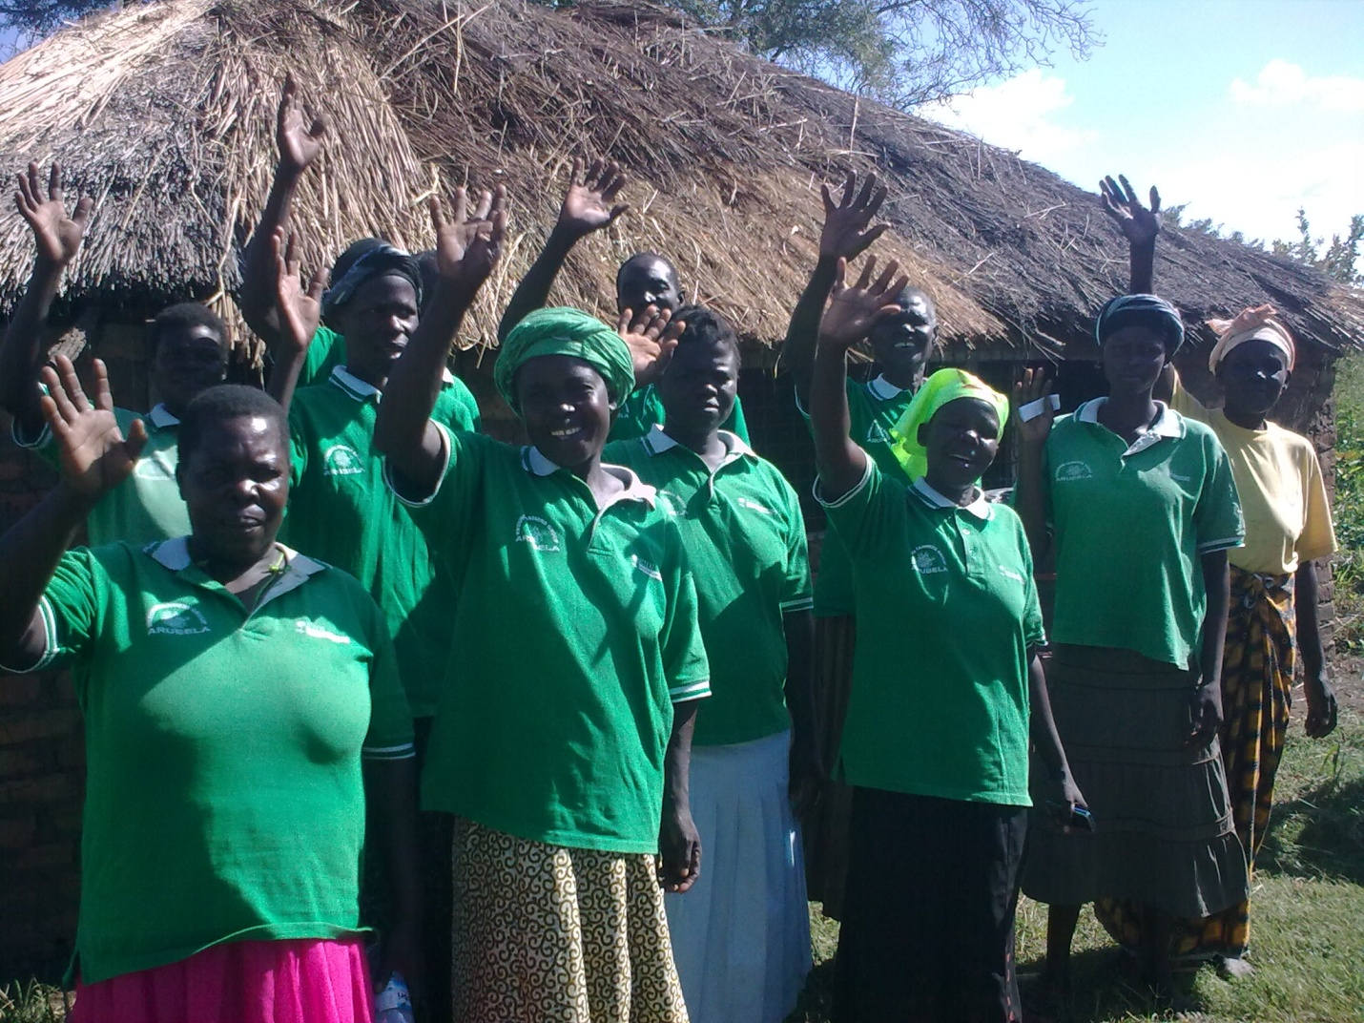
Strong group formation and leadership as a key to success.

Annex

Terms of Reference
Final Evaluation of Concern Worldwide’s
Sustainable and Equitable Wealth Creation in Amuria Programme
2010-2014

- Overview: The Amuria Food Security and Livelihoods Support Programme

Concern Worldwide (hereinafter, called Concern) received funding from Comic Relief to implement the “Sustainable and Equitable Wealth Creation in Amuria” (SEWCA) programme from 2010 to 2014. This programme supports poor farmers to improve agricultural production, product processing, business skills and understanding of markets. Participants are organized into groups and into marketing associations, which will help them to achieve economies of scale, strengthen their position within the value chain and increase their voice with government.

- Background:

Concern is a non-governmental, international and humanitarian organization dedicated to the reduction of suffering and working towards the ultimate elimination of poverty in the world’s poorest countries. Concern was founded in 1968 with its headquarters in Dublin, Ireland. In Uganda, Concern first worked in early 1980s to response to famine in Karamoja region with focus on relief. From 1990s, Concern has continued to support Emergency and Development programmes with focus on Health, HIV and AIDS, Food, Income and market in the various parts of Uganda. At present, Concern is operating in 11 districts of Uganda; Amuria, Pader, Agago, Nakapiripirit, Amudat, Napak, Moroto, Adjumani, Arua, Koboko, and Kiryadongo.

Concern’s vision in Uganda is; “A Uganda where absolute poverty is eliminated and social equity exists”. The organisation intends to achieve this by working with and through relevant partners to improve the living standards of people who cannot meet their basic needs.

- Overview of the Programme:

Programme Goal: Sustainable and equitable wealth creation in four sub-counties of Amuria District which will contribute significantly to sustainable development in the region and contribute to MDGs 1 and 8

Programme Purpose: Producers benefit from increased food security through the diversification and increase in household agricultural production and income from surplus trade through increased access to local and national markets.

Programme Coverage: Four sub counties in Amuria District, Uganda (Obalanga, Kepelebyong, Acowa and Morungatuny)

Programme Implementation Strategy: The programme is being implemented through three partners namely Volunteer Efforts for Development Concerns (VEDCO), Community Integrated Development Initiatives (CIDI) and Uganda Debt network (UDN)

Target: Programme Target: A total of 240 Groups (60 groups per sub-county) representing approximately 4,800 households in the four target sub-counties. The programme targets at least two members of each participating household so a total of 9,600 individuals will participate directly, benefiting a total of approximately 28,800 individuals (6 people per household).

4. Rationale for the Consultancy
The SEWCA programme is due to end in December 2014. As such, Concern requires an independent consultant to conduct the final evaluation of the programme in order to assess the relevance, effectiveness, efficiency, sustainability and impact of the programme. The results of the evaluation will be shared with programme participants, partners, local authorities and Comic Relief as the key programme donor. Learning and recommendations will be applied to future programmes in Concern and to subsequent programming in Amuria.

5.Specific tasks.

The Consultant will be required to review the programme against the standard DAC criteria with particular attention on the specific questions under each sub heading. The Consultant’s final evaluation report will be inclusive of any data compiled since the beginning of the programme on key indicators identified in the programme log frame and for comparison with data collected at the baseline and endline stage. Qualitative data will be collected through focus group discussions, analytical data and interviews. Whereas possible the Consultant should provide evidence of outcomes and impact in people’s lives over the term of the programme. It should be noted that programme teams will undertake collection of end line data prior to the start of the evaluation.

Relevance  The extent to which the objectives of a development intervention are consistent with participants’ requirements, country needs, district needs, Concern and partners policies. | - Review and evaluate the relevance of the goals and objectives as laid out in the programme document.  - Assess the appropriateness of programme interventions in relation to target beneficiary needs and priorities.  - Review the appropriateness of the programme in terms of its design and approaches with respect to Concern policy, strategy, and programming documents.
Effectiveness  The extent to which the development intervention’s objectives were achieved, or are expected to be achieved, taking into account their relative importance. | - Assess the effectiveness of the programme in attaining its purpose including an analysis of promoting and hindering factors.  - Assess progress made towards achieving the programme purpose, and the overall key outcomes and/or impact of programme activities linked to each output measured according to the indicators in the log frame.  - Assess to what extent have programme participants benefited from the livelihood interventions.  - How effective was Concern at building partners capacity to deliver livelihood programming to their local communities.
Efficiency  A measure of how economically resources/inputs (funds, expertise, time etc) are converted to results | - Were the resources used cost-effectively and properly allocated?  - Comment on the management structure and the implementation strategy in light of partner capacity and project context.
Impact  Positive and negative, primary and secondary long term effects produced by a development intervention, directly or indirectly, intended or unintended. | - Provide an assessment of what has changed so far (outcomes and impact both negative and positive) as a result of the programme interventions, based on programme indicators.  - Assess the extent to which the most vulnerable beneficiaries have benefited from the programme.  - Assess the extent to which gender relations have been influenced or have been affected by the programme.
Sustainability  The continuation of benefits from a development intervention after major development assistance has been completed. The probability of continued long-term benefits. The resilience to risk of the net benefit flows over time. | - To what extent will the project benefits continue after the project has been completed?  - What are the major factors influencing the achievement or non-achievement of sustainability of this project?
In addition, the Evaluation should address the following questions that will be used for learning for both Comic Relief and Concern:

What difference has the programme made to people’s lives (what, who, where, when)?
- To what degree have programme outcomes been achieved in the targeted communities in Amuria? Were there any unexpected outcomes?
- Who has benefited (women, men, girls and boys) and in what ways?
- Are those changes (outcomes) relevant to people’s needs?
- Are they likely to be sustainable in the long term?
- To what extent has the programme contributed to the achievement of broader policies, targets etc in Amuria district and targeted subcounties?
- To what extent has the achievement of the changes/ outcomes in the relevant communities in targeted sub-counties in Amuria been influenced by external context and other factors?

How has the programme made this difference?

Approaches used by the programme and implementing organisations:
- What was the overall theory of change for this programme? Has it been effective in bringing about lasting change? Were there any gaps?
- What have been the most effective methodologies and approaches the organisation used to bring about changes to people’s lives? What has worked and what has not? What lessons have been learned? Who have they been shared with?
- How have relationships between partners throughout the relationship chain helped or hindered the delivery of change /outcomes?
- How effective have the programme management, monitoring, learning and financial systems been? How have they helped or hindered the delivery of lasting change?
- Has the programme been cost effective?

Approaches used by Comic Relief:

- How have Comic Relief’s grant making policies and processes (e.g. how we define our programme strategies and outcomes, how we assess applications) helped or hindered the delivery of lasting change?
- How has Comic Relief’s approach to grant management (e.g. individual work with grant holders, and learning activities with other funded organisations) helped or hindered the delivery of lasting change?
- How has the way Comic Relief used its organisational assets helped or hindered the delivery of change (e.g. use of the media, access to decision makers)?
- Are there any other ways in which Comic Relief has helped or hindered the delivery of change?

6. Methodology

The consultant will be expected to;

- Submit an Expression of Interest (EOI) outlining the approach and methodology and timeframe of this Terms of Reference.

- Conduct a document review to familiarise him/herself with the programme by pre reading the following documentation:

  - Organisational documents: Concern Worldwide Uganda Strategic Plan, Food, Income and Markets (FIM Strategy), How Concern Understands Extreme Poverty, and Concern partnership guidelines.
  - Project documents: project proposal and logframe, baseline report, endline survey data, PM+E Plan, monthly reports, Mid-term Evaluation, annual reports 2009-2014
  - Partner’s documents; proposals, work plans, monitoring reports and any other documents that are important to the evaluation.

- Develop and refine the evaluation work plan and methodology based on Concern feedback on EOI submission.
- Indicate local human resource and logistics requirement requirements one month in advance of fieldwork
- Hold meetings with the implementing partners, relevant district representatives and other stakeholders as per evaluation plan
- Interview target programme participants, partners’ programme staff as well as relevant Concern staff both at head office and Amuria field office.

Expected Outputs
- A final endline report presented in two bound hardback copies and a copy on CD-ROM.
- The report should be clear and simply written, free of jargon. The main body of the report should not exceed 30 pages and should include an executive summary and recommendations. Technical details should be confined to appendices, which should also include a list of informants and the evaluation work schedule. Background information should only be included when it is directly relevant to the report’s analysis and conclusions.
- The report’s author(s) should support their analysis of a programme’s achievements with relevant data and state how this has been sourced. Recommendations should also include details as to how they might be implemented. Additionally, the report is to include guidance on the process by which findings will be shared and discussed with Concern, Comic Relief and all stakeholders including those who are benefiting from the programme.
- Recommendation in the final report should be targeted.
- Feedback and debrief session to Concern staff in Kampala Head Office.
- Feedback and debrief session to Partners and stakeholders in Amuria

7. Time Frame
The proposed timeframe to begin field work is start date is the 24 of September 2014. The final report must be submitted by the end of November 2014. We are anticipating a six week process.

TOR Annex I: Outline - Format for the Final Evaluation Report

- Cover page
- Table of Contents
- Index of tables, charts and graphs
- Definition of terms
- Abbreviations
- Executive Summary (maximum 3 pages). It is suggested that a synopsis of the following are included in the executive summary: Successes, Difficulties, Special Comments/Insights and key findings

- Chapter One: Introduction
  - Background, Outline purpose and scope of the evaluation and construct a table listing the location, timeframe, higher objective and a synopsis of the project. Comment on the context of the evaluation objectives, team composition, methodology and process.
  - Limitations or constraints encountered,
  - Brief narrative history/overview of the project reviewed

- Chapter Two: Findings and Analysis
The report should describe all findings and analysis under the headings of the DAC evaluation criteria and address the specific questions outlined in section 3 specific tasks.

Relevance | The extent to which the objectives of a development intervention are consistent with participants’ requirements, country needs, district needs, Concern and partners policies.
Effectiveness | The extent to which the development intervention’s objectives were achieved, or are expected to be achieved, taking into account their relative importance.
Efficiency | A measure of how economically resources/inputs (funds, expertise, time etc) are converted to results.
Impact | Positive and negative, primary and secondary long term effects produced by a development intervention, directly or indirectly, intended or unintended.
Sustainability | The continuation of benefits from a development intervention after major development assistance has been completed. The probability of continued long-term benefits. The resilience to risk of the net benefit flows over time.

The specific issues of targeting, participation, capacity building and cross cutting themes (equality, partnership, right based approach, Programme participant protection, HIV and AIDS and advocacy) should be variably addressed in different sections as appropriate and assessed to what extent and how successfully they were implemented by the project).

Relevance
Relevance means the extent to which the project conforms to the needs and priorities of the participants (the extreme poor), and the policies of Concern Worldwide Uganda, Concern Worldwide and partners. Relevance implies a consistent fit with the priorities of the principle stakeholders and participants (the extreme poor). With respect to this, Concern Worldwide Uganda attests to the strategic importance of working with and through partners as well as developing appropriate linkages. The issue of relevance should also extend to commenting on the project fit with country and organizational Strategic Plan, the Food Income and Market strategy, and global livelihood security strategy. The importance of context and adapting to changes in context and how the project dealt with it should also be dealt with. In this section, appropriateness in technical and managerial terms should also be assessed.

Effectiveness
Effectiveness is a measure (both in qualitative and quantitative terms) of the extent to which the project has achieved its objectives, taking their relative importance into account. Measuring effectiveness involves taking the perspectives of the participants (the extreme poor) of the project into account. This section should review the issue of project planning and monitoring. More specifically the evaluation should examine whether there was sufficient, reliable, verifiable and accessible information that was used in decision-making during the project implementation; whether the standards of best practice in the sector were met; whether the quality of monitoring reports were satisfactory.

Efficiency
Efficiency is comparing the outputs against the inputs. It illustrates the relation between means and ends. The underlying question to ask when looking at efficiency is this: to what extent can the costs of the project be justified by its results, taking into account alternatives? An important aspect of this is the scale achieved for the resources utilized.

Impact
The term impact describes the totality of the effects of the project, positive and negative, intended and unintended. Specific consideration should be given to participants’ view on the impact of the project including to what extent the project contributed to changes in their lives. As with effectiveness, changes can be measured against PRA data that describes the situation before the project took place.

Sustainability & Replication
The term sustainability describes the extent to which the positive effects of the project continue after the external assistance has come to an end. Here, the issue of ownership, management, governance, sustainability and financial viability should be addressed. This section should also review the available sustainability options developed and comment on the adequacy of these.

- Chapter Four: Case studies (at least 2 case studies)
- Chapter Five: Conclusion and Recommendations: Note recommendations should be targeted.

Evaluation Schedule
Date | Time | Activity
Tues. 23rd Sept. | 22:50 | Consultant Arrives in Entebbe
Wed. 24nd Sept | 9:00  11:00  13:00  14:00  16:00 | Meet with Concern ACD-P in Kampala  Meet with Representatives of CIDI  Lunch  Meet with Representatives of UDN  Meet with Representatives of VEDCO
Thurs. 25th Sept. | 7:00  14:00  16:00 | Travel to Amuria  Lunch in Soroti  Arrive at Project Office
Fri. 26th Sept. | 7:45  8:00–9:15  9:15–12:30  12:30 – 13:00  13:00 – 13:35  13:40 - 14:40  14:40 – 15:05  15:05 – 16.15 | Day Plan – Kapelebyong Subcounty  Travel to Okoboi FMA  Okoboi Farmer Marketing Association – Group Interview  Roadside lunch  Travel to Amaseniko  Emorut (commercial farmer –all project aspects)  Travelling to Nyada  Nyada Community Group – Focus Group Discussions (VSLA, Agriculture Inputs, Teete Farmer Field School, Grant,  Return to Amuria
Sat. 27th Sept. | 7:45  8:00  9:00 – 11:00  12:30  14:00  14:30 – 16:30  16:30 | Day Plan – Obalanga Subcounty  Travel to Obalanga Subcounty (1hour)  Obalanga Community Monitors ( meeting for 1 ½ hours) (issue: streamlining the agriculture extension systems)  Akujo Margaret – HH interview (travel time 20 min. / 1hour)  Emonoto Ekeunos – Agonga Commmunity (30 min drive) (Commercial Farmers – vegetables)  Roadside Lunch  Ocongoda Ekeunos – Agonga Community (Food Security and Commercial Farmers, Grant)  Ogwotai Agange and Ogwotai Akankwap in Ogwotai village(affected by floods)  Travel to Soroti
Sun. 28th Sept. |  | Desk Work
Mon. 29th Sept. | 7:30  8:30  9:00  9:00 -9:45  10:00 – 10:15  10:30 – 13:00  13:00- 14:00  14:00- 16:30  16:30 | Travel to Amuria  Day Plan: Ogolai Sub-county  Travel to Ogolai Sub-county  Olupot James – HH interview  Meet Ogolai sub county Leadership  Ogolai Community Monitors – issue – tax on agriculture inputs and equipment – represented at national level  Roadside Lunch  Ogolai Teete Field School Group (looking Commercial Farmers, Gender, off-farm activities, piggeries)  Travel to Amuria
Tues. 30th Sept. | 9:00  11:00- 12:30  12:30- 13:30  13:30-15:30  15:30 – 16:30  16:30 | Chief Administrative Officer, Assistant Chief Administrative Officer, District Agriculture Officer, Farmer Field School Master Trainer, District Community Development Officer, District Land Officer, Commercial Officer  Resident District Commissioner and District Chairperson  Lunch in Amuria  Acowa Ekeunos Farmers Group (VSLA, production, grinding machine) (1 hour 10mins)  Ongodia (child HH- interview. In same community); Ochen Patrick Child Headed household – less successful)  Travel back to Amuria
Weds. 1st Oct | 7:45  8:00  9:00  9:20: - 12:20  12:20 – 13:20  13:20 – 14:30  14:30- 16:30  16:30 | Day Plan: Acowa Subcounty  Travel to Acowa Subcounty  Meeting Acowa Sub county Leadership (15 mins)  Acowa Farmer’s Marketing Association  Roadside Lunch  Meet non-beneficiaries (FGD with about 10 people 5M&5F)  FGD with indirect beneficiaries  Learning and review meeting with Concern, CIDI and VEDCO Coordinators (Harriet, Emma and Ketty).  Travel back to Amuria
Thurs 2nd Oct | 7:45  10:00 | Debrief Partner Field Staff  Travel back to Kampala
Fri. 3rd Oct. | 9:00  12:00  14:00  21:30 | Preparation and Debrief Meetings with Concern  Review Endline survey feedback meeting (Finola)  Debrief Meeting with Partners  Leave for airport
Sat. 4th Oct | 01:10 | Flight back to the UK

Detailed Evaluation Methodology
The principle methodologies of this evaluation have included;
- A detailed review of project and related documents.
- Participatory evaluation – with donor and partner discussions and involvement of staff in identifying project impacts, achievements, learning and recommendations.
- Semi structured key informant interviews with key staff, all partners, donor and principle stakeholders (see Annex 7.5 for list of stakeholders consulted) at principally, district and local levels, as identified by the evaluation itinerary in Annex 7.2, there was insufficient time to cover the national level.
- Rapid participatory debriefings with programme partner staff at Amuria and national level.
- Nine separate diverse semi structured focus group discussions over the course of 5 days in the field with beneficiaries and non beneficiaries across partners and covering a diverse number of sub districts:
  - FGD 1 & 2 - One strong/successful and one weak/less successful marketing association
  - FGD 3 & 4 - One strong/successful and one weak/less successful Community Monitoring Group and attached Savings and loan Association (VSLA)
  - FGD 5 & 6 - One strong/successful and one weak/less successful Self Help Group (SHG) and associated VSLA.
  - FGD 7 – One Flood Prone FGD with a SHG who were currently and have suffered from particularly extreme floods (and drought) in all project years (twice in 2014)
  - FGD 8 - One FGD with indirect beneficiaries (living close by a SHG and a marketing association bulking store)
  - FGD 9 – One FGD with non beneficiaries.
In all of these discussion groups and interviews, the participation of women and vulnerable groups was encouraged, monitored, recorded and ensured through best practice in conducting interview and meetings. ,
- One short FGD and additional short meetings with district level government stakeholders
- Ten Individual beneficiary household case study interviews selected purposively as those who had been very successful and an equal number of less successful beneficiaries using a semi structured questionnaire (men and women together if possible). The most pertinent of these case studies are included in the report.
- A variety of communities were visited, spread widely across rural areas and the two sub district rural centres of Amuria district. Staff were asked to avoid HHs visited during the MTR and end line survey, and to encourage the participation of vulnerable groups (PWD, CHH, elderly and the chronically sick or PLWHA etc), and those households where the project had faced both challenges and successes.
- Extensive use of triangulation wherever possible in order to cross check opinion and evidence from varied and potentially biased sources.
- Two rapid participatory concluding workshops to identify lessons learned by staff and their recommendations and ‘way ahead’ for future programming, and provide feedback on the evaluation findings.

Beneficiary, Groups and FGD Question guidance tool
It is important to outline that the following tool is the full list of questions, and that because of the limited time available, it was not always possible to ask all these questions of all of the beneficiaries and stakeholders. The question guidance tool thus acted more as a checklist to ensure as many diverse aspects of the programme were covered in the time available.

Date: Location/Community: FGD # = Enumerator:

FGD with:
Numbers of participants: Total = Men= Women = Youth= Disabled = Elderly=
Introduce the reason for the meeting (want to see what has worked well and less well). Ask the women beneficiaries to sit to left side and Men to sit to the other, with more elderly and disabled persons towards the front. Explain that this is so we can understand the different views of different types of people.

Questions for Self Help Groups and Marketing Associations:

General (strengths/weaknesses/ targeting etc)

- What have the main benefits of the project been? How has the project improved life?

- What has not gone so well? Have there been any problems?

Questions for Self Help Groups
- How many of SHG leaders are : Men ____ Women_____ PWD_____PLWHA______Elderly_______Youth_____
- How many group IGAs/activities are you doing?______ and what type?
- Is the SHG doing any group post harvest/storing/ processing etc? What________________________?
Savings:
- On average how much does each HH save/month?
- What proportion of HH income do people on average save? 10/20/30/40/50/60/70/80/90/100
- How many members are involved in VSLAs? _____ why are some people not saving?
- Does SHG/MKT ASSOC have a lock-box/safe to store money? Y/ N
- Is SHG/MARKET ASSOC using an MFI/SACCO/ bank/ Other.................? why/not?
- How many group savings have been used for individuals to start small enterprises?
- How many of these are off farm (not ag/LS related? ______
- Were the right/poorest people targeted for the assistance (poorest/children/young/PWD/HIV/CHH etc)?

- Was anyone missed out? WHY?

- Did you hear about anyone having to give a gift or do a favour to be included or get any help from the project? Y/ N

Outcome1– Agricultural & LS&P Production & LH Incomes Impacts (SHG)

EXPLAIN: we are trying to see what has changed since the BEFORE the project (2009), so please tell us only about the things that have happened AS A RESULT OF THIS PROJECT ONLY...not other NGOs. (USE CATEGORY CARDS)
As a result of this project:
- By how much have you been able to increase area planted? Not, Quarter, half, three quarter, doubled, more
- How much have you been able to increase yields per acre (of principle crops)? Not, Quarter, half, three quarter, doubled, more
- How much have you increased total overall
- crop production? Not, Quarter, half, three quarter, doubled, more
- How much more have you been able to sell than before? Not, Quarter, half, three quarter, doubled, more
FOOD SECURITY:
- Are you now able to meet HH food needs all year round (no hungry times of year)? Not/ mostly/ all year (no shortages)
- Number meals per day - 1 / 2/ 3 (all year?...........................................................................................................................)
- What foods are your family eating more of now?

- What foods are you eating less of now?
- How have your portion sizes at meals times changed? Smaller/ same / bigger
- Number of vegetable varieties grown? 0 / 1 / 2/ 3 / more
LIVESTOCK:
- Have you increased number of livestock and poultry as a result of this project? Not / a little / a lot
- Any problems encountered?

- Are people using better animal husbandry practices (which?)?

Market Linkages and Value Added (questions for SHG & Market associations)
- Have you had assistance to improve storage? Y / N
- How much grain/seed were you losing during storage before? 10/20/30/40/50/60/70/80/90/100
- How much grain/seed do you lose now storage? 10/20/30/40/50/60/70/80/90/100
- Have you been able to add value to your crops? How?

- Have you been able to get a better price for your crops by selling in a different place to before? Y / N where?

- Are you finding out price information now before you plant or sell you crops? Y / N (where from?
- Are you selling though bulk stores? (if not, why not?)
- How do the bulk stores help?

Outcome 2 – Income Generation (SHG)
- Have any new enterprises/income generating activities been re/started as a result of project? Average Number per HH ? /
- What types of enterprises/income generating activities been started or re-started? (any off farm IGAs?)

- Have you started bee keeping as part of this project?
Any Problems?

Project Impact & Success (SHG & Market assoc)

- PRA Activity 1;: – Put 4 categories on the floor and ask the question. Record the number of people in each category. Ask them each time to explain or discuss why and how (e.g. - In what ways has your food security situation changed?)

- How successful do you think your new livelihood/enterprise (ag/livestock/etc) will be in 5 to 10 year time? (sustainability)
Not successful = / A Little successful = / successful = Very successful =
- How successful do you think it will be in withstanding droughts or floods? (Climate change resilience)
Not successful = / A Little successful = / successful = Very successful =
- How successful have the projects been in helping you to increase your savings?’
Not successful = / A Little successful = / successful = Very successful =
- How successful have the projects been in helping you find new and better market outlets for your goods/services?’
Not successful = / A Little successful = / successful = Very successful =
- How successful have Trainings been in helping HH? : Not successful = / A Little successful = / successful = V.Successful
- Which trainings were most useful?

Outcome 3 – Vulnerability groups
- How appropriate has the project approach been to HHs with less access to able bodied labour such as FHH/CHH/ PWD/ PLWHA/Chronically Sick/ Elderly?
- What types of LH/IGA would have suited these HH better?

- Has the project had an impact on how people treat PLWHA & PWD? (Stigma)

- Has the project help PLWHA understand and access better services available to them? Y/ N

Outcome 4 – Influencing Decision Making (SHG, market assoc & CBM)
As a result of this project:
- Are you MORE able to take part and influence the decisions made in the community? No/A little/ Alot / DK
  - Made at district / regional or /national level? No /A little/ Alot / DK
- What changes in policy and practice has your group/organisation made/going to make?
  - How many submissions have your group made to local/regional/national government/authorities? Number_____

- As a result of this project: Are women MORE able to take part and influence the decisions made in the community? No/A little/ Alot / DK
- Are there benefits to the community from having the community based monitors/ Scouts? Y/ N, What?

Any Problems or concerns?
- What changes in policy and practice have people been able to make?

- As a result of this project have you been able to access any of the following any better:

  - extension services or NAADS any better?: No /A little/ Alot / DK
  - financial services/ credit. MFI/banks any better? No /A little/ Alot / DK
  - services or products/seeds of agricultural research institutions? No /A little/ Alot / DK
  - are government services improved as a result of this project? No /A little/ Alot / DK

- What rights do you/people know about that they did not know about previously?

  - How have you/they acted on this?

- How successful have the trainings been? (which trainings specifically?):
Not successful = / A Little successful = / successful = / Very successful =
- Were there any problems/how could they be improved?

- Are linkages with organisations representing the elderly / disabled / HIV AIDS better?

  - How?

DRR Aspects (SHG)
- What ways are you adapting/doing things differently to tackle risks or changes in the climate (floods/droughts) as a result of this project?
- Is your HH planting more drought resistant seeds than before? Yes = ____ No = ___Don’t know = ___
  - How many types?
  - are they surviving/having any problems?

- Is your HH planting more flood tolerant crops/ varieties/ seeds than before? Yes = ____ No = ___Don’t know = ___
  - How many types?
  - are they surviving/having any problems?
- Is your HH using organic manure/composting or soil improvement techniques as a result of this project? Y / N / DK

- Have you had any training or information on DRR or climate change? Y / N / DK
  - If so, what sort (leaflets/poster/radio etc)?

- OPTIONAL PRA Activity : Spending of project gains
Give people 10 (pref. 5 women, 5 men) counters/beans and ask people to put them on the picture cards listed below in answer to: ‘What have you spent any surplus money/income from any increased crops, livestock or income generating activities on? Monies generated as a result of this project ONLY?’:

 | Shelter  /rent | Food | Water | HH items | Health/medic | Education | Ag | LS | IGAs/  Business | Savings | fuel | transport | Cigs or alc | Repay Debts | Other (specify)
W
M

Thanks for participation in the evaluation.
Any Questions or remarks.

Key Stakeholders Consulted by Evaluation
Name | Organization | Role
Simon foster | Previous CD | CWW
Chris Charles Oyua | Previous area manager Northern Uganda | CWW
Mary O’Neill | Concern | Country Director
Laura Lalor | Concern | Assistant Country Director - Programmes
Miyunyo Conrad | CIDI | Accountant
Henry Nsereko | VEDCO | Programme Director
Finola Mohan | Concern | Programme Support Officer
Ciara Passmore | Concern | Nutrition Programme Support Officer
Sando Patrick | CIDI | M&E Officer
Eletu Emmanuel | CIDI | Programme Manager
Godfrey Mutesasira | CIDI | SPO- Resource Mobilisation
Okoed Moses | UDN | Programme Officer
Julius Kapwepwe | UDN | Director of programmes
Odore Jude | UDN | Senior Programme Officer
Harriet Anyango | Concern | Livelihoods Coordinator
Joseph Bemba | VEDCO | Executive Director
Ketty Nakirya | VEDCO | Project Coordinator
Dr. Jjuuko Furguson | CIDI | Executive Director
Pantric Sando | CIDI | SPO M+E
Emmanuel Eletu | CIDI | Project Manager
Edotu PAUL | Amuria Local Government | Assistant Chief Administrative Officer
Collins Epio | Amuria LG | Production/Commercial Officer
Egalu selestino | Amuria LG | Ag. District Agricultural Officer
Onoria Ambrose | Amuria LG | Deputy Residential District Commissioner (RDC)

Livestock and Poultry Data

Data from CIDI:
Goats:
Total number goats given=111 (85 local Mubende) +26 (boar goats)
Total no. of original goats currently alive = 102
Survival percentage = alive/given x 100 = 91.89189%
Percentage death/mortality rate = 8.108108%
Number of animals passed on to others = not yet passed on

Sheep:
Total number given= 141 (local)
Total no. of original animals currently alive = 115
Survival percentage = alive/given x 100 = 81.56028%
Percentage death/mortality rate = 18.43972%
Number of animals passed on to others = not yet passed on

Oxen:
Total number given= (local) 240 bulls/oxen
Total no. of original animals currently alive = 233
Survival percentage = alive/given x 100 = 97.1%
Percentage death/mortality rate =2.9 %
Number of animals passed on to others = not applicable

Chickens:
Total number given= 120 broken down as (local) =100 (improved) =20
Total no. of original poultry currently alive = 104
Survival percentage = alive/given x 100 = 86.66667%
Percentage death/mortality rate = 13.33333%
Number of animals passed on to others =0/ not yet passed but by November 2014

Data from VEDCO
Goats:
Total number goats given=110 (80 local ) + 30 (boar goats)
Total no. of original goats currently alive = 105
Survival percentage = alive/given x 100 = 95.45454%
Percentage death/mortality rate = 4.5454545%
Number of animals passed on to others = not yet passed on

PIGLETS:
Total number given= 24
Total no. of original animals currently alive = 19
Survival percentage = alive/given x 100 = 79.16%
Percentage death/mortality rate = 20.833%
Number of animals passed on to others = 36

Oxen:
Total number given= (local) 114 bulls/oxen
Total no. of original animals currently alive = 111
Survival percentage = alive/given x 100 = 97.36%
Percentage death/mortality rate =2.63%
Number of animals passed on to others = not applicable

Detailed Breakdown of Training Modules
S/N | Main Training Topic | TRAINING MODULES (CIDI)
1 | GROUP DYNAMICS TRAINING | Group formation
 |  | Roles of members
 |  | Roles of leaders
 |  | Election of Leadership
 |  | Constitution development
 |  | Conflict resolution
 |  | Record Keeping at group level
2 | AGRIC ANIMAL REARING | Housing of animals
 |  | Feeding of animals
 |  | Identification of parasites and disease
 |  | Treatment of minor diseases like Newcastle, cough, de-worming
3 | VSLA TRAINING | How to start a VSLA group
 |  | General Principles of VSLA
 |  | Leadership in VSLA
 |  | Roles of the General Assembly
 |  | Roles of elected leaders
 |  | Election of leaders
 |  | Record keeping in VSLA
 |  | By-laws governing VSLA
4 | AGRIC ADVISORY SERVICES | Raw planting
 |  | Nursery bed establishment
 |  | Post harvest handling
 |  | Weed control
 |  | Pest and disease control
5 | LIVE STOCK & POULTRY MGT | Housing of animals
 |  | Feeding of animals
 |  | Identification of parasites and disease
 |  | Treatment of minor diseases like Newcastle, cough, de-worming
6 | VALUE CHAIN DEVT (VCD) | Concepts of value chain Development
 |  | General Objective of VCD training
 |  | Specific objectives
 |  | Value chain development concept
 |  | Conception and theoretical frame work of value chain
 |  | Importance of VCD
 |  | Examples of Value Chains
 |  | Key elements in value chain analysis
 |  | Advantages of Subsector Market Development
 |  | Comparison of Traditional & Value Chain approach
 |  | Comparison of supply chain and value chain
 |  | Key actors in the value chain
 |  | Roles and responsibilities of different actors in the value chain
 |  | Value chain selection
 |  | Identification of different enterprises
 |  | Selection criterion and Prioritization of selected enterprises
 |  | Value chain mapping
 |  | Value chain stake holders, their roles and responsibilities
 |  | Concept of Gross Profit & Gross Margin
 |  | Value chain analysis
 |  | Stakeholder and institutional Analysis in Value chains
 |  | Profitability analysis along the value chain
 |  | Constraints and Opportunities
 |  | Producer organizations and VC
 |  | Integration of small holder farmers into value chain
 |  | Collective marketing/bulk marketing
 |  | Development of action plans
7 | FAAB (FARMING AS A BUSINESS) | Concept of FAAB
 |  | Enterprise selection
 |  | Enterprise mix
 |  | Cost Benefits Analysis and Matrix Ranking.
 |  | Season long calendar
8 | HIV AND AIDS | Basic facts about HIV/AIDS
 |  | Origin& causes, signs-symptoms of PLAWHS, ways of transmission, prevention, & control methods of HIV
 |  | ABC & to zero strategy, safer sex
 |  | Counselling & guidance- voluntary counselling and testing
 |  | Techniques & HIV/ testing guidelines
 |  | Qualities of a good councillor
 |  | Referrals to anti-viral therapy – art clinics, types of ARVS
 |  | Service providers offering art services – art clinics
 |  | Care & treatment issues to consider
 |  | Positive living-meaning:
 |  | USE OF ART AND DRUG ADHERENCE & FOOD & NUTRITION, TREATMENT OF CHILDREN/ADULTS, SIDE EFFECTS OF ARVS
 |  | STIGMA & DISCRIMINATION AGAINST PLAWHS
 |  | Opportunistic infections
 |  | Exercise & spiritual therapy
 |  | Challenges of positive living/poverty
 |  | NATIONAL GUIDELINES FOR PREVENTION FROM MOTHER TO CHILD TREATMENT (PMTCTS) :
 |  | Infant feeding guidelines
 |  | Early infant treatment regimes
 |  | Male circumcision pros & cons
 |  | HIV/aids mainstreaming in programming & challenges
 |  | Use of risk & vulnerability analysis tool for external mainstreaming
9 | GENDER TRAINING | What is gender/gender mainstreaming? Difference between sex & gender
 |  | Gender roles in production- use of family labour
 |  | Use of participatory tools- gender activity daily calendar, problem tree – resource access &ownership
 |  | Use of gender referral path ways for gender based violence cases – use of standard operating procedures
 |  | Access and resource use and ownership
 |  | Advocacy issues on gender – land rights, use of ISU - PPRR customary land tenure system, types of land tenure system in Uganda
10 | ONFARM | Nursery bed establishment &management
 |  | Transplanting
 |  | Raising tree seedlings
 |  | Planting of vegetables in seed bed
 |  | Pest and disease control in Nurseries
 |  | Storage and Preservation
 |  | Post harvest handling
 |  | Identification of sick animals
 |  | Construction of housing structures for animals
11 | TRAINING ON FRUIT AND VEGETABLE PRODUCTION | Seed selection
 |  | Site selection for both Nursery bed and main garden
 |  | Nursery bed establishment and management
 |  | Composite making /manure making
 |  | Hardening off
 |  | Transplanting
 |  | Spacing
 |  | Mulching,
 |  | Staking for some vegetables
 |  | Pruning
 |  | Pest and disease control
 |  | Weed control
 |  | Harvesting and storage
 |  | Marketing and value addition
12 | BEE KEEPING TRAINING | Establishment of apiaries
 |  | Management of bee hives and apiaries
 |  | Harvesting of honey
 |  | Training of bees
 |  | How to use protective gears
 |  | Equipment/tools for harvesting
13 | MUSHROOM TRAINING | Making spawns
 |  | Preparing the growing media
 |  | Establishing dark room (for growing)
 |  | Management of the planted media
 |  | Harvesting and preservation of oyster mushroom
 |  | Feeding and marketing oyster mushroom
 |  | Nutrient levels in Oyster mushroom
14 | TECHNICAL SUPPORT ON ANIMAL TRACTION | How to train drought animals for traction in a farm
 |  | How to spray and care for animals
 |  | Application of animal traction on a farm so as to reduce labour
 |  | Equipment to be used and how to use them.
15 | FARMER INSTITIUTION DEVELOPMENT (FID) TRAINNING | Concept of farmer Institution development (FID)
 |  | Group formation
 |  | Roles of members
 |  | Roles of leaders
 |  | Election of Leadership
 |  | Constitution development
 |  | Record Keeping at group level
 |  | Types of records to be kept and documentation at group
 |  | Concept of records and record management
 |  | Impotence off record keeping
16 | TRAINING ON COLLECTIVE MARKETING | Importance of collective marketing
 |  | Challenges involved with collective marketing
 |  | Objective for collective marketing
 |  | Market linkages
 |  | Market research
 |  | Commodities that can be collectively marketed
 |  | Introduction to value chain
 |  | Contract farming and its importance’s
17 | Disaster risk reduction | DRR- coping mechanisms,
 |  | Understanding the seasons
 |  | Setting up of energy saving stoves
 |  | agro-forestry
 |  | Planting of drought resistant crops and identifying them
18 | Live stock management | Small animal mgmt,
 |  | feeding,
 |  | poultry breeding
 |  | Tick borne & disease identification &control
 |  | de-worming, spraying
19 | Business skills development | Start-ups
 |  | Customer care
 |  | Business records
 |  | Financial records & mgmt
20 | NURSERY BED ESTABLISHMNET AND MANAGEMENT FOR TREES AND VEGETABLES | Site selection
 |  | Land clearing
 |  | Preparation and shade erection
 |  | Sterilization
 |  | Planting of seeds
 |  | Watering and weed management
 |  | Pests and diseases at nursery level and there control
 |  | Hardening off
 |  | Transplanting
 |  | Protection of nursery from animals and poultry.

Principal Advocacy Impacts
The information below was provided by UDN as a way of highlighting the principal impacts of the advocacy and influencing decision making aspects of the programme.
Main Categories of matters taken up | Key categories with specific examples | Approx. number matters raised | Approx.  number successes
Agriculture Sector | - Petitioned Speaker and Parliament on Agricultural Inputs  On 26th August 2014, UDN in partnership with other civil society organizations under the auspices of Civil Society Budget Advocacy Group (CSBAG) who had mobilized small scale farmers and Community Based Monitors (CBMs) and CBOs from Amuria and other parts of Uganda, petitioned the Speaker and Parliament in Kampala, to reject the taxes on kerosene and agricultural inputs proposed in Financial Year 2014/15. Small scale farmers, CBMs and CBOs were supported and collected 525 (326 males and 177 females) signatures from communities in Amuria district, as part of the One-Million Signature Campaign countrywide, against these taxes. The petition attracted support from some Members of Parliament and so far the proposed tax on kerosene was scrapped in September, 2014. The campaign is still on-going, spearheaded by Uganda Debt Network and other civil society players in Kampala, against the remaining proposal for taxes on agricultural inputs.  - Advocacy for agricultural extension, financing and institutional reforms in 2011, 2012, 2013 and 2014, Informed by concerns of small scale farmers and other communities in Amuria and elsewhere, Uganda Debt Network together with VEDCO, CIDI and other CSOs- PELUM, ESAFF and CSBAG have since 2011 engaged with the following institutions a) Ministry of Agriculture Animal Industry and Fisheries (MAIIF) b) Parliament of Uganda and c) National Agricultural Advisory Services (NAADS). The three major issues of agricultural transformation were;  - Agricultural financing  - Agricultural extension services  - Institutional reforms for accountable and improved delivery in the agricultural sector  With representatives of small scale farmers, Community Based Monitors and CBOs from Amuria joining other Non-State Actors and engaging at the national level, the following so far has been registered;  - With our various concerns that NAADS was taking the majority of funds in the agricultural sector, yet it was reaching a small section of small-scale holder famers who are, moreover, not often in groups, the President has since halted the program and revisions for improved service delivery, targeting and reach out, coupled with transparency and accountability are being addressed, before a new phase of implementation is undertaken.  - Government has consolidated the hitherto scattered agricultural extension services into a single-spine under MAIIF since 2013, for improved and better coordination of institutions in agricultural extension services at the Local Governments and Central Government.  - Lobby Meeting with Minister of State for Teso Affairs over agriculture.  UDN flagged with other CSOs representatives, Small scale farmers and Community Based Monitors held three meetings with the Minister for Teso Affairs, Hon. Christine Amongin Aporu at her offices in Kampala during September 2013, January 201 4 and June in 2014. Small Scale Farmers facilitated by UDN presented their concerns about challenges and recommendation for improving Agricultural sector in Teso sub region. Amuria forms one of the districts of Teso sub-region. Government was reminded about the long promise of a Fruit factory in Teso; as well as the likely adverse implication on the newly proposed taxes on kerosene and agricultural inputs to be imposed in FY 2014/15 on agricultural inputs. The Minister presented the community issues before whole Cabinet, the Cabinet sub-committee on NAADS and the NRM caucus (of the ruling party) forums in Kampala. The Fruit factory was during September, 2014 launched in Teso. In this regard, Small scale farmers, UDN, other CSOs and CBOs in 2014 have made input into policy discourse at local and national levels, accountability and service delivery in Uganda  - UDN applauded by MAAIF on agricultural institutional reforms  The UDN positions about the need for Government to reform and harmonize Government institutions related to better delivery of agricultural services have since been adopted in the September 2013 National Agricultural policy. Based on the consultations done with the communities in Amuria district, UDN equally continued to engage with MAAIF, through the Minister and the Focal Person Mr. Patience Rwamugisa appreciated the work done by CSOs like UDN in promoting better services in the Agricultural sector in Uganda. This was particularly in regard to the UDN position on the duplication of roles of Local Government officials in delivery of Agricultural services. From this undertaking, UDN had recommended that the position District Production Officer and NAADS coordinators should be removed and NAADS funds be channelled through the production. The NAADS coordinators have since 2013 to-date been scrapped by Government.  - Advocacy through the Local Governments and national budget. Pre and Post Budget Dialogues  UDN has supported the CBMS, CBOs and small scale farmer representatives who have for three years participated in Pre and pot-budget dialogues. These are public fora organized at national level for both the general public and policy makers like Community monitors, small scale farmers, Members of Parliament, CSOs, private sector, academia Ministry of Finance to interface debate and discuss the national budget. Prior to these meetings, community monitoring groups are mobilized to identify critical issues /concerns that need the urgent attention of policy makers and compiled into a CS position paper and later presented and discussed in the dialogue. This kind of interventions have yielded some positive results as some of the issues from community monitoring reports were incorporated in the national budget to discuss to national budget proposal . For Instance:  - UDN together with other CSOs lobbied Parliamentary Committee on Budget to scrap taxes off paraffin in FY 2014/15.  - Also VAT was scrapped off on essential commodities such as water, making it more affordable to the poor. Likewise, since most of the poor people are employed in the agriculture sector, their concerns of making farm equipments more affordable was addressed in the national budget, i.e., in the 2011/12 national budget, a proposal was made to reduce excise duty on hoes from 10% to 0% , which has made the hoe more affordable.  - As a follow up of the CS pre-budget meeting, in July 2012, two lobby meetings were organized with 2 committees of Parliament namely the budget committee and the social services committee. In this meeting, UDN together with 5 other CSBAG members were invited to deliberate on the 2012/13 national budget proposals as well as to share with Members of Parliament the civil society statement and position on the national budget. This paper (CS paper) was used by these MPs as a guide when discussing the national budget. As a result, efforts of CS actors were applauded by legislators, and hence an MOU was signed between CS and Parliament (on the 25th September 2012) to institutionalize the CS-Parliamentary forum. This paved way for CSO members to make submissions on the budget. | 94 issues | 41 issues
Roads Sector  Health Sector | - In June 2012, the community monitors of Obalanga Sub County, in their usual monitoring, generated a number of concerns regarding the construction of Alito –Aeket road and some of them were; the bills of quantities had indicated that, the bridge only needed 3 culverts to have it done. The monitors shared a number of issues with the Sub county and District leaders on how the bridge can be supported by only 03 culverts. The community based monitored in August 2013 advocated for more culverts. And in response to their concerns , the district leadership in August 2013, added on more 8 culverts to which was appreciated by the community monitors and this has improved the road network system and access to the markets and other areas.  - In the subsequent dialogue meetings held in Morungatuny sub county and district dialogue meetings, one of the issues that was constantly raised by the monitors is the poor condition of Abeko- Akore road which factor affected the movement of farmers to the markets since it was in accessible to traders that would give market to the farmer produce, In the district dialogue meeting held in June 2013, the Chief Administrative Officer pledged to address the matter. Follow up meetings were done by the community based monitors in September 2013. And in the district dialogue meeting held in November 28th 2013 in Amuria district. In response to the issue, the district allocated 100 million shillings for the grading of the road. The road works commenced in December 2013. The road has therefore improved farmers’ access to local markets within and out of the district.  - The community based monitors in Morungatuny Sub County in their process of monitoring arrested one nurse of Oluwa health centre II for stealing medicine. The nurse was taken to Oluwa Police post for interrogation, later on the case was taken to Amuria police Station and the case is with the State Resident Attorney for further action. The nurse has been interdicted from her duties until the case is cleared. This can of vigilance by the community based monitors has been passed on the communities where their attitude on ownership has improved. | 46 issues raised on the roads  58 issues raised. | 23 addressed successfully.  37 are successful
Education | - In March 2013 a pit latrine that belonged to Opot Primary School, was blown off by the wind a condition that subjected the school in difficult situation where the only available latrine was shared by the girls, boys and their teachers. A condition that caused a numbers of diseases to the pupils. The monitors carried out their monitoring exercise on 16th of March 2013, and generated issues that were then shared at the sub county dialogue meetings and the district meetings in May and June respectively. The district leadership in November 2013 responded to the matter. The school was allocated a new pit latrine and in December 2013 it was commissioned for use.  - Community through continuous sensitization have started to own community projects for example a bore hole facility was fenced by community members who have also started contributing/collecting money for routine maintenance in Kapelebyong sub county. Community vigilance has improved as one monitor reported ‘’people now report directly to our office and we only follow-up for action with duty bearers”. In addition the community has built 3 grass thatched houses for teachers at Alupe P/S and lobbied through District Education Officer for school furniture and in response to their demands, 70 desks were supplied to the school from the district | 64 issues raised | 43 issues addressed

Bibliography
The following documents were referred to, above and beyond all the standard project documents that would be expected:
- The Concern Five-Step Road Map to HIV Mainstreaming (2013)
- HIV Advisor Amuria Support Visit Report (18th – 22nd, July, 2011).
- Report on the Mainstreaming Coordinator’s Support Visit to Amuria (12th – 16th Nov, 2012)

Logical Framework
Intervention logic | Objectively verifiable indicators | Means of verification | Assumption
Goal  Sustainable and equitable wealth creation in four sub-districts of Amuria District which will contribute significantly to sustainable development in the region and contribute to MDG 1 and 8. | - 75% reduction in number of targeted households living below the poverty line.  - Improved access to and utilisation of livelihood resources in a sustainable manner | - UNDP Human Development Reports  - Baseline, impact assessment reports  - Evaluation report  - Programme and district reports | - Sustained peace and security in the area particularly in relation to the 2011 election
Purpose  Producers benefit from increased food security through the diversification of and increase in household agricultural production and income from surplus trade through increased access to local and national markets. | - Male and female members of participating households have increased access to food and income  - 80% of men and women in the participating households increase their incomes by 30% by project end  - 60% of households headed by elderly man/woman, widows, woman or are HIV and AIDS affected/infected are not reliant on hard physical labour for their livelihoods | - Baseline report comparison with Mid-term & End of programme report  - Case studies  - Record of household assets  - District plans  - District agriculture reports  - Observations and reports on improvement in livelihood assets | - Stable socio-economic & political environment  - Few or limited occurrences of natural disasters
Outcomes  Outcome 1  240 target groups increase and diversify food production for sale and home consumption, by 60% based on domestic household requirements and market demand to improve livelihoods options and increase food security by the end of programme. | - 60% of participating households are headed by an elderly man/woman, widows, woman or are HIV and AIDS affected/infected  - 50% of the SHG members are women  - 80% of households increase agricultural production by 50% through growing at least three drought resistant crops (acre cropped/yield per acre)  - 100% of households plant crops based on accessing market price information  - 80% of households sell 70% of their produce as surplus  - 100% of households are accessing at least 4 improved seed varieties by year 3  - 75% of households maintain healthy livestock through demonstrating effective livestock management practices  - 75% of households increase domestic vegetable gardening by 20% growing at least three varieties. | - Work progress  - Group minutes  - PM&E reports  - IP reports  - Baseline study and post survey reports  - MTR and final evaluation reports  - District agriculture reports  - Case studies  - Market assessments  - Interviews | - Strong commitment of partners and community in implementation process  - Favourable government policies, programmes and level of collaboration  - Support by traditional and community structures  - Rural input dealers are present  - Poor households/women have the time to participate in training/project activities  - Sufficient rainfall/good weather for first two years of the project  - Communities recognize the importance of saving seed and are not forced to sell or consume it.
Outcome 2  190 target groups have at least two diversified sources of income which are able to improve household livelihoods from on-farm and off-farm activities through expanded agricultural production, processing and marketing activities by the end of programme. | - 80% of SHGs operate at least 4 different income generating activities  - 40% of households generate their own income through non-farm activities by project end  - 80% of households engage in processing agricultural produce  - 50% of SHGs mobilize group savings for small enterprise investment in year 3  - 75% of women demonstrate an equal control over IGA proceeds  - 60% of households save 20% of their income per month  - 80% of households are members of SACCOs and 50% of households access microfinance loans by project end | - Baseline study report  - Survey reports  - District Commercial office reports  - MFI reports  - Case studies  - Progress reports  - End of project evaluation | - Willingness of the participants to take risks, including uptake of new technologies  - Training and demonstrations are effective  - Positive development attitude rather than “relief mentality” among the communities  - Gender biases minimised  - Private sector responds to emerging markets
Outcome 3:  Implementing partners have policies and strategies in place that ensure HIV and AIDS and gender are considered in all aspects of their operations and the programme. | - At least 50% of participants in all training activities are women  - 50% of SHGs representatives in sub county umbrella groups are women  - 30% of participating households are HIV and AIDS infected/affected  - Concern and Implementing Partners have gender balanced staff  - 75% of people infected/affected by HIV and AIDS report reduced levels of stigma/discrimination and demonstrate awareness of HIV and AIDS service providers  - 95% of programme participants are aware of their HIV status  - Reduction in reported cases of gender based violence | - KAPB studies  - observation & minutes community meetings  - Community and sub county gender plans  - M&E reports  - Gender audit reports and action plans  - Interviews with programme participants and stakeholders  - Risk and vulnerability analysis reports | - Men and women are reluctant to change gender roles  - Concern and Partners are organizationally committed to gender equality
Outcome 4:  Target groups input into and benefit from district- and national-level policy debates to achieve measurable improvements in their own competitiveness and access to markets. | - Number of submissions from SHG umbrella organizations to national platforms  - Local government service delivery/development plans indicate strategies to address the needs of women, elderly, child headed households  - 100% of households are able to access local government services  - 75% of households report that agricultural extension services eg NAADS are effective and appropriate | - Interviews  - Progress reports  - National platform reports  - District plans for service delivery  - District progress reports  - Minutes of planning meetings | - Changes in central government policies do not lead to reduced support to decentralisation or bottom-up planning.

A detailed baseline was undertaken by staff with consultant Moses Odeke in 2010 and Mid Term Review by staff and consultant Debora Randall (2012).
The animals are given to either individuals, community selected caretakers or breeding centres and then as offspring are born, they are ‘passed on’ to selected target beneficiaries.
With some elements of passing on offspring to neighbouring beneficiaries
Including some water and sanitation and nutrition elements.
Though not always uniformally applied or sensitised adequately.
If using regional family size data of 6, or 42,240 if the end line figure for average family size of 8.8 is used.
Meals per day was not used for the final evaluation as it requires a great deal of follow up explanation and clarification in order to get an accurate figure.
The evaluation team were unable to visit one village so eight people were asked to walk to a neighbouring community for the interview. They reported that almost all the people in their communities had lost virtually all of their seed each year for three years. It is not known how accurate this report is or how many other villages there are that have suffered similarly.
Allows fallows to be maintained and large areas of unused land improves infiltration reducing flood risk, and reduces the contribution to creating climate change.
Too early to say for livestock elements, and livestock are more usually kept as a form of savings to be
This figure is a qualitative estimate based on the number of people interviewed who said they were regularly producing a large proportion of surplus crop for sale themselves and their perception of the number of others within their communities doing so.
By a neighbouring VEDCO and CR funded programme in Pader.
As well as to strongly impact upon improving soil retention and all the ensuing knock on benefits from this.
Including access to bicycles, at least some of which were already reported as being addressed by the programme.
(30% for men and 50% for women)
Principally oxen, ploughs, livestock and school fees reported.
Comic relief funding was revised by 43% from £1,092,680 in 07/08/12. Additional earlier funding came from CWWs own funding and Irish Aid.
Each household was asked to select two people, at least one of whom should preferably be a woman.
The project calculated this based on 6 people per household, however the baseline, MTR and end line survey support a figure closer to 7 persons/HH which would raise the estimated beneficiary numbers to 33,400.
But not government at regional and national levels)
Insufficient spare time could feasibly be addressed through labour saving devices like FES or bicycles or through job sharing.
They may have disabilities or not be chronically sick and that do not limit production much, or there may be plenty of other able bodied members of the HH.
Grain amaranth was promoted to PLWHA though red sweet potato rather than white was not etc.
Partners were following up in these cases, though it was not possible to verify this.
Groups were encouraged to use a lockable box, but some still considered more should be done to keep the money safe.
This is not necessarily ‘profit’ and the sample was from two FGD of 20 BFs each.
7% were growing 3 at baseline
In addition to what they were growing prior to the project.
Meals per day was not used as it requires a great deal of follow up explanation and clarification in order to get an accurate figure.
due to a number of factors related to differences in questioning and times of year that the survey was conducted (see full report a separate technical annex ), as well as too few HDDS categories being used.
Preferred question as ‘meals’ is more open to interpretation and will often not be understood or translated to include breakfasts and substantial mid day snacks and foods eaten whilst at work or in the fields.
Grain Amaranth was promoted fairly widely but the evaluation were not able to find many who had gained sweet potato and it was not reported to be the red fleshed variety. More could have been done in a wider variety of fruits and vegetables with specific links to specific vulnerable group needs.
The baseline also included individuals who were not beneficiaries of the programme.
Differing categories given making comparison over time more difficult.
Concerns related to high loss of offspring at birth caused by interbreeding of large improved animals with small local females.
Project is not routinely disaggregating data by gender or vulnerability groups. These figures are based on best estimates based on evaluator recognition of women’s names in records and may not be thoroughly accurate.
Though in some cases, animals are simply listed as ‘alive’ and this does not indicate whether they are being used for the purpose intended, or may have been acquisitioned by individuals or sold off or too young to function as draught animals yet etc.
Heifer international Uganda, VEDCOs partner in Pader.
Though the question also included a similar category for insect pest infestation of crops – 35%
Too early to say for livestock elements, and livestock are more usually kept as a form of savings to be
For example, current farm gate prices through middlemen for a sack of ground nuts is 55,000UGX. A beneficiary might get 60,000UGX selling through the market association, but the MA is getting between 100-120,000UGX per sack.
This in essence means that a small few may have made great gains, but potentially the most vulnerable have made no gains, and possibly even made losses.
This recommendation has now been made to Comic relief on three separate occasions.
Particularly in relation to livestock rearing.
This figure included post-harvest practices such as timely harvest, carrying (not dragging) and drying on mats or tarpaulins as well as value addition processes such as milling, shelling and packing.
Which can reduce fallows.
Possibly indicating misinterpretation of the question which could have asked more directly regarding selling through MAs or bulking stores.
in that many farmers may have reported selling to MAs (which sell at regional markets on their behalf) as a sale ‘locally’.
Not necessarily income or profit.
Though this does not take inflationary factors into account.
Both these figures included those who didn’t save anything and the questions asked ‘how much do you currently have saved’ and ‘how much did you save in the last 30 days’, so they were not confined to savings from IGAs.
Does not include practices that were not widely adopted. BFs were asked to try to give answers that did not include most of the costs of the activity, but in reality, this is a complex analysis and unlikely to have been accurate. These figures should be used as a general guide only.
Not necessarily income or profit.
Including access to bicycles, at least some of which were already reported as being addressed by the programme.
Though it is understood that the very positive move to on line data monitoring was partially responsible for this not being able to be achieved.
Groups should select a suitable person but the community mobilise would seem a possible person to be responsible for monitoring, understanding and encouraging group actions to assist weaker members.
Tarpaulins, vegetable seeds, FES, W&S etc.
Communities know best what crops, trees and livelihoods suit their particular conditions and combine and test this with expert advice from agencies nationally and internationally including FAO etc.
Particularly purchasing local goods and joint transport to meeting points and then group trading.
Potentially available from VEDCO partner and neighbouring office agency Heifer International Uganda and Joseph at the Sorotti beekeepers association (technical input to VEDCO Pader apiary units).
That may also involve an element of castration of local male animals/poultry.
For example some crops such as upland rice and chilli were grown in quite large quantities but crops were either lost as not suited or markets were not found for the harvest.
The tomato variety in 2014 was considered poor.
Seed distributions are still likely to be required in the emergency and relief phases or where local services do not exist at all.
For example spreading monies between leaders.
Community monitors currently pay 10,000UGX per day to hire bicycles to attend meetings or pay for motorbikes at 20,000 on average. Monitors are sometimes charged 500UGX for lateness though they may have travelled for 2-3 hours in some cases.
Job shares, mentoring of quieter women, taking on two CBMs, a primary one who accesses training and then cascades information to a secondary one, male CBMs help persuade husbands to allow women to continue etc.
In some groups share outs are arranged my each member so that HHs with two beneficiaries gain twice the dividend of HHs with only one beneficiary such as FHH.
If group accounts are too costly, perhaps partner agencies or marketing association/CBM groups could open an account for these funds?
Including data protection
Briquette making molds, oxen plough/carts for hire, processing machines etc)
Such as eggs and poultry raising for PLWHA
There were some concerns that inappropriate use of testing may have occurred, and this should be followed up.
Including adaptation to climate change
Particularly through reducing post storage losses
Each FGD had on average 15 to 20 participants.
Indicators will be further refined after the baseline survey
Hard physical labour is defined as manual work such as opening land, brick making, load carrying

