Key Findings and Trends
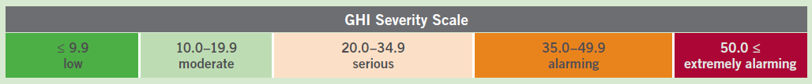
Scores among the 118 countries in the report varied widely. Scores of 9.9 or lower denote low hunger; scores between 35.0 and 49.9 denote alarming hunger. This year no countries hit the threshold of 50, which signifies extremely alarming hunger levels. Yet, it is impossible to know exactly how severe hunger is in some of the world’s poorest countries that lack GHI scores.
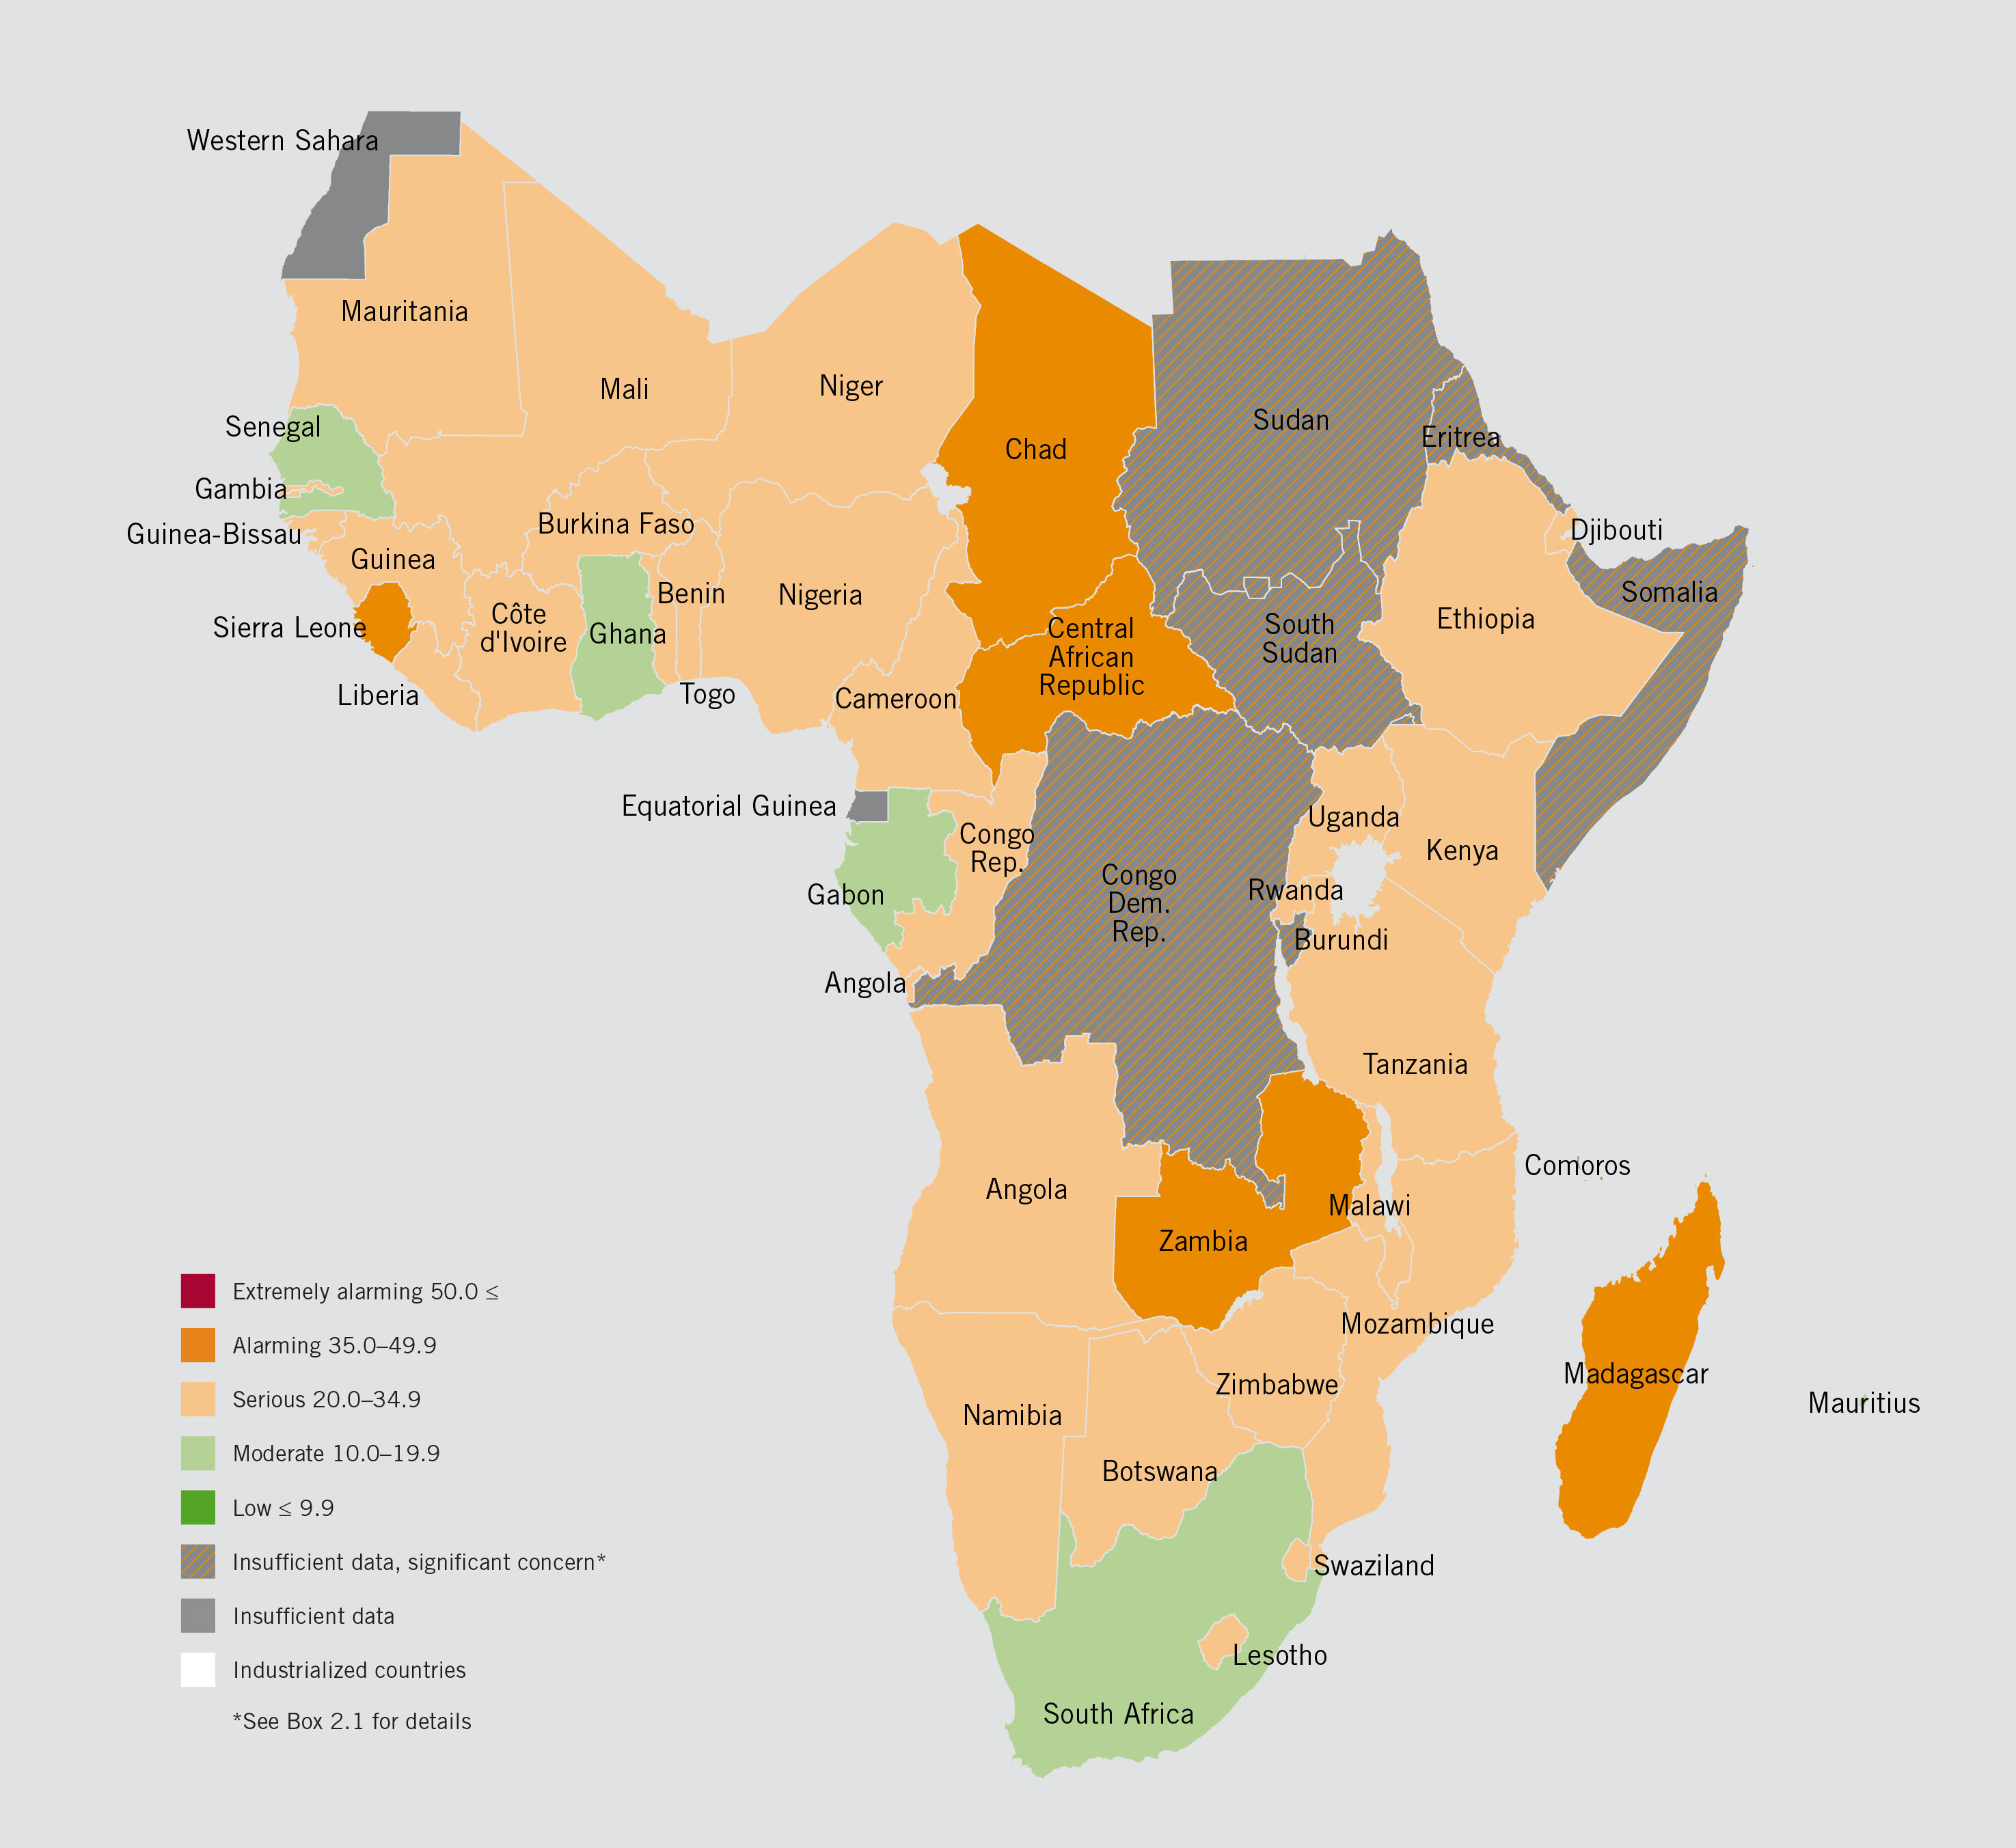
2016 GHI Scores in Africa
The countries in Africa South of the Sahara with the lowest hunger levels are: South Africa, Gabon, Mauritius and Ghana.
The countries in Africa South of the Sahara with the highest hunger levels are: Central African Republic, Chad, Zambia, Madagascar, and Sierra Leone.
These five countries are among only seven countries in the world that have “alarming” hunger levels based on their GHI scores. However, several countries have missing data.
Rwanda, Ghana, and Senegal have seen the biggest reductions in hunger in Africa since 2000, with GHI scores down by 50% or more.

- Africa South of the Sahara has a higher level of hunger than any other region on the planet.
- Thirteen countries in the report have insufficient data to calculate GHI scores, yet based on the existing data and reliable reports, 10 of these countries have hunger levels that are cause for significant concern. In Africa South of the Sahara these include: Burundi, Comoros, the Democratic Republic of Congo, Eritrea, Somalia, South Sudan, and Sudan.
- Regional GHI scores:
  - Africa South of the Sahara: 30.1
  - South Asia: 29.0
  - East & Southeast Asia: 12.8
  - Near East & North Africa: 11.7
  - Eastern Europe & Commonwealth of Independent States: 8.3
  - Latin America & Caribbean: 7.8
- Tremendous progress has been made toward eliminating global hunger. The level of hunger in developing countries has fallen by 29 percent since 2000.
  - The 2016 GHI score for the developing world is 21.3, which is still considered “serious.”
  - Twenty-two countries around the world—including Senegal, Ghana, and Rwanda—reduced their hunger scores by 50 percent or more relative to their 2000 GHI scores.
  - Globally, 70 countries made considerable progress with scores that dropped by between 25.0 percent and 49.9 percent relative to the 2000 GHI scores.
  - Despite the progress made, levels of hunger remain “serious” or “alarming” in 50 of the 118 countries with GHI scores.
- If Africa south of the Sahara and South Asia were to reduce their hunger levels between now and 2030 at their current pace, they would still have moderate to serious levels of hunger—falling far short of the goal to reach Zero Hunger by 2030.

Global Hunger Index Background
The 2016 Global Hunger Index (GHI) is calculated for 118 countries for which data are available for four indicators:
- the percentage of the population that is undernourished,
- the percentage of children under age five who suffer from wasting (low weight for height),
- the percentage of children under age five who suffer from stunting (low height for age), and
- the percentage of children who die before the age of five (child mortality).

How do you interpret a GHI score?
An increase in a country's GHI score indicates that the hunger situation is worsening, while a decrease in the score indicates improvement in the country's hunger situation.

Could GHI scores be calculated for all countries?
No, due to missing or unavailable data, GHI scores could not be calculated for all countries.

More information can be found at: http://www.ifpri.org/topic/global-hunger-index

