Risk Analysis Guidelines

Emergency Unit
September 2012

Secondary data collection
Preparation
Identification of hazards
Prioritisation
Mapping
Seasonality
Frequency and trends
Predicting future changes, unpredictability and the wider context
Root causes
Disaster impacts and who is vulnerable
Reasons for vulnerability
Institutional analysis and response capacity
Analysis and cross-checking
Risk informed planning

Above: a flow chart of the risk analysis process given in these guidelines. The green boxes indicate work that is done by the facilitation team; the brown boxes research and analysis work with the community (using PRA) and the blue box the planning stage (also to be done with the community).

Contents
1. Introduction 1
Purpose 1
2. Risk analysis and Disaster Risk Reduction 2
What is Risk Analysis? 2
Risk analysis as the foundation of Disaster Risk Reduction (DRR) 2
Different types of risk 3
Future unpredictability 3
Doing risk analysis at different levels 4
3. Secondary data collection 4
Types and sources of information 5
4. Planning and Preparation 6
5. Hazard Identification 7
Time taken: 7
Methodology: 7
Notes and comments: 8
6. Risk assessment 8
Key questions: 8
Time taken: 9
Methodology: 9
Key questions: 9
Notes and comments: 10
7. Splitting the group into sub-groups 11
8. Mapping 11
Time taken: 11
Methodology: 11
Notes and comments: 12
Key questions: 12
9. Seasonality 14
Time taken: 15
Methodology: 15
Key questions: 15
Notes and comments: 16
10. Trend and Frequency Analysis 18
Time taken: 18
Methodology: 18
Key questions: 19
Notes and comments: 20
11. Predicting future changes, unpredictability and the wider context 21
Time taken 21
Methodology: 21
Key questions: 21
Notes and comments: 22
12. Root Causes 22
Time taken: 22
Methodology: 22
Key questions: 23
Notes and comments: 24
13. Disaster impacts and who is vulnerable 24
Time taken: 24
Methodology: 25
Key Questions: 25
Notes and comments: 26
14. Reasons for vulnerability 27
Time taken: 27
Methodology: 27
Key Questions: 27
Notes and comments: 28
15. Institutional analysis and response capacity 29
Time taken: 29
Methodology: 29
Using colour, size and distance 29
An example 30
Notes and comments: 31
Key Questions: 31
16. Analysis and cross-checking 31
Methodology: 33
Notes and comments: 33
Key Questions: 33
17. Identifying solutions 34
Time taken: 34
Methodology: 34
Key Questions: 34
Notes and comments: 35
18. Risk informed planning 35
Time taken: 35
Methodology: 35
Key Questions: 35
Notes and comments: 36
19. Reporting and proposal writing 37

1. Introduction

Risk analysis (RA) is the starting point and the foundation of Disaster Risk Reduction (DRR). Without risk analysis it is impossible to undertake properly informed DRR interventions.

The paper “How Concern Understands Extreme Poverty” (2010) defines extreme poverty as having as a core dimension a lack of assets and/or the low return of these assets. The paper also suggests that poverty’s key causes include inequality and risk and vulnerability. As one of Concern’s approaches, DRR is crucial for assisting extremely poor people to reduce their vulnerability to shocks and stresses. All staff must therefore be familiar with risk analysis methodology.

In Concern’s current strategic plan (2011-2015), strategic objective 4 states that Concern will be “Consistently addressing the root causes of extreme poverty through programming and increased influence”. By 2015, all proposals will be based on our Contextual Analysis Guidelines (CAG) and have improved assets, reduced risk and vulnerability, and greater equality as outcome objectives.

Purpose
The purpose of these guidelines is to present a way of doing risk analysis with communities, by explaining a series of participatory methodology tools that can be applied when doing this. The guidelines have been designed to allow RA to be undertaken relatively quickly and efficiently, minimising the number of tools needed and ensuring that the process is easily accessible to staff and communities.

Taking into account that facilitators have different styles and participation ‘toolkits’, these guidelines can be used by experienced staff as examples of how participatory tools can be adapted to be used for a comprehensive risk analysis, or followed by staff who have less experience in the facilitation of PRA or PLA (Participatory Rural Appraisal or Participatory Learning and Action) methodologies. For every tool there are key questions which can be used as a checklist to ensure that the risk analysis is comprehensive.

These guidelines also advise Concern staff on how to collect a standardised information set that comprises the full risk analysis. Omitting parts of the risk analysis will lead to incomplete information gathering and potentially faulty decision making. Adding extra steps to the process may waste the time of both community members and staff. Analytical tables in the annexes provide a guiding framework for research, whereas the guidelines themselves explain the process of collecting and analysing that information.

While the information set needs to be as complete as possible, the process for gathering it outlined in this paper is expected to be adapted; if you have different or better ways of doing it, use them. However, please feedback to the Emergency Unit on what you do and how your way is better or different so that these guidelines can be updated and improved.

2. Risk analysis and Disaster Risk Reduction

What is Risk Analysis?
Risk analysis is the systematic gathering and analysis of information relating to the hazards that affect communities, their vulnerabilities to the impact of these hazards, and the capacities available to communities to reduce the frequency, scale, intensity or impact of these hazards.

Risk analysis is variously referred to as: Hazard, Vulnerability and Capacity Assessment (HVCA), Vulnerability and Capacity Assessment (VCA), or Community Risk Assessment (CRA), but they all mean roughly the same thing. In Concern it is usually referred to as risk and vulnerability analysis or simply Risk Analysis (RA), within which there are three components: hazards, vulnerability and capacity.

It is important to note that while there are three components to risk analysis, this is a conceptual distinction only. It is a mistake to do separate analyses of hazards, vulnerabilities and capacities – it would take too long and be repetitive. The key to speeding up the process, whilst retaining the richness of a comprehensive risk analysis, is to analyse each of the three components using the same tool, and doing this at the same time. The tools presented in these guidelines are widely familiar and commonly used. They are already used for all kinds of community research and programme development. A simple way of making risk analysis less onerous is to add in the analysis of risk (following the key questions in these guidelines) whenever these tools are being used for another purpose. In fact, not only will this speed up your risk analysis, but will make risk analysis a more systematically used process, which is exactly the point.

Risk analysis as the foundation of Disaster Risk Reduction (DRR)
DRR is the process of protecting the livelihoods and assets of communities and individuals from the impact of hazards.

The process starts with risk analysis. When risk is understood through the analysis of hazards, vulnerability and capacity, interventions can be undertaken that fall into the three following categories:

- Mitigation: reducing the frequency, scale, intensity and/or impacts of hazards and/or the vulnerability of the people exposed to them
- Preparedness: strengthening the capacity of communities to anticipate, cope with, respond to, and recover from hazards; when the communities’ capacities are overwhelmed, establish speedy and appropriate interventions by government, implementing partners and/or Concern
- Advocacy: favourably influencing the wider context (social, political, economic and environmental) that contributes to the causes and magnitude of hazards and disasters and their impacts

The end goal is of DRR interventions is to enhance the resilience of communities, helping them to ‘spring back’ from an adverse event (‘bounce back better’). In an increasingly unpredictable world, this includes and implies a measure of flexibility and adaptability.

Different types of risk
We all live with risk to one degree or other. We all accept a certain amount of risk, either because we are confident that we can manage it (low impact), or because we think that the likelihood of an event happening is low enough (low probability) that we are ‘willing to take the risk’. The threshold of acceptable risk is different for everyone and is entirely subjective. It is also influenced by a lack of knowledge (some people may not be aware of the risks they live with) or marginalisation (some people do not get the choice to live anywhere else other than in vulnerable areas). Within the limits imposed by their realities, our target beneficiaries should be allowed to make up their minds whether they accept certain risks or not – but should be informed by the extra information that we can bring to the discussion, and with the awareness that it may be possible for them to be assisted in managing the risks with which they have to live. Whilst there are undeniable benefits to doing participatory risk analysis, we must acknowledge that the community members do not know everything about their hazard environment, and it is therefore necessary for us to ‘fill in the gaps’ so that decision making can be properly informed. Even though these guidelines focus on participatory risk analysis, the importance of secondary data collection, and talking to scientists and other professionals, cannot be underestimated. We must help our beneficiaries and partners to be aware of the cyclical and regular nature of hazards that erode development gains and which, if left unaddressed, will result in unsustainable practise.

From Concern’s perspective, we take equally seriously both intensive and extensive risk. Although extensive risk often leads to limited or only localised loss of lives or assets, these losses may be a significant proportion of individual poor families’ assets. Because extensive risk events are so frequent, their compound effect can be considerable. The continual erosion of assets prevents wealth from being built up, and so significantly contributes to maintaining poverty and reversing development gains. All of the communities with which Concern works experience extensive risk; the same cannot be said for intensive risk.

Future unpredictability
A key part of risk analysis is identifying and anticipating trends of hazards and risk, and understanding how the wider context influences them. Hazard trends are influenced by many factors, including:

- migration and urbanisation (more than half the world’s population now live in urban areas, many of them in high risk areas; the rate of urbanisation often exceeds the rate of provision of essential services)
- increasing population
- absent, poor or unapplied policies, poor governance, instability and conflict
- global economic factors like international market stability and prices for staple foods and oil
- development choices and practices
- environmental degradation, in particular deforestation, unsustainable water management, soil erosion and desertification
- climate change

Concern works in many countries considered most vulnerable to climate change – poor, vulnerable and less resilient countries which, although they contribute the least to the causes of climate change, are the ones likely to be most affected by it. These countries must learn to adapt to a changing environment.

Climate change adaptation is easily integrated into Concern’s DRR framework, and analysed as part of the risk analysis process. These guidelines explain how to do that, identifying what is predicted and what future uncertainty exists, leading communities towards the realisation that adaptability and flexibility are key parts of community resilience.

Doing risk analysis at different levels
Risk analysis is conceptually the same regardless of the level that it is done at: an entire population (national level); areas within a country (regional / district / provincial risk assessments); in the specific communities where we have programmes; at the level of individual installations (such as defining the risks pertinent to a water supply scheme); or even at a micro level of the risk context of an individual field. Risk analysis can also be applied to our activities, and the risks that we impose on our beneficiaries, or the risks we impose on ourselves in the course of our work.

All of these different levels of risk analysis use the same basic key questions, which are given in annex 6, although the methodology one would use to ask the questions may differ. To help guide the compilation and analysis of the answers to these questions, analytical frameworks have been developed. Filling out the frameworks will provide us with enough information to make decisions on what we can do about it – the planning and implementation of risk reduction measures.

3. Secondary data collection

It is likely that a significant amount of information has already been collected by other NGOs, local government, regional or national government, disaster management committees, the UN (often OCHA or UNDP), etc. To save time for yourself and the community, try to get as much information as you can in advance. Be guided by the key questions in annex 6.

Bear in mind that there may be some information you can get from these secondary sources that the beneficiary communities may be unaware of – for example seismic scientists are aware of the earthquake risks in Bangladesh, but many of the people are not. Similarly, HIV professionals may have statistics on HIV incidence of which the wider population may be unaware.

In many of our countries of operation, the government will be implementing activities associated with their commitments to the Hyogo Framework for Action. Information in relation to this work may be available locally or on the UNISDR website (see box below for details).

We have a responsibility to share and analyse this type of external information with the vulnerable populations, so we need to be able to understand it and translate it into a format that our target groups can understand, which is related to the education levels of the people we are working with. If you aim your explanations at the people who have benefitted least from formal education, you should not assume that they understand scientific concepts, so remove all the jargon, use pictures and spoken explanations, encourage them to ask for clarification on any point, and be patient. Some people in Nepal do not understand a graph, so attempts to explain trends in disasters using a graph failed. It could be a good idea to ask for help from school teachers who have experience in explaining complex subjects to people who have never encountered them before.

4. Planning and Preparation

Types and sources of information
- Hazards information: types, frequencies, intensities, etc.
  - www.preventionweb.net – country profiles for all natural disasters, data from the em-dat database by CRED (Centre for Research into the Epidemiology of Disasters), which collects data on worldwide natural disasters that affect more than 100 or kill more than 10 people
  - UNOCHA and/or UNDP
- Hyogo Framework for Action (HFA) progress, policies and hazard-related information
  - national platform for DRR in your country
  - www.unisdr.org – the website of the UN International Strategy for Disaster Reduction
- Health statistics – mortality and morbidity per disease, HIV&AIDS prevalence, capacity for response, locations of health centres, etc.
  - Ministry of Health
  - WHO and their country profiles at http://www.who.int/countries/
  - UNAIDS
  - national platform for HIV in your country
  - NGOs working in the health / HIV sectors
- Statistics on livelihoods, hunger, migration, etc.
  - WFP (especially the VAM unit)
  - FEWSnet (famine early warning system) for some countries: http://www.fews.net/
  - Relevant line ministries
  - other NGOs
  - UNOCHA and IOM
  - UNHCR - http://www.unhcr.org/ has statistics on refugees and displaced populations
- Economic data and other statistics
  - national statistics department
  - UNDP
  - UNOCHA
  - other NGOs
- Climate change predictions and impacts
  - http://daraint.org/climate-vulnerability-monitor/ - assessment of vulnerability to climate change according to impacts in weather related disasters, habitat, health and economic productivity
  - http://sdwebx.worldbank.org/climateportal/ - this is the World Bank portal for climate change predictions and impact
  - http://gain.globalai.org/ - global adaptation index which also indexes climate change exposure and vulnerability
  - http://www.vulnerabilityindex.net/ - the environmental vulnerability index (EVI)
  - http://country-profiles.geog.ox.ac.uk/ - University of Oxford’s country profiles for climate change.
- Response capacity, geographical and sectoral emergency response coverage, DRR interventions, etc.
  - UNOCHA (who, what, where)
  - NGO coordination fora
- General information pertaining to the humanitarian and development community
  - http://www.trust.org/alertnet/ - Reuters news articles
  - http://reliefweb.int/ - news, country profiles, etc.
  - http://www.eldis.org/ - country profiles, articles and much more

- Where are you going to do risk analysis? This depends on the ‘level’ you are doing it at and the objectives of the programme you are working on:
  - Strategic planning external analysis: you will not do community research. Only secondary data collection and analysis is needed for this.
- Contextual analysis (prior to programme design): you will want to do some PRA to get a clear idea of the risks that the communities you want to work with face, but you will not have the time to do it everywhere. Based on your secondary information collection, divide your research area into sectors based on risk (e.g. high, medium and low risk areas; or flood or landslide risk areas, etc.), and randomly select a number of communities for risk analysis. You will need to explain carefully why you are doing the risk analysis so you do not build up expectations. You will not need to do the planning steps.
- Programme design: You will need some deeper analysis of risk and how it informs the programme (for example risk factors that prevent children from attending school, those that affect agricultural productivity or disease incidence, etc.) as well as how the programme (and your activities) imposes risks on your beneficiaries. For this deeper analysis you should select focus groups to do the analysis with (e.g. school management committees, health volunteers, farmers, etc.).
- Stand-alone DRR programmes, projects or interventions: It is likely that you will be supporting disaster risk management (DRM) committees to do risk analysis in all of the programme communities. You will also need to do the planning steps which will lead to community implementation of DRR measures. It may be necessary to prioritise the most risk prone communities first (which you should be able to partially pre-determine from your secondary information).
- Risk analysis for specific interventions: If you are installing a water supply scheme, building a school/health centre, opening a new Concern office, or starting a farmer field school, these sites need to be analysed for risk as well. You will not need to go through all of the steps of the risk analysis process, but you will need to do the hazard analysis, so that you can design your installation or intervention accordingly - such as earthquake proofing schools or making wells useable during floods.

- Who you do risk analysis with. This is related to the above points, but in general it is a good idea to get a good cross-section of the community together, as many different perspectives are useful, and necessary for the planning steps. However, the benefits of having many perspectives have to be weighed up against the difficulty of facilitating large groups of people. As a rule of thumb, the maximum size of a group should not exceed 30 people.
- If there is a DRM committee in the community, you must include some of its members.
- If there is no DRM committee, you may want to establish one first, train them in risk analysis and get them to do it. In establishing a DRM committee, ensure broad representation - do not forget to include:
    - community leaders, elders, community-respected people like teachers or health staff, etc.
    - Representatives of different social groups: ensure that some of the participants are from the extreme poor. Also consider other groups if there are a mix of tribes, castes, ethnic groups, etc.
    - Be as gender and age sensitive as possible – ensure there are a significant number of women, older people (they have the historical perspective that is necessary) and youths (they have the strength to implement plans, and they can also learn from the process).
    - Representative of different geographical areas of a community (which also depends on the size of the community your risk analysis is considering).

  - When, where and for how long will you conduct your meetings?
  - You will need to arrange in advance the time and date of your community meeting(s), and ensure that the people you want to meet are invited. Select an appropriate time of day to hold the meetings, which fits in with your security restrictions (taking into account travel time) and the community’s daily activities. This could be handled by one of the field staff.
  - Select a suitable venue for the meetings – this could be in a community hall or under a shady tree – as long as it is relatively quiet and comfortable. You will be running up to three group activities simultaneously, so there needs to be enough space to do this.
  - You will need to have more than one meeting in each community. The process outlined in this guide would take at least 15 hours in total (12 hours for the analysis and a further three hours for the planning steps). At the very least, therefore, this is a three day process; if the community have other things to do and cannot spare that much time for you, it may consume more than three days.

- Methodology
- What are the steps and key questions (per session – see the following sections in this guide)?
- What PRA tools are you going to use (the following sections of this manual explain a number of tools)?
- What materials will you need (see annex 5 for a list of materials you may need)?
- Who will be on your facilitation team? There are parts of this methodology that need three facilitators working simultaneously, and many sessions that are done in women’s and men’s groups. Therefore you will need at least three facilitators, one of whom must be female to talk specifically to women’s groups. You may also need a translator.

For a short discussion on participatory methods, see annex 4.

5. Hazard Identification

Time taken:
About 30 minutes.

Methodology:
Do this with all the participants in a big group or, alternatively, split into two groups, one for natural hazards and one for human-derived hazards.

Step 1: Define what a hazard is in as simple a way as possible. Do not overwhelm participants or the translator with too much jargon. If you are going to split them into sub-groups, make sure they understand the meanings of each category. Each sub-group needs a facilitator.

Key questions:
- What hazards occur in your area?
- What about ...? {diseases, conflict, etc.}
- What are the obstacles that are preventing you from realising your goals?
- Are there any policies from the government that result in damage to your livelihoods?
- Have there been any negative consequences arising from recent infrastructure developments in the area?
- Are there any traditional practises that can cause damage, loss of life or injury?
- Are there any hazards that affect your crops, livestock or infrastructure?
- Is there anything that can reduce your ability to earn money or get enough food to eat (inflation, price rises, etc.)?

Step 2: Identify hazards – just list them out. Make sure they capture all aspects of both natural and human-derived hazards (see annex 2).

Step 3: Ask someone to write or draw the hazards onto pieces of paper (one hazard per piece of paper), or in the sand, separated out so that they can be used for the next session. Try to avoid doing this yourself, it is better to get someone from the community to do it (if writing is being used, make sure the illiterate people know what gets written).

For your own reporting and information collection, take photos of what they do.

Notes and comments:
It might be difficult to get some stigmatised hazards identified, and you may not want to ask about GBV, marginalisation, or HIV in a public forum like this. If that is the case, wait for a focus group discussion and have your female facilitator ask the women, or ask the ethnic minority group separately. If you have already collected some information on these subjects from other sources or organisations, you can share this information as a way of bringing some topics out into the open, but use your judgement as to whether you can do so.

If the participants do not identify a hazard which you think is present, ask them what they think about it. They may have forgotten to consider it, or they may not know of it.

Allow them to interpret your questions on hazards as they wish. Participants may list hunger, unemployment and child labour as hazards. Are they hazards or consequences of something else? Does it really matter? What is important is to start to see the world through the community’s eyes; and to analyse and understand the causes and effects of the hazards, however they are expressed. The issues they raise will get ‘unpacked’ in further sessions, so that they can come to an understanding of the underlying causes of the issues they raise, some of which will be hazards as we understand them (which will get further unpacked.)

6. Risk assessment

In an ideal world, where everyone has an abundance of time, you could do the analysis of each hazard and then, far more accurately, assess the risk of each hazard. However, the world is not ideal – as facilitators you have much else to do, and the participants are also busy, so we cannot ask them to spend days doing risk analysis. Therefore we do the risk assessment near the beginning of the process, so we can prioritise which hazards to analyse in detail.

Time taken:
40 mins. - 1 hour (depending on the number of participants).

Methodology:
Step 1: Split the group into men and women and do the same thing with each group.

The name of this tool is proportional piling.

Risk is the magnitude of impacts of a hazard and the probability of it happening in a given time frame. It is often expressed as a formula risk = impact x probability. This tool aims to determine these two characteristics, which can be combined to form an assessment of risk.

Step 2: Present the hazards (identified in the previous session and written on pieces of paper or drawn into the sand) on the ground with enough space between them for people to move around them.

Step 3: Ask each participant to collect some stones (or seeds, beans, bits of stick, etc.). The number of stones collected should be the same as the number of hazards (so if 10 hazards are identified, they collect 10 stones each).

Key questions:
- Which of these hazards has the greatest magnitude of impact?
- Does this hazard have greater impacts than {another hazard}, or less? (People find it helpful, when ranking, to compare one thing against another.)

From step 7 onwards:
- Which of these hazards has the greatest probability of occurring?
- Is this hazard more probable than that one?
- Which hazards can happen every year? Which hazards can happen more than once a year?
- Which hazards are increasing (or decreasing) in frequency?
- Is the risk of this hazard something you can live with, or do you want to do something about it?
- Do you need to do something about this now or are there other risks that are more important and should be addressed first?
Step 4: Ask them to rank the hazards according to impact (if they think each hazard has the same magnitude of impacts they would put one stone on each, but if they put several stones on one hazard, indicating it has a higher magnitude of impact, they would not be putting any stones on some of the other hazards). Everybody does this; the combination of many people answering the question provides a fairly accurate assessment – and several people can be putting their stones down concurrently, to save time.

Step 5: When everyone has had their turn, count up the stones per hazard, and write the numbers on the pieces of paper with the hazard written on it. Immediately you can see which hazards have the greatest magnitude of impact.

Step 6: Ask everyone to collect up their stones again.

Step 7: Repeat the ranking, but this time you are ranking according to probability in a given time frame. The time frame is up to you – I normally say ‘in the next five years’ (any more than that and the discussion starts getting theoretical and academic). Bear in mind that some hazards will therefore have a 100% probability of occurring, and so participants should be putting many of their stones on these hazards. This is important information - these hazards are extensive risk.

Probability vs. Frequency
Probability: advantages
- Infrequent hazards like earthquakes may be predicted to happen once in many years. Their frequency is, therefore, very low. However, if the seismic cycle has been exceeded, the probability of an earthquake happening would be very high; using probability would indicate whether some hazards are ‘expected’ even if their frequency is low, and thus need to be prioritised.

Frequency: advantages
- Hazards that happen every year or every couple of years would all have a 100% probability of occurring in a five year cycle, so they become harder to compare if you use probability, but with frequency you can immediately see which hazard occurs more often.

You can, if you want, rank according to frequency instead of probability. See text box for the advantages of each.

Step 8: Add up the probability scores and write them onto the pieces of paper (in a different colour).

Step 9: Ideally, you plot the scores on the risk assessment chart (see annex 7) but you may feel this is alienating to some participants – especially those who have not been to school. If the education level of the group is such that they would understand a graph, then use the chart. If not, then another simple way to end up with a ranked list is simply to add the impact and probability scores together.

The problem with adding is that it does not shed light on what is extensive risk (low magnitude of impact but very probable or frequent – certainly happening every year and often more than once). If you are adding the scores then make sure you pay particular attention to those which are high probability in the analysis discussion – these need to be analysed further.

Step 10: Use the final risk-ranked list to prioritise which hazards to look into in detail. The decision about which hazards to focus on for further analysis is for the community to decide; but the facilitator has a responsibility to bring in his/her ‘extra’ knowledge from the secondary data collection, or regarding our position on extensive risk. This is a tricky point, as we should allow the communities make up their own minds, but if you are convinced that a hazard needs to be addressed, and the community are not prioritising it, you need to state your case so that their final decision is an informed one.

Help the participants realise that if they decide to include a hazard it is because they feel something should be done about it – the risk is unacceptable and so needs to be controlled. If they do not include a hazard it is because they feel the risk is acceptable and so can be left (for now) (see the final two questions in the key questions box).

At the end you will have two lists – priorities for women and priorities for men. All priority hazards will now be analysed in greater detail.

Notes and comments:
Do not forget that from Concern’s perspective, we need to look carefully at BOTH intensive risks (large scale events in areas of dense population or economic activity, usually high impact events) and extensive risks (low to medium impact, very high frequency). From our perspective, those on the right hand side of the risk assessment chart get chosen automatically, and the discussion is whether to include risks which are high impact low probability or not.

Getting the list of priority hazards from both men and women is important knowledge for understanding vulnerability – hazards affect different people in different ways, and in a big group the priorities of the more marginalised group (women) can often be overlooked.

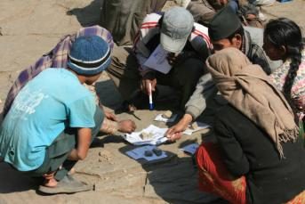
The photo shows ranking hazards according to probability and magnitude of impacts in Daha, Nepal, 2009 (photo by Dom Hunt). Risk was determined by adding up the points:
- landslides; 100 points
- drought and fire; both with 51 points
- corruption; 48 points
- deforestation; 46 points
- hail; 42 points
- HIV&AIDS; 25 points
- diarrhoea; 24 points
- politics; 19 points
- rabies; 17 points
- foot and mouth disease and cholera; both with 9 points

7. Splitting the group into sub-groups

The next three tools – mapping, seasonal calendars, and historical time lines – can be undertaken concurrently to save time. Therefore we need to split the group into three. For these tools it is good to ensure each small group has representatives of all the different social groups that you have among your participants, in particular that there is a relatively good balance of men and women.

8. Mapping

Time taken:
About 1 hour.

Methodology:
Do this with one of the three sub groups (see above).

Step 1: Explain that they are to make a map of their community lands which shows:
- key features like roads, rivers, built-up areas, shopping areas (urban), forest patches, agricultural areas, grazing areas, etc.
- where the priority hazards occur (note that some hazards can occur everywhere, but their effects can be more pronounced in some places – drought would have the greatest impact on rain-fed agricultural land and less impact on irrigated land unless the irrigation source dries up too)
- where the hazards originate from (if relevant – such as for floods or wild fires, for example)
- where the areas of highest risk are (an entire river valley can flood, but the areas of highest risk are where there are settlements or fields)
- where certain key buildings are that can be used in times of disaster (e.g. health centres, schools, shelters, food stores, shops, etc.)
- where useful resources are for use either in times of disaster or for reducing risk (building supplies, wild foods, etc.)

Step 2: Have the participants start the map using sticks, stones, seeds, leaves, sand, etc., placed on the ground (a ‘mud map’); do not let them immediately draw the map onto paper with a pen. This is because mistakes will be made – if the mistakes are made on paper they are indelible so it is preferred to make a ‘mud map’ where the materials used to build it can be moved around. Take notes on what people say and the stories they relate while they explain the features in their map.

Step 3: When the ‘mud map’ is completed, present it to members of the other two groups and allow them to discuss it and add to it if needs be. When they are finished, take a photograph of the map.

Key questions:
On basic geographical features:
- Where does the sun rise from (to determine the orientation of the map)?
- Where is the road we came in on? Where are we now (to establish a starting point)?
- Where are the ...? {community fields, grazing lands, water points, homes, forest resources, etc.}

On hazards, risks and vulnerability:
- Where are the risk areas for {hazard name}? Where does it {hazard name} come from?
- Who is most vulnerable to this hazard? Where are they living? Which livelihood(s) are most vulnerable to this hazard?
- Where are the camps of the military forces, and their territory (if appropriate)? Where are the areas of conflict? Note: be careful asking these questions – this information may be considered sensitive.

On capacity:
- What buildings can you use for shelter in times of disaster?
- Where is the {health centre, community hall, stores, shops, safe areas for people and animals, fire fighting equipment, etc.}?
- Do you have evacuation routes? Where are they? If not, which routes are safest to get to the safe zones? These may differ depending on the hazard.
- Which roads stay open all year round, and which ones can get cut off, and why?
- Where are the communications points (telephones, radios, TV, etc.)?
- Where is the police post? Fire station? Military camp (unless you feel this is sensitive)?
- Where would you go in times of displacement?
- What alternative foods can you eat in times of hunger / disaster / displacement?
- Do you know if any buildings are earthquake proof? Which ones?
- Where do you keep your {search and rescue equipment, first aid kits, emergency food stores, etc.}?

Notes and comments:
As you can see from the questions in the box above, this tool kills four birds with one stone – it is a resource map, a risk map, it starts to identify who or what is vulnerable to the different hazards, and is a capacity map - all in one.

We may need to return to the map when we talk about climate change – there may be some areas in the map that are more vulnerable to the effects of climate change than others (for example rain-fed agricultural areas, low-lying coastal zones, settlements at the mouth of a river, or buildings on steep slopes, etc.). We will also need to return to the map to collate who is vulnerable, combining this information with information from other tools.

If they want to transcribe the map onto a piece of paper (or a sheet) they can, but this takes time, so perhaps it is best left until later, and they can do it in their own time. If they do, they can keep the map for future use, we will just have a photograph of their map.
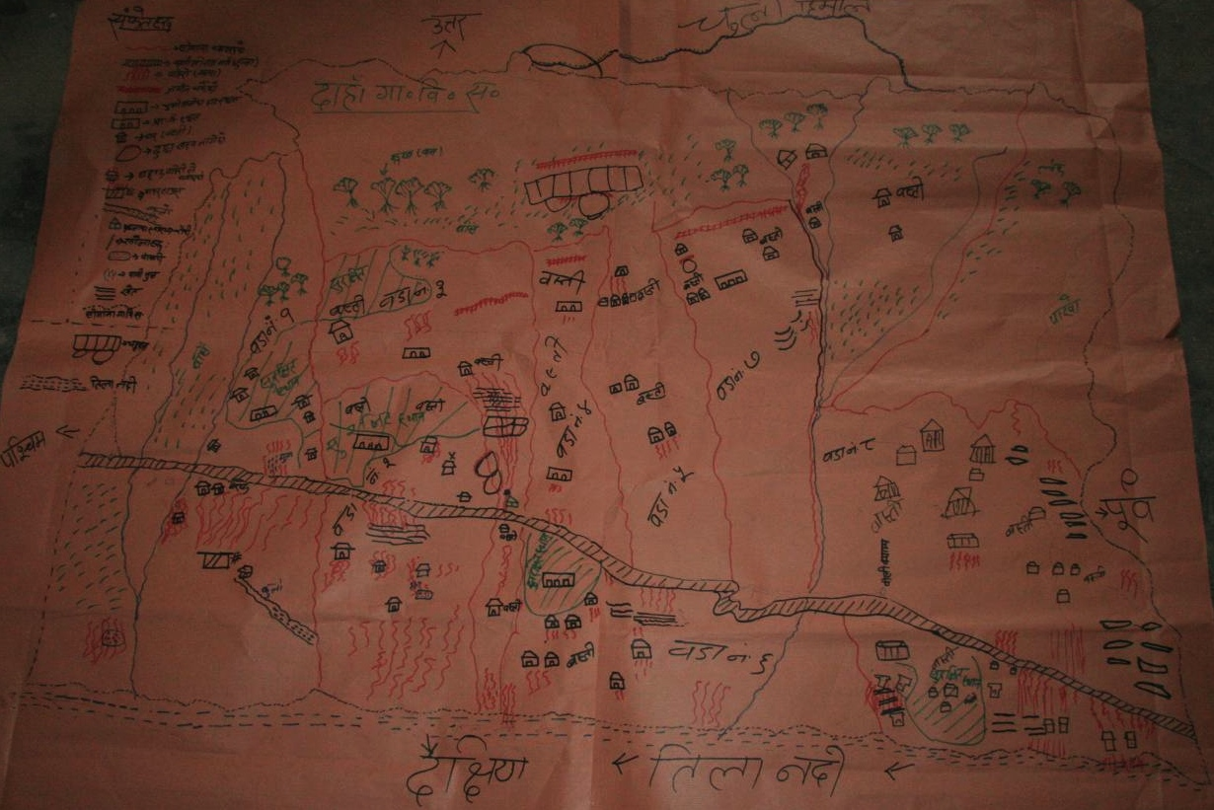
Risk map of Daha, Nepal, showing community features, risk areas (in red) and resources available to address risk (school, health centre, offices, communications, infrastructure, fields, forest, etc.). Photo by Dom Hunt, March 2009.
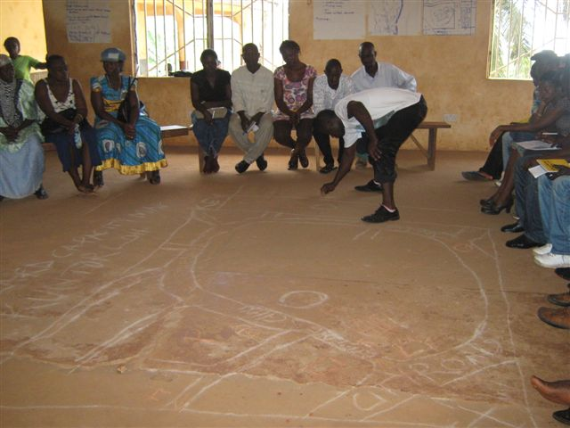
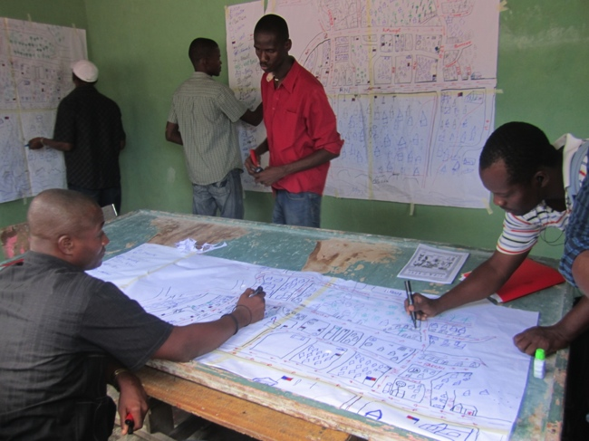
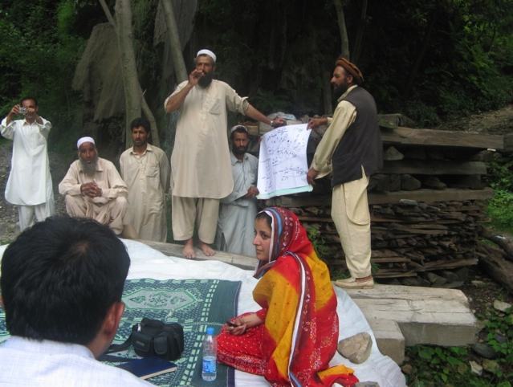
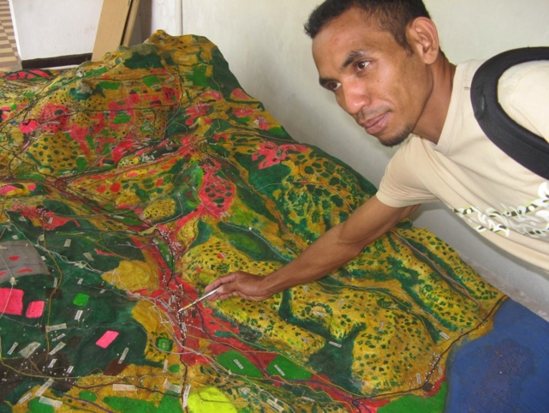
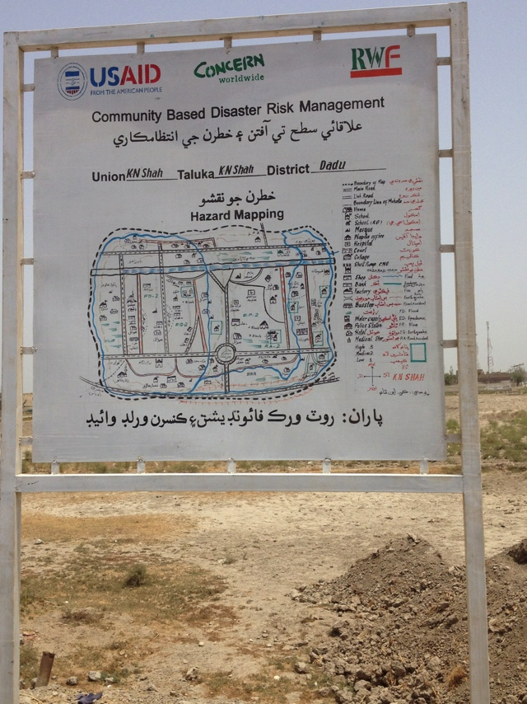
Photos on this page:
Top left: Making a risk map, Dwazack, Sierra Leone. Photo by Sheku Kanneh, July 2011.

Top right: Putting detail on the map, Port-au-Prince, Haiti. Photo by Ando Ratsim, 2012.

Middle left: Showing the map to others, Kashmir. Photo by Peter Crichton, May 2007.

Middle right: Looking at high risk areas in a 3-D map, Lautem, Timor Leste. Photo by Peter Crichton, 2008.

Bottom: Risk map in full view in the middle of a community, Dadu, Sindh, Pakistan. Photo by Syed Sulaiman, 2011.
Photos on this page:
Top: starting the mapping process, Kroo Bay, Freetown, Sierra Leone. Photo by Sheku Kanneh, 2011.

Middle: pointing out features on a 3D map, Lautem, Timor Leste. Photo by Peter Crichton, 2008.

Bottom: sharing salient features on a map to others in the community, Kashmir. Photo by Peter Crichton, 2007.

9. Seasonality

Time taken:
About 1 hour.

Methodology:
Do this with one of the three sub groups (see above).

Key questions:
On seasons:
- When does the rain start falling, and when does it end?
- When is there the most rainfall? When do you get storms?
- When is the period of {greatest heat/coldness, new growth, leaf fall, etc.}?

On agriculture:
- What are the planting times of the main crops (and what are they)? Vegetables?
- When are the harvesting times of these crops? Fruit? Non-timber forest products? Wild foods? (Note: this may not be important in an urban setting, but availability of food stuffs and their prices will certainly have seasonal variations even in well-connected urban contexts)
- When are the prices for these products high and low in the market? In which months do you store food products, and when do these stocks run out?
- When do your livestock give birth?

On society:
- What are the main community festivals and gatherings, and when are they? Community meetings? Government meetings and events?
- When are the school holidays?

On hazards and vulnerability:
- When are you most likely to experience {hazard name}? When are the intensities the greatest?
- Who or which livelihoods are most vulnerable to this hazard?
- Within those groups, who are most vulnerable (men or women, elderly or young, etc.)?

On capacity:
- Do you do any preparation for these disasters? What do you do and when? (this could be doing simulations, collecting reserve food stocks, building up house protection mechanisms, repairing fences, etc.)

The tool to use for this is the seasonal calendar.

Step 1: Explain to them that they will build a calendar which shows:
- the key seasons and the intensity/extremes of temperature or rainfall
- the agricultural calendar – planting and harvesting times of the main crops
- community activities like key festivals, school times, etc.
- when the priority hazards are likely to happen (If relevant – some hazards, like earthquakes, do not have seasons, but most do)
- the times when the most intense events are likely to happen (this is often the case with weather related phenomena like storms – they can happen over a period of a few months but the most intense ones happen in a shorter period. Conflict often also has seasons)
- when to store food, do preparedness training, simulations and drills and any other mitigation or preparedness activity

Step 2: Always start with the seasons as almost all other activities happen in relation to them, so they become the reference for the rest of the calendar and are more accurate than using the names of the months. It is important for them to be able to describe to you what they consider to be ‘normal’ weather (so we can track when weather has not been ‘normal’ as part of the climate change analysis).

Ask them to draw a line that represents a year, and then mark in the seasons. Using this as a baseline, ask them to indicate when different events happen. Each different activity that is being mapped onto the calendar should have a separate line for clarity.

Make sure that intensity captured – for example rain can fall over several months but at some points it is heavier than at others. Similarly, pest infestations or diseases can peak at certain times of the year.

Step 3: Take notes on what people say and the stories they relate while they explain the features in their calendar. Especially important is to capture their stories regarding how they prepare themselves for the disaster season, and how they cope when disasters strike. Also, be sure to ask questions about who is vulnerable: some livelihoods are more vulnerable to seasons, seasonal hazards and variability than others. This is also true in an urban context, where traders would rely on seasonal produce, for example.

Step 4: When the calendar is done, present it to members of the other two groups and allow them to discuss it and add to it if needs be. When they are finished, take a photograph of the calendar.

Notes and comments:
As with the mapping, this tool kills several birds with one stone: analysing seasonality of community activities and agriculture, when hazards happen, which livelihoods and who is vulnerable to the hazards, and preparedness (capacity) steps that are in place in relation to these.

From the perspective of DRR, the seasonal calendar allows us to anticipate disasters, which means it is an important tool for preparedness and the establishment of early warning systems; furthermore, it allows us to plan preparedness and mitigation before the disaster season, and to time interventions to ensure that they do not coincide with when the community is most busy (for example field clearance, planting, harvest or community festivals). In Angola it helped us shape our intervention, because it became clear that the peak agricultural season coincided with the peak malaria season. A proposed agricultural diversity programme would never have its desired impact unless malaria was also addressed.

We will need to come back to the seasonal calendar when we look at climate change, as climate change makes seasonal patterns increasingly unpredictable. We need to understand when this variability is and what it affects.
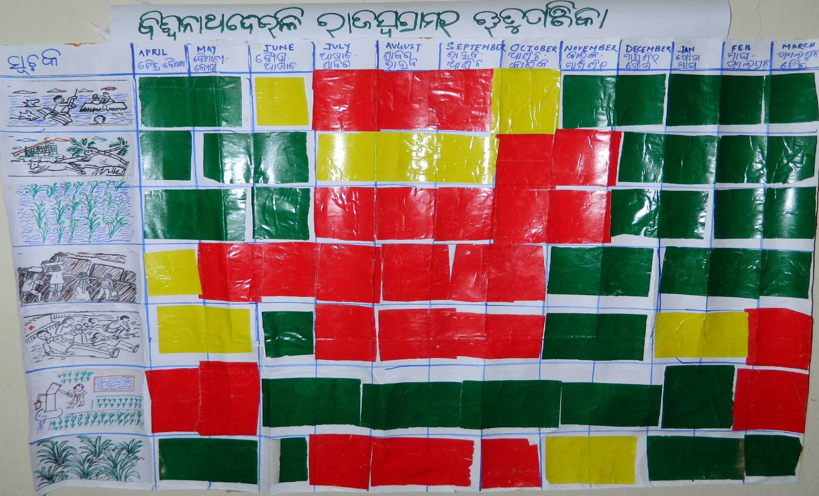
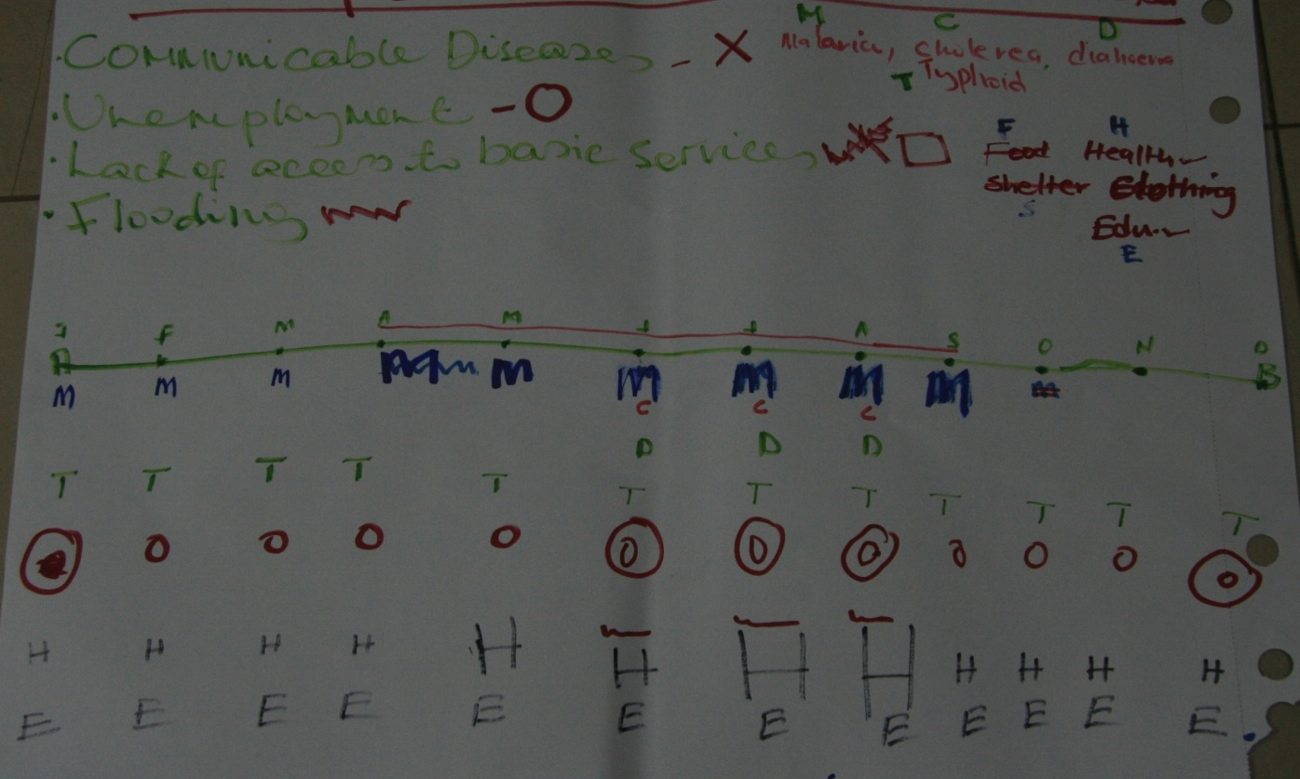
A seasonal calendar from Freetown, Sierra Leone. The rainy season is also the period for malaria, cholera, diarrhoea, unemployment and lack of access to health services. Photo by Dom Hunt, May 2011.
A seasonal calendar from Biswanathdeuli, India. July to November sees floods, cyclones, crop damage, displacement, injuries and pest infestations; March to May sees drought. Photo by Chiranjeet Das, 2011.

10. Trend and Frequency Analysis

Time taken:
About 1 hour.

Methodology:
Do this with one of the three sub groups (see above).

The tool we will use is the historical timeline.

Step 1: Draw a long line in the ground and indicate which end is ‘now’ and which end is ‘some time in the past’. Exactly when in the past is up to the age of the participants. You could say ‘when the eldest here was a youngster’ – in other words between 30 and 60 years ago. It is good to have elders in this session as they have the memory of what things used to be like, and how things have changed.

Step 2: While people may have decent memories, it is often the case that they can remember the event but not the year. However, if they can remember one event happening around the same time as another it is quite easy to get the chronology correct, and even put dates on events; so we need to start by establishing some ‘reference events’.

Explain that you want them to indicate the main events that have happened to their community in that timeframe. Start by creating a number of reference points on the timeline by asking about well-known events (that could be, but are not necessarily, disaster events) and proceed from there, for example:
- start / end of a conflict
- key political or regime changes
- major disaster event

These events can be written down on pieces of paper and placed at the appropriate point on the timeline, or drawn on the ground. For extra clarity, it is better that several lines be established using the same time scale – a different line could be done for each hazard, contributing factors and other events.

There may be some hazards that do not really happen in one event, but whose incidence tends to spike (for example water borne or crop diseases and other forms of extensive risk). Indicate the fluctuations of incidence (perhaps with a wavy line).

Step 3: Once each priority hazard has been mapped onto the timeline, ask questions about the severity of each event and have someone record this information (for example, if it was a flood, ask someone to show you the high water mark, or if it was an earthquake, how many buildings were damaged, if you are dealing with conflict, when was the conflict most intense in this area and how many people were affected?).

You may find that they have only mapped the most extreme events. If so, ask them to also indicate the lesser events, and how intense they were, until you have mapped the frequency of events for each hazard.

Step 4: Discuss the results with the group until you build up a picture of the frequency of events that everyone can agree on (e.g. big floods happen roughly every 15 years, medium floods every three years; cholera outbreaks every 15 years or whenever there is a big flood; the last earthquake was two years ago and prior to that before any of us were alive).

Key questions:
Regarding past disaster events, their intensity and frequency:
- When did the last {hazard name} happen? When before that?
- How big was this {hazard name} event? Were there also {hazard name} events that happened but were not as big? When?
- Who lost (or suffered) the most in this {hazard name} event? Were they the same people who suffered most in previous events of the same type?
- How often do these events happen? Are any of them changing in frequency? In what way?
- Why do you think this is changing in frequency; what else has changed?

Regarding specific events, focusing on their past experience, vulnerabilities and capacities:
- Did you get any warning that it was coming? From where and how long a warning did you get? What did you do in response to that warning?
- How did you survive the {hazard}, or cope with the effects of it? How did you help save others?
- Who suffered most in this event? Why? Why was it different to how much other people suffered?
- Did anyone help you to respond to this event? Who and how?
- What happened afterwards? How did you get back to where you are now? How long did it take to...? {rebuild your houses, recover your livestock, re-start schools, return from displacement, etc.}

Regarding trends and the wider context:
- Have weather patterns changed, and in what way (in terms of quantity, timing and distribution of rainfall, and temperature)?
- What have these changes meant for...? {agricultural production, access to water, wildlife, wild foods, pests, etc.} Who has been most vulnerable to these changes?
- What have been the changes in what the government says or does regarding disasters or your livelihoods? How?
- How have the costs of basic commodities changed? How has the value of money changed? Who has been most vulnerable to these changes?
- Has the population of this community changed in this period? If so, has it increased or decreased? If it has increased, how do you manage to feed more mouths? Who have been struggling to keep up with demand? Why?
- Do people migrate, either seasonally or permanently? Where do they go, who migrates, and why? Is the amount of migration changing in recent times, and if so, how?
- How has access to services changed in this time period (schools, health centres, access to information, roads, markets, stores, agricultural inputs, etc.)? Has anyone missed out on these? Why?
- Have there been any changes in the amount of natural resources in your area (forest, fish, wildlife and wild foods, water, etc.)? If they have changed, why? Has the rate of exploitation increased or decreased? Who is vulnerable to decreasing access to natural resources?

Step 5: Ask participants what they did to survive the large disaster events, what happened, whether they had any warning and how much time were they given, who helped them to respond and survive the event and how they recovered afterwards (including how long it took and who helped). Their answers can also be put into the timeline (before an event, during and afterwards, either in a timeline of their own or in the relevant hazard time line).

Step 6: At the same time you can ask who was most vulnerable – who paid the biggest price in past disasters, and start to determine why some people are more vulnerable than others

Step 7: You may have noticed that some events are increasing or decreasing in frequency in recent years. This is important and must be noted (e.g. extreme floods used to occur every 15 years but in recent times are happening every five years, etc.). Go through all of the hazards and see if there are any trends that can be noted, and have a discussion as to why this might be. Based on their answers, start recording the contributing factors as well; each factor can have its own timeline - for example:
- Climate variability, when weather departs from what is considered ‘normal’. In rural communities this is often marked by departures from the normal planting time, but can also be marked by increasing or decreasing numbers of extreme temperature events, unpredictable rainfall patterns (like storms occurring outside of the expected months, or changes in distribution of rainfall), or changes in productivity of crops linked to factors such as disease, etc.
- Trends in population growth and movements – seasonal or permanent migration, urban drift, etc.
- Trends in the political context and the stability of the country.
- Trends in development such as provision of health services, education, the rule of law, infrastructure, markets, irrigation, factories, etc.
- Economic trends such as increases in commodity prices.
- Environmental trends such as deforestation, desertification, quantity of groundwater, etc.

See if there are any obvious links between hazard trends and contributing factors – for example there may be an increase in floods at the same time as an increase in deforestation, or there may be a link between disease outbreaks and reduced health provision.

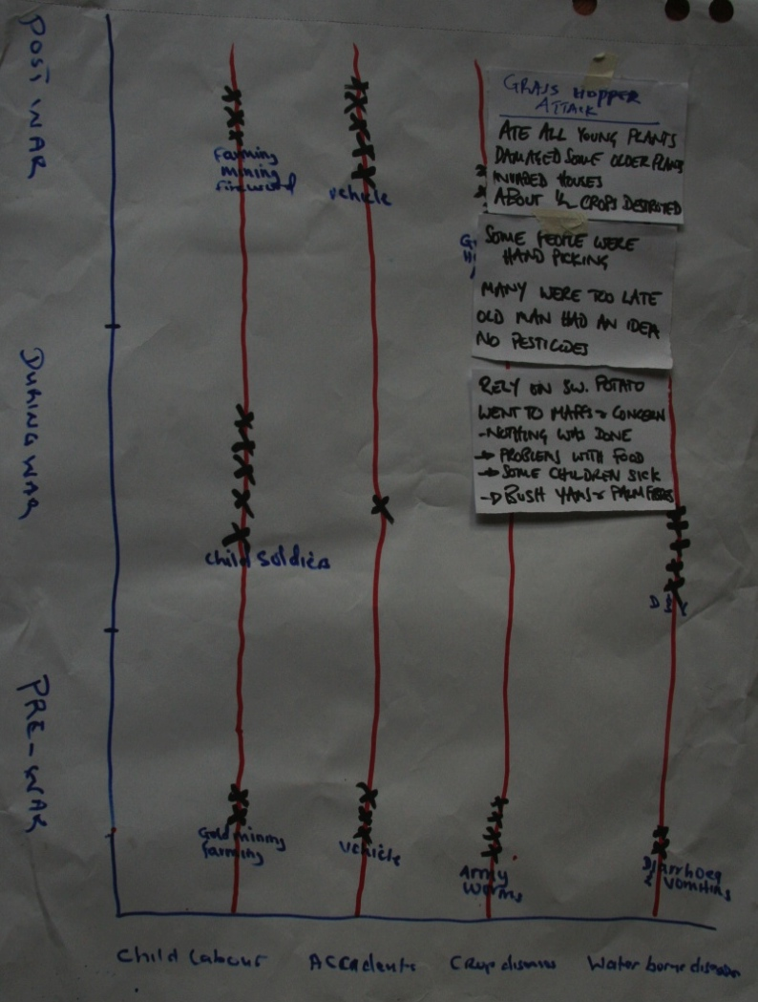
Notes and comments:
This is another multi-functional tool, which helps communities to understand the frequency, intensity and trends of hazards and people’s capacity to respond to, cope with and recover from them based on their past experiences. It identifies who has been most vulnerable and furthers understanding of the impact the wider context can have on disasters and livelihoods.

You should come back to this tool in the larger group and continue to ask these questions, so it is not hugely important if you run out of time because the other groups have finished their map or calendar. Try to finish the analysis of frequency and the experiences of the participants during prior disaster events; the analysis of trends can be done in the larger group.

An important aspect of this tool is capturing people’s experiences of past disaster events. This is an opportunity to collect information about one aspect of capacity, so make sure you capture all of the points they mention (including where things went wrong).
A historical timeline from Tonkolili, Sierra Leone, showing trends in child labour, accidents, crop diseases and water borne diseases; and ordered according to pre-, during -and post-war. Information about how communities coped laid on top. Photo by Dom Hunt, May 2011

11. Predicting future changes, unpredictability and the wider context

Time taken
1-2 hours.

Methodology:
Do this with the whole group.

This uses the historical timeline as the basis for analysis of trends identified thus far, and then uses focus group discussions to try to predict what may happen in the future, and what we (the community, Concern, scientists, and academics, etc.) are uncertain about. Part of the process relies on explaining the mechanisms behind a number of factors that contribute to the changing frequency of disaster events (including but not limited to climate change), so as to help the community predict what lies ahead.

This session must be done before the root cause analysis (see below).

Step 1: If the historical timeline process was not finished, continue it with the whole group (from step 6 above). If the entire timeline process was finished, ask some people from that group to present the key points to the larger group, especially focusing on the changing frequencies of certain hazards and trends of the contributing factors that have been identified.

Step 2: Some of the causalities may be obvious and require little explanation (like reduced incidence of water borne disease once a water supply system was installed), but others may be more difficult and might require an explanation. Be prepared to explain what climate change is, or why global or regional economics can affect the price of food. You may not have time to go through a proper explanation of climate change but it is better if you can. However, you should have done an analysis of climate change while doing secondary data collection, so you should be prepared to explain what the actual and predicted changes are in your country and region, and how these changes may affect local livelihoods.

Key questions:
Some of the questions are in the historical timeline section above.
- What do you think the frequency of disaster events will be like in the future? Based on what we know, can we predict either increases or decreases in events?
- Of the factors contributing to changes in the frequency of disasters, which ones are most important?
- What remains unpredictable, and can we do anything to be more flexible/responsive in the face of this unpredictability?
- Who do you think is most vulnerable in your community to the effects of...? {climate change, population growth, environmental degradation, political instability, economic change, etc.}

Step 3: While explaining the predicted changes that result from climate change, check with the group whether they are experiencing any of them. If they are, and these are not captured on the historical timeline, ask them to add to the timeline.

Step 4: Once you are satisfied that the historical timeline captures trends in the wider context, and that these have been analysed and understood by the whole group, extend the timeline into the future (draw the scale line longer) and ask participants to predict what the frequency and trends may be in the next 10-20 years. Some of these may be easy to do (if hydro-meteorological disasters have been increasing, we can suppose that they will continue to increase), but some may require a bit more analysis (even though water borne diseases have been reduced due to a better water supply system, they may go back up again as a result of climate change), and some may be difficult or impossible to predict (e.g. natural re-growth of some habitats or productivity of some crops). If they cannot predict changes, leave it blank – this is also important information, as any risk informed plan will need to be flexible enough to address what is unpredictable, as well as contributing to a climate change adaptation strategy if the community needs to develop one.

Step 5: Do not forget other external factors that can influence disaster frequency (population growth, urbanisation and migration, economic factors, political instability, environmental degradation, etc.). These should have been mapped onto the historical timeline so that they can be extended into the future as well.

Step 6: Go back to the seasonal calendar. Mark in the unpredictable period for the rains and seasons, and then anything else that becomes unpredictable as a result (agriculture, some hazards, etc.).

Step 7: Analysis and conclusions. Ask participants to discuss and indicate which of the wider context factors are very important drivers of disasters or poverty; mark them accordingly and make sure they are recorded in your notes.

If the community wants, some of these can even be added to the list of priority hazards for further analysis. If not, they will nonetheless be analysed to some degree in the forthcoming root cause analysis; and responses to the influence of the wider context need to be reflected in the risk informed plan that the community will develop (see later steps).

Notes and comments:
As depressing as discussions on these issues can be, it is vitally important that communities start understanding how their environment is changing so that they can adapt to these changes. The sooner they start on this journey, the more resilient they will become. This kind of discussion can open up a huge array of potential things they could do to become more resilient, and can make the risk analysis process go on longer than expected. Do not try to shorten this step though.

Do not fall into the trap of accrediting all changes to climate change. Climate is naturally variable, and other extremely complex factors can also affect weather and disaster patterns (like the El Niño Southern Oscillation (ENSO), environmental degradation, etc.).

12. Root Causes

Time taken:
Up to 1 hour.

Methodology:
Do this in sub groups - as many sub groups as there are priority hazards, as each sub group will look at one of the priority hazards.

This session makes use of the problem tree tool; where the tree is a hazard, and the roots are the causes. One problem tree must be done for each of the priority hazards.

It is essential that this tool is done after the analysis of the wider context as an understanding of the influence the wider context has on hazards is needed to properly analyse root causes.

Key questions:
- What causes {hazard name}?
- What is the cause of that?
- Why?
- What about...? {climate change, population growth, migration and urbanisation, environmental degradation, economic changes, political instability, etc.}
- What is controllable?
- What is not controllable? Why do you think this is not controllable?
Step 1: Explain the concept of the problem tree, and split the group into sub groups. Tell them that they should brainstorm what the causes of each hazard are, and write them down on pieces of paper, so they can be moved around into an order that shows how causes are inter-related.

Also ask them what causes the causes. Some causes can be further analysed: deforestation could be caused by fuel gathering, timber for construction, no replanting, land clearance for agriculture on marginal land) and then analysed again (example: land clearance for agriculture could be caused by insufficient land available for all, overpopulation, weak or unequal land tenure and distribution, soil depletion in less steep areas, etc.).There will be more than one cause, they may be inter-connected and probably work together.

Other hazards can be a causal factor too (example: a landslide can be caused by heavy rain, weak soil structure, steep slopes, deforestation, poorly constructed terraces and a flood that undercuts the slope).

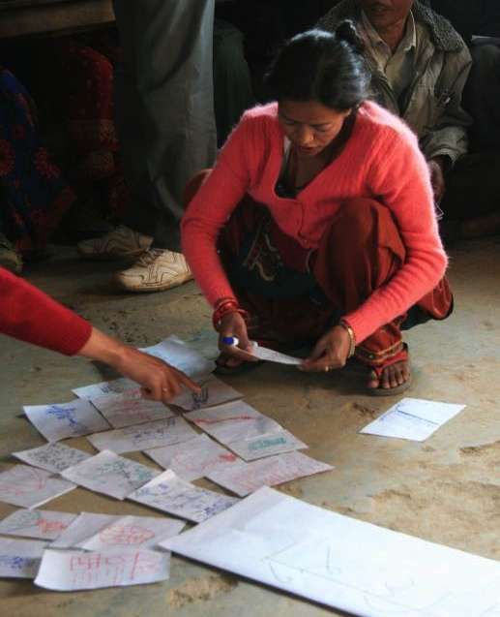
Make sure that the influence of the wider context is captured in this analysis (based on discussions in the previous session).

Step 2: Ask them to arrange the pieces of paper with causes on them into groups and order them in a line so that it is clear how the hazard is caused by a cascade of factors, and lay them at the base of the hazard (trunk) so they are like roots (see the photo to the right– different causes are grouped into inter-related factors, put in order, and laid out like the roots of a tree).

Step 3: The final step is to indicate what is controllable. You can do this by asking the participants to discuss and indicate with a stone or a mark what hazards they think are controllable. You may be asked who does the controlling – the answer is by anyone; it could be a good idea to distinguish between what the community can do and what they cannot; however what the community cannot control they may be able to advocate for, so this is also important information.
The photo shows Jagadeswori Shahi, Concern’s Social Monitoring Officer, Nepal, facilitating a problem tree for landslides. Kalikot, March 2009. Photo by Dom Hunt.

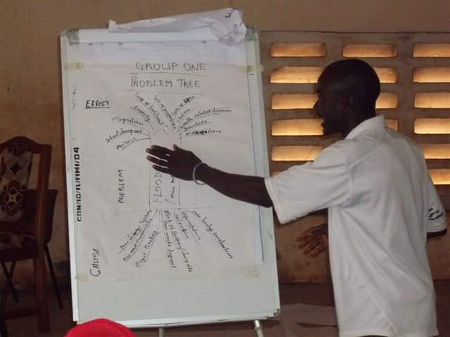
It often becomes apparent that the analysis has not been considered in enough detail when this question is asked, so more analysis of causes needs to be done. For example, some underlying causes of deforestation can be controlled, and some may not be – so deforestation needs to be broken down first (for example they may say these are controllable: no replanting, no protection against open grazing of livestock, no alternative fuel wood sources; and these may be uncontrollable: native trees are slow growing, hot season wild fires destroy forests, no alternative fuels available in market, no other livelihoods for firewood collectors).
Problem tree analysis, Kroo Bay, Freetown, Sierra Leone. Photo by Sheku Kanneh, 2011.

Step 4: When they have completed this step, ask the participants to present their root cause analysis to the other groups – keep the presentations short but allow members of other groups to comment and add things if they have been forgotten.

Keep an accurate record of the problem trees (photographs), and properly record all the controllable causes as these will later be used in the planning sessions.

Notes and comments:
Root cause analysis can be complicated and difficult, and can also be time consuming. Good facilitation is essential, so assign a facilitator to each group if you can, or two groups per facilitator if needs be.

This analysis could theoretically go on forever, so there comes a time when it has to be ended – it is fairly obvious when the analysis becomes pointless to continue. For example, heavy rain is caused by a multitude of factors like atmospheric movement patterns, locations of water bodies, temperature, vegetation, time of year, and possibly made unpredictable by climate change which in itself has a multitude of causes, but this information does not help you to understand the important causes of a flood so that you can do something about it.

13. Disaster impacts and who is vulnerable

This is a continuation of the root cause analysis in the previous session, in that we will continue to use the same method (problem trees) but this time focus on impacts (the branches of the problem tree). We will then identify those who are most vulnerable to these impacts. Once that is done we will look at the coping strategies of these people.

Time taken:
2-3 hours.

Methodology:
Do this with men and women concurrently in different groups. It is helpful to have paper of three different colours for this – one colour can be used to determine disaster impacts, another for who is most vulnerable, and the third for their coping strategies.

Step 1: Explain to the participants that we are now going to use the same technique (problem trees) to analyse impacts of the priority hazards; impacts are the ‘branches’ of the tree. However, where the root causes were analysed in the larger group, impact will be analysed in male and female groups because hazards can affect these groups in different ways. We already have one root cause analysis for each priority hazard; now each group will develop an impact analysis for each priority hazard. Adding to this we will determine who is most affected by them (specific vulnerability), and how people react to and cope with disasters (coping strategies).

Step 2: Ask each group how disasters impact on them – what happens to them and their assets when disasters occur. Ask questions about their lives, their health, their assets and belongings, their livelihoods, and community assets. Make sure they also factor in predicted effects that have been identified in the session on climate change and the wider context.

Key Questions:
On disaster impacts:
- What happens to you in the event of {hazard name}?
- What happens to your belongings in the event of {hazard name}?
- What happens then?
- What are the effects of {hazard name} on your livelihoods, your lives and health, and your assets?
- What is controllable?
- What is not controllable? Why?

On who is vulnerable:
- Who is most likely to suffer from {impact}?
- In what way do they suffer?
- Who takes the longest to recover? Who cannot recover?
- Where are the areas of most vulnerability? Who lives there? Whose livelihood is centred there? When are they most vulnerable?

On coping strategies:
- What do you do to stay alive when {disaster effect} happens? Where do you go? Who helps?
- Where do you get food from?
- If you do that, how does it affect your ability to...? {earn money, produce food, undertake livelihood activities, etc.}
- Where do you borrow money from? What is the interest? How do you pay it back? What happens if you cannot?

As in the root cause analysis, each impact should be written or drawn onto a piece of paper which can be moved around, so that the ‘branches’ of the tree can be built with one impact leading to another, and so on. Keep these answers on one colour – other colours will be used later on for different aspects of analysis.

For each impact, ask what the ‘knock-on impacts’ are – for example, if housing is damaged or destroyed, this leads to displacement for that household, which causes a large number of impacts – difficulties for the host families, hunger, sickness, insecurity, exposure and so on.

Try to guide the participants so that they are as specific as possible – this richness is important when designing interventions to limit suffering in the event of a disaster, and it is needed to determine who or what is most vulnerable.

Step 3: Ask your group members to identify which of the identified disaster impacts are controllable – as was done at the end of the root causes analysis (see page 21).

Step 4: Ask who is most affected by the impacts that have been identified. Some impacts will not be felt by everyone, or will be felt to varying degrees, with some people being more affected than others. You will probably need to push participants to be specific, because there will be a tendency to say ‘everyone’ when in fact some people are more affected than others. Ask them to put their answers on different coloured paper and add them to the problem tree so it is clear which pieces of paper refer to impacts, and which ones refer to the most vulnerable people.

It helps to use the outputs of the previous PRA sessions to properly understand specific vulnerability, so guide your group through a review of the preceding steps:
- Review the map, and identify location-specific vulnerable people.
- Review the seasonal calendar, and determine which livelihoods are most vulnerable (overlap between key livelihood activities and disaster seasons). Do not forget to review variability and unpredictability here – these can also have a significant impact on some livelihoods.
- Review the historical timeline: testimony of past experience will identify which parts of society have paid higher prices in past disaster events.

Step 5: Ask the group what their coping strategies are for each impact, building on information already collected from earlier sessions (especially from the seasonal calendar and historical timeline sessions). Ask about the specific strategies of the most vulnerable people that have been identified in the preceding step. These coping strategies can be added to the problem trees – write them onto pieces of the third colour paper, in the same way as you have already done for impacts and the most vulnerable.

Step 6: Ask about the long term impacts of both the disaster and their coping strategies – such as indebtedness, loss of productive assets (land, breeding livestock, seeds, etc.), disease and malnutrition, time taken to recover back to pre-disaster wealth levels (if at all), etc. Use their answers to questions about coping to frame your questions; for example if someone says that they sell livestock, ask them whether they have to sell all of them and how they get their livestock back after the disaster. If someone says they borrow money, ask them from whom they get this credit, what the interest rate is, and how they repay it (if at all), etc. You will probably find that some people have different coping strategies to others, so it is important to ask all participants about their experiences. If you do find these differences in your groups, ask them why. This is important information for your understanding of the causes of vulnerability.

This additional information should be added to the problem tree. If this is not possible, it needs to be recorded by a note taker.

This step identifies coping strategies that are ‘erosive’ and lead to long term poverty, and coping strategies that only draw on surplus, which probably do not result in ever-deepening poverty. This is an important element of the analysis for the next step and session (identifying who is most vulnerable and why).

Notes and comments:
Without having women and men doing the analysis of disaster impacts separately, differences between men and women may not be mentioned. An example of gender differences arising from a hazard may be seen during flooding in Nepal, when women were bitten by snakes in the home (the snakes went there to get out of the water) but the men, who were more likely to be outside the home, were less affected by this problem. Similarly, in Timor Leste, women suffer from branches and coconuts falling from trees during strong wind storms; men suffer less as they are more likely to be in the fields where there are few trees, or not burdened by carrying or caring for children. In Bangladesh, women suffer from reproductive health issues in floods that do not affect men. It is often difficult to get this detail from a mixed gender group, where women are often dominated by men and tend to stay quiet.

Different perspectives go beyond gender: the poor are impacted differently to the rich (for example, in Nepal, poor people’s homes are often constructed from sticks and mud which are easily destroyed by flooding, whereas rich people’s concrete houses are more resilient), different livelihoods are affected in different ways (a farmer of vegetables can lose all his or her crops in a flood, whereas a fruit tree farmer may only lose parts of the crop, or not lose any, and a person working in a office may not have his or her livelihood affected at all). Do not forget to get perspectives from all members of the group with which you are working, and try to get them to think about how disasters can affect people in different ways.

It is not only causes that can be controllable - some impacts can be as well; for example, flood waters destroying stored food and seed can be easily controlled by storing these commodities out of reach of the flood waters (high up in houses, or in stores constructed on higher ground).

Displacement may or may not be controllable (depending on the nature of the disaster); but the harmful effects of displacement can be controlled – for example by building shelters, providing clean water and other life saving services.

You may think something is controllable (example: by identifying or providing an alternative livelihood for firewood collectors), but the participants may disagree. It is important to discuss with them why they think this is so – they may be unaware of ways to control something, or you may be unaware of a constraint to something happening.

14. Reasons for vulnerability

Time taken:

Key Questions:

On causes of vulnerability:
- Why are you/they most vulnerable?
- Why do you/they suffer more than others?
- What do you/they not have that would help you/them cope better in disasters?
- Why does it take you/them longer to recover from disasters than others?
- Are any of these reasons for your/their vulnerability controllable?

On capacity:
- What advantage do you have that makes you less vulnerable than them?
- What can you use to reduce your vulnerability?
- What assistance can you get in times of need, and from whom? Who can ask for help?
- How do you help each other?
- What do you use to help you recover from a disaster?
1 hour.

Methodology:
Do this with the men’s group and women’s group concurrently.

Step 1: Staying in the men’s and women’s groups, guide a discussion to identify the reasons for vulnerability. This will require skilful facilitation as there is a lot of information to bring together at this point: impacts of disasters, past experiences, locations, negative coping strategies, access to and control of resources, ethnicity and marginalisation, voice and representation, etc. Some of the reasons for vulnerability may be rather difficult to discuss in public – such as stigmatised issues of health status, GBV and so on, so be careful.

Some of the causes of vulnerability could be the common characteristics between the listed vulnerable groups, but some may be rather specific, so it is important to look at each group in turn and understand why they are vulnerable.

Make sure you record the reasons for vulnerability well on flip chart paper so that everyone can see it, as this will be needed in the next step.

Step 2: Ask them to identify which of the causes of vulnerability are controllable or can be influenced. This can be done in the same way as it has been done in the root causes and impacts analyses. See page 21 for more on this.

Step 3: Ask them what capacities they have that help them to anticipate, cope with, respond to, or recover from disasters. You may need to explain the question – capacities are what help people to achieve something (that can be strengths, assets, influence, etc.). As you have already determined physical and natural capacities in the mapping exercise, and coping strategies and past experiences in the historical timeline, this is an opportunity to determine their financial, social, and political capacities (see key questions in the text box).

Step 4: When there are no more causes of vulnerability or capacities to list, end the focus group discussion and bring the men and the women back together into the big group. Ask the groups to present their problem trees, lists of who is vulnerable and why, and the capacities that are available in the different groups.

Point out and discuss the differences between men and women. This is a key moment for increasing understanding between genders, which can contribute to increasing gender equality. It is important to point out that there are differences in vulnerability (with women probably being more vulnerable that men, in general) but also in capacity (so as to avoid stereotyping women as helpless victims).

There will probably be some similarities between the lists, and some key differences. You can combine the lists into one final list of who is vulnerable, but make sure that you only combine the similarities (e.g. both groups may have identified the disabled as being a highly vulnerable group), and that the different components of each list are not lost (e.g. if the women’s group has identified menstruating women as being vulnerable to floods, linked to reproductive health issues, make sure this group is not left out of the final list. Similarly, if the men have identified hunters as most vulnerable to wildfires, linked to loss of resources and the location of their livelihood, make sure this group is not left out).

You can also combine their lists of capacities, making sure that you do not ‘lose’ capacities that are specific to certain groups.

Notes and comments:
Do not be surprised if most of the vulnerability is found in the poorer section of the community, but at the same time there is likely to be vulnerability among the wealthier sections of the community.

For all of this session we have maintained male and female groups right up until the last moment when the groups present to each other and combine their lists. Maintaining separation is important to ensure that gender-specific risks are not lost or forgotten.

Bringing the final male and female lists together is also important – this is when each gender group learns about the specific vulnerabilities and capacities of the other group, which hopefully will contribute to a culture of respect and mutual assistance in times of need.

15. Institutional analysis and response capacity

Time taken:
1 hour.

Methodology:
It is generally better to do this with the whole group, but you could do it in sub-groups of men and women.

This session uses the PRA tool Venn diagrams to analyse institutions.

Using colour, size and distance
Colour:
- Green = government (including community leadership, committees, etc.)
- Blue = NGOs and other agencies
- White = businesses and sources of labour
- Yellow = informal or formal community groups like livelihood groups, religious bodies, youth groups, etc.

Size:
- Large – important to the lives and livelihoods of the community
- Medium – medium importance for the lives and livelihoods of the community
- Small – little importance for the lives and livelihoods of the community

Distance from centre:
- Near – very relevant for disaster management
- Far – not relevant or only slightly relevant to disaster management
Step 1: Pre-prepare: cut some different coloured cards into different sized circles (or squares, the shape is not important). Decide what they are going to represent. See the box on the right for an example.

Step 2: Explain that we are going to analyse institutions. This is because institutions are often very important for addressing disasters – although there is a level of personal preparedness that all people should undertake, anticipation, mitigation, preparedness and response activities are often handled by institutions.

Begin by defining ‘institutions’ – groups that have a shared identity. They could be formal – CSOs, NGOs, government bodies, community leadership, etc. - or they may be informal – groups of fishermen, farmers, etc. They could be internal – community leaders, village disaster management committee, etc. - or external – local government, police, INGOs, etc.

Explain that we are going to analyse institutions in two ways – by looking at their relevance to disaster management, and their importance in general to the community (in terms of livelihoods, social interactions, etc.).

Step 3: Explain how the tool will be run and provide examples in order to assist the process.

Hand out the cards to people and explain what they mean (see step 1).

Draw a large circle in the ground to represent the community, and mark the centre of the circle with a point or an X which represents the ‘goal’ of disaster management. Community institutions can be placed inside the circle, external institutions are placed outside the circle. Explain that an institution that is important to the lives and livelihoods of the community should be written on a large card of the appropriate colour. Where it is placed relative to the circle is dependent on its degree of relevance to disaster management. See the example to the right, or the picture on page 32 for examples of how this is done.

An example
A fishermen’s group:
- Big card (important to the lives or livelihoods of the community)
- Yellow (informal institution)
- Inside the circle (internal to the community)
- Close to the edge of the circle or far from the central point (not very relevant to disaster management)
Red Cross / Crescent volunteers:
- Medium card (medium importance to the lives or livelihoods of the community)
- Blue (NGO or other agency)
- Inside the circle (volunteers are members of the community, so this is an internal structure with clear links to external institutions)
- Near the central point (very relevant to disaster management)
Canning factory:
- Big card (major employer, major purchaser of fish, important to the lives or livelihoods of the community)
- White (business)
- Outside the circle (external institution)
- Far from the circle (not relevant to disaster management)
National Red Cross / Crescent Society:
- Small card (low importance to the lives or livelihoods of the community)
- Blue (NGO or other agency)
- Outside the circle (external institution)
- Near the circle (very relevant to disaster management)

Step 3: Allow them to complete the tool, prompting them with questions to ensure they do not forget any important institutions (see key questions below).

Step 4: When the tool has been completed, collectively analyse it to determine the points below, while keeping track of the responses on a sheet of flip chart paper.

Institutions that are relevant for disaster management:
- In what ways are they important (preparedness, early warning, response, recovery, etc.)?
- What resources and assets do they have available?
- What level of knowledge and understanding, helpfulness, reliability, etc. do they have?
- What are their capacity gaps, and other issues?

Institutions that are important for the livelihoods or lives of the community:
- In what way are they important to the community (employment, community cohesion and influence, etc.)?
- In what way do they contribute to disaster management?
- What resources and assets do they have at their disposal that could be used for disaster management?
- In what ways can their involvement in disaster management be enhanced?

Institutions that are either not important to the lives and livelihoods of the community, or weakly relevant to disaster management:
- Why are they not important or relevant?
- Should they be encouraged to be more influential or relevant to disaster management / livelihoods (identifying the potential value that they can add)?
- If so, in what way?

Step 5: Derive from the discussion above a list of:
- Partners for disaster management – institutions that are strongly relevant to disaster management, and through whom activities that address risk could be implemented.

Key Questions:
On identification of institutions:
- What government departments visit your community?
- What security or safety services are there (e.g. police, fire brigade, health services, etc.)?
- What government representation is there inside your community?
- What community committees are there?
- What NGOs come to your community?
- Are there any community based organisations working in or established within your community?
- What businesses are there that community people trade with or work for?
- What informal groups are there (women’s, youth, livelihoods related, etc.)?
- What traditional groups are there?
- What religious bodies are there?

On determining their importance and capacity:
- Is {institution name} important to the lives or livelihoods of the community? In what way?
- Is {institution name} relevant or important to disaster management? In what way?
- What resources do they have for disaster management?
- Do you think they could or should be more involved in disaster management? In what way? What is the likelihood of this happening? What could be done to make it more likely?
- What are they (who?) not very good at (but should be better at)?
- In what way can they improve their work?
- Targets for inclusion in the DRR process, stakeholders who should be encouraged to participate more in DRR, either through advocacy, capacity building or other means:

  - either: institutions that are not particularly relevant for disaster management but are important to the community lives or livelihoods; where the community consider that they should be encouraged to participate in DRR activities
  - or: institutions that are strongly relevant to disaster management but currently have only a weak importance in the lives or livelihoods of the community, which indicates that they should become more important and effective.

Notes and comments:
This is the final step of the research or data gathering part of risk analysis. Now the information must be analysed and gaps identified and filled – see next section.
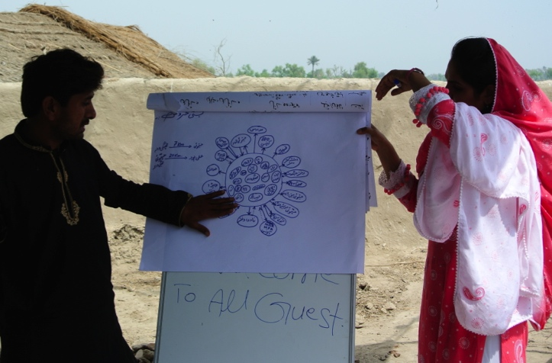
This photo shows community people presenting an institutional analysis to others in the group, Singh, Pakistan. Photo by Syed Sulaiman, 2011.

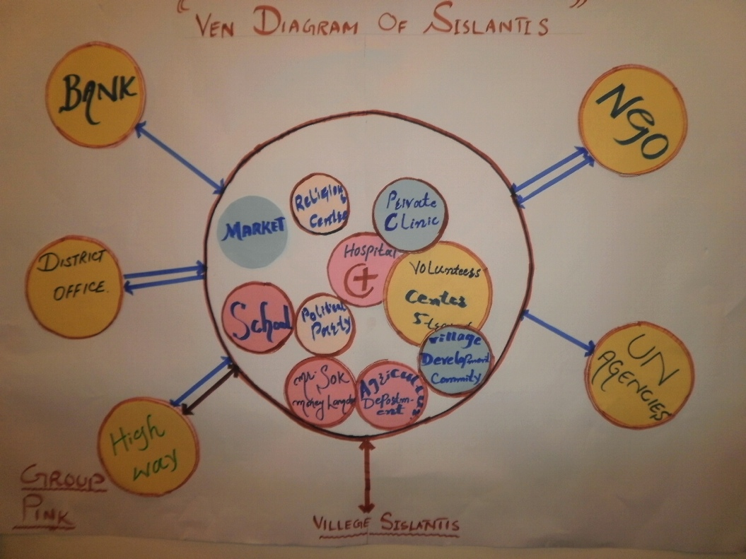
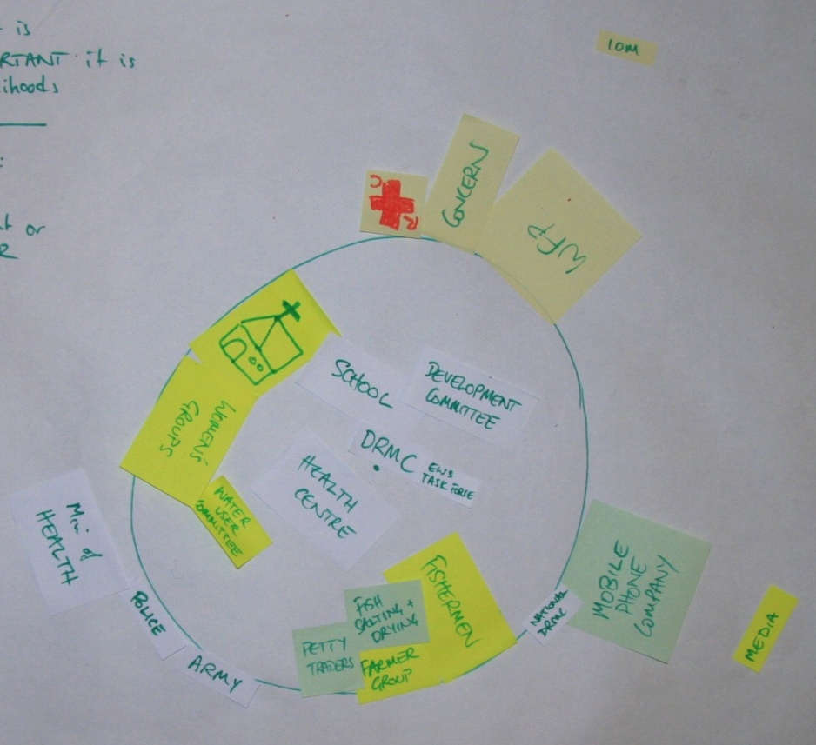
An institutional analysis using Venn diagrams in Sislantis, Pakistan. The most important institutions for DRR are the hospital, clinic and volunteers, with strong links to NGOs, the district office and the highway. Photo by Syed Sulaiman, 2011.
Institutional analysis to illustrate the use of colour, size and position. The church, women’s group and fishermen are very important to the lives and livelihoods of the people but are not active in disasters – and so they are opportunities for better disaster management. The mobile phone company has an interesting relationship with the national disaster risk management committee, as they send alerts and messages to the village disaster risk management committee, who use a task force to get the messages to the vulnerable people. The health centre and school are both important for disaster management – the former in recovery and the latter as a shelter. Concern, WFP and Red Cross are all involved in disaster management, whereas IOM is not. Venn diagram and photo by Dom Hunt, Jan 2012.

16. Analysis and cross-checking

Methodology:
This is done in the research team, not with the community. You may want to do this more than once (ideally every evening after a day doing PRA in the field). This is when you should fill in the analytical frameworks given in annex 7 of these guidelines.

If you can fill the analytical frameworks in, you are ready to go on to the next community session, risk informed planning. If, however, there are things you do not understand, or gaps in your knowledge, you need to either return to the community to fill in your knowledge gaps, or seek the information elsewhere (NGOs, other analyses, etc.).

Key Questions:
- Do we understand enough to be able to fill this framework in with confidence, or are there still things we are unsure about, or do not know?
- Are we satisfied that all of the most important hazards are covered?
- Have all members / representatives of the community been able to participate properly?
- Do we have ‘extra information’ that the community does not have that gives us a different point of view? What are the differences and why?
- Have we understood the differences in risk between men and women, rich and poor, marginalised and mainstreamed? Have we identified all the social groups?
- Have we ‘missed out’ any key stakeholders?
- Do we know why some people are more vulnerable than others?
- Are we satisfied that we know the capacity of all the relevant institutions, and the coping strategies of the community?
- Have we identified capacity gaps and ‘entry points’ for Concern programmes?

ALWAYS feed the results of your analysis back to the community. The information belongs to them. Avoid being ‘extractive’. The analytical tools summarise and order the collected information, and can therefore be of benefit to the community for their own planning purposes. Share the analytical frameworks with them, and ask the literate members of the community to share what they say with others. Present the key findings in a community meeting. Also, you can use this feedback process to identify thorny issues, mistakes and points of confusion.

Another way to cross-check your conclusions is to compare your result with other risk analyses – either ones you have done in other villages or ones that other agencies have done.

Notes and comments:
If you are not satisfied that you can properly fill out the analytical frameworks, you need to go back to the community (or elsewhere) and fill in your gaps. This can be time-consuming and frustrating for all. If you try filling out the analytical frameworks as you go along, you can minimise the time it takes to do this analysis, and quickly fill in knowledge gaps when you next meet with the community (like in a half-hour recap session).

17. Identifying solutions

Time taken:
1 hour.

Methodology:
Do this with separate groups of men and women.

This session uses the PRA tool ‘management options’ which is essentially listing and ranking (using proportional piling).

Step 1: Preparation: list out all the controllable causes and impacts of hazards, and the causes of vulnerability. Remember that these are not necessarily ‘controllable’ by the community alone. In the next session we will distinguish between things that are controllable by the community, by the community with assistance (from us or other agencies), or by the government (perhaps with our help). If there are adaptation issues that need to be taken into account (derived from discussions about future predictions, climate change and the wider context, etc.), add them to this list.

These are the things we need to address to reduce risk in the community. Have the list written out on two sheets of flip chart paper before you go back to the community. Organise your list so that the issues are grouped according to the hazard.

Step 2: Split the group into men and women, and assign facilitators accordingly.

Step 3: Each group brainstorms what can be done to solve the issues. Every idea is valuable, and many ideas should be sought for each issue. The more ideas the better – participants may come up with innovative solutions that you may not have thought about, so allow them to propose many ideas. List them out.

Once the participants’ ideas have been exhausted, you may propose additional ones to the group (be careful not to dominate the process – this is their plan).

Step 4: Some ideas will be more workable than others, so the next step is to rank them – in terms of easiness and effectiveness. We will use the same proportional piling method that we used when we did the assessment of risk.

Key Questions:
- What can we do to solve this issue?
- What other ideas are there?
- Which of these ideas would be most effective in solving the issue (and thus reducing risk)?
- Are you happy with us discarding this idea (seeing as it is not effective)?
- Which of these ideas would be easy to implement?
Each participant gets the number of stones / seeds / sticks equal to the number of choices (so if they are ranking four options, they get four stones).

First ask them to rank the options according to ‘effectiveness’. In this context, an effective solution is one that fully achieves what it is meant to achieve (some solutions may be weak or only partially effective). Count up the scores. Discard the ideas that are not effective, as agreed by the group, but be ready to step in here, as their opinion on what is effective may not be the same as yours if they do not really understand the process of a given solution. The discussion on whether something is effective is also important to the empowerment aspects of PRA.

Reduce the number of stones accordingly, and follow by ranking the remaining ideas according to easiness, and count up the scores.

You will have to do this repeatedly – each issue will have a number of solutions, and they all need to be ranked.

Step 5: This time we will not combine the scores of easiness and effectiveness. Instead, organise the information so everyone can see it clearly. The analysis is done thus:
- Options that are not effective – discard them. There is no point in doing something that might not work, or is of limited benefit.
- Options that are effective and easy – they immediately go into the next session (planning).
- Options that are effective but not easy – these need to be discussed. Is the potential outcome important enough that, in spite of it being difficult, we should do it anyway? Do we have the capacity to do this? Is there anyone who can help so we can get this done?

Notes and comments:
This tool works best with ideas that describe an activity but not in detail. For example, an idea could be ‘channel flood water’. That would be enough – there is no need (yet) to go into detail about how that would be done – that is for the next session. This tool just identifies the broad strokes of the plan and discards unworkable ideas.

Doing this in groups of men and women allows women to retain a level of control over the resultant plan, and allows them to define solutions that suit them and their circumstances, whilst empowering them to make significant decisions over their lives.

18. Risk informed planning

Time taken:
1-2 hours.

Methodology:
Do this with the whole group.

This session uses an adaptation of the PRA tool ‘action planning’. It guides participants logically through the chosen options, determining how to do them, and assigning tasks to the key stakeholders. This is where all the information from the risk analysis needs to be used.

Step 1: Explain the process. There will be a planning framework completed for each of the priority hazards that the community identified.

Key Questions:
- How would you do this?
- Who does this?
- Is assistance needed? What kind of assistance? How do you get that assistance?
- What is the role of {institution name} in this?

List the key stakeholders (derived from the institutional analysis) on the left hand side of the DRR planning framework, and label the framework with the name of the hazard.

Step 2: Take the first solution that was selected from the previous session. Ask participants to suggest what the main activities would be to achieve this, and who would do it. Depending on the nature of the issue to be solved, and the nature of the activity proposed, write their suggestions into the relevant box in the planning framework.

If help is needed, but it is not known whether the help will be provided or not, it must be asked for. For example, if the community want to undertake a programme of reforestation, perhaps they want to use department of forestry seedlings to do this. If they have not yet asked the department of forestry if they can, they will have to; which implies getting the department of forestry involved. That implies needing to influence them; this is an advocacy activity for the community (perhaps with assistance from Concern or a partner).

Step 3: Continue going through all the selected options until the plan is done.

Notes and comments:
You can split the proposed activities up into mitigation, preparedness or advocacy (see the risk informed planning framework in annex 7) as I find the results are better, but it is also more complicated as people are easily confused between mitigation and preparedness. If it is not working, abandon these distinctions, and use these alternatives:
- label the top row ‘activities that address causes (of vulnerability or the hazard), activities that address the effects of disasters, and activities that influence the wider context. These will correspond approximately (although not exactly) to mitigation, preparedness and advocacy.
- label the top row ‘activities’, ‘when to be done by’ and ‘resources required’.

What is important is that the activities are properly assigned to the right stakeholder. Make sure the community assign themselves as much as possible (without overburdening them) – as this is a community based DRR action plan, they must not be allowed to fall into the trap of simply asking others (government, us, etc.) to do everything for them.

Make sure their answers use the capacity they have, draws on available external capacity, addresses vulnerability etc. – use all of the preceding risk analysis sessions to inform their answers. Question their proposals, test them, make them think. Ensure that women and potentially marginalised groups are involved and be prepared to support their ideas if needs be.

This is an action plan against drought designed by the VDC disaster management committee, Daha, Kalikot, Nepal, 2009.

Level | Mitigation | Preparedness | Advocacy
Community  (VDC disaster management committee leads) | - Establish community forestry / reforestation  - Contribution to irrigation project  - Control open grazing  - Establish a nursery | - Public awareness in VDC  - Off-season vegetable production  - Use waste water in kitchen gardens | - Get forestry dept support  - Look for funds to support nursery  - Share info on drought impacts with govt
Government (forestry, agriculture, water) | - Formulate a policy to reduce deforestation  - Establish a forestry office in the VDC  - Manage water resources properly | - Subsidise food for lean period  - Subsidise seeds  - Support fencing of forest areas  - Build awareness of deforestation / drought | - Seek facilitation and technology support
Others (NGOs: Concern and partners, SCF) | - Support irrigation  - Introduce drought resistant crops  - Water harvesting | - Capacity building for quality irrigation  - Orientation regarding drought adaptation | - Bring in or catalyse technical support for VDC
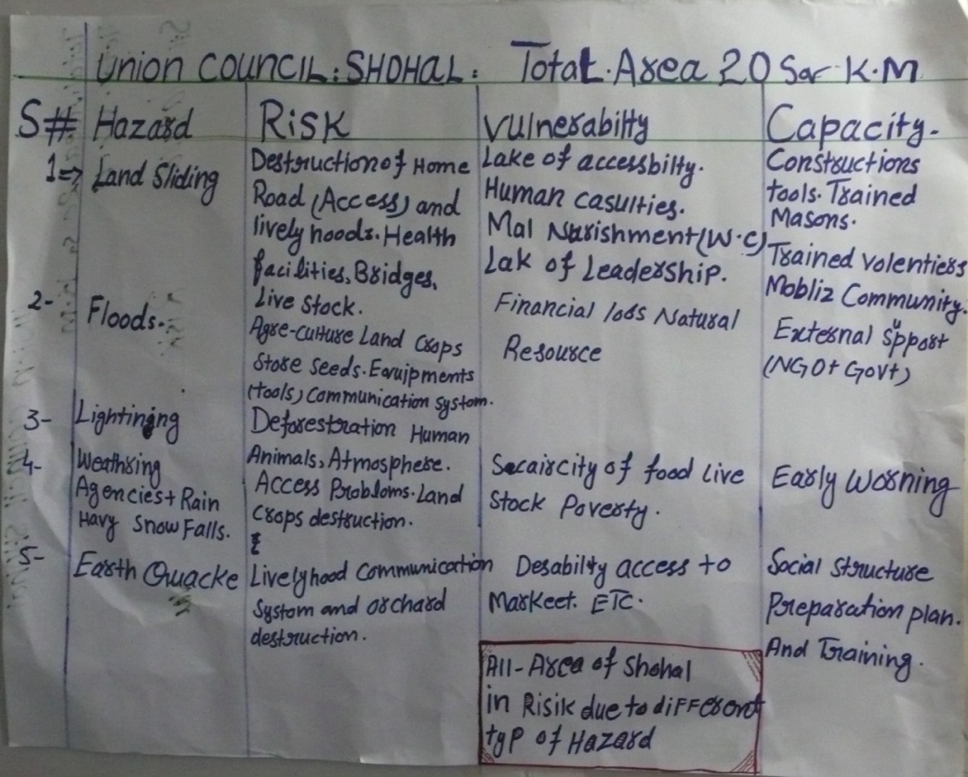
A hazard, vulnerability and capacity analysis from Shohal, Kashmir.
Photo by Peter Crichton, 2007.

19. Reporting and proposal writing
Above: Compiled village risk analysis information, Kashmir. Photo by Peter Crichton, 2007.

If you have used the analytical frameworks provided in this manual, reporting is easy – the analytical frameworks themselves can be the report. Just put them into one document, write a short introduction to set the scene, and a short conclusion to bring out key points. Add photographs of the map and anything interesting you have photographed in your field visits, and you will have a fairly complete report. Photographs are important – make sure you capture examples of the environmental conditions, evidence of past disaster events, existing mitigation structures and capacity.

If you are undertaking multiple risk analyses (in many communities), you will have to combine the analytical frameworks into a set that covers the region. You will need to combine a multitude of risk maps into one, which will require layering risk information on top of a master map of the region you are working in.

You will also need to work on the summary and conclusion. This is where you identify the key risks, vulnerabilities and what needs to be addressed to reduce risk. This information should get condensed into a maximum of three pages for an executive summary.

It is important to do this summarisation properly because this is the list you will probably use to design a proposal. You should attach the risk analysis report to this proposal – the donor will check it to ensure your logic is sound; at the very least they will read the executive summary.

The community will also need a record of their work. The physical outputs of the PRA sessions belong to them and they can keep them if they wish, although they may prefer the photographs and other materials as you have documented the process.

They will need to use this information for their planning, and ideally the information should be collated into one place. For a hint on what information is important for a risk informed plan, see annex 8.

Concern’s Approaches to Disaster Risk Reduction, Emergency Unit, 2005
ibid
Although we would only intervene in cases were the capacity of the communities and governments to respond is overwhelmed – which was not the case in the March 2011 Japanese tsunami, for example.
See the glossary in the annexes
The wider context includes environmental, political, social and economic factors and how they influence hazards and community capacity to manage risk.
With the exception of countries with a high rate of tropical deforestation like DRC.
This can be done by spinning a pen on a map and choosing the community the pen points to, for example.
A group of people chosen for their similar characteristics (e.g. they are all women) with whom you have a discussion on a certain topic, so you can get their collective point of view.
Disaster Risk Management Committee is a commonly used term for the committee that handles DRR activities, although the exact term varies from country to country.
See the annexes for a description of these classifications. Be aware that they are indicative only, and that some hazards are difficult to classify. Ultimately it does not matter as long as all hazards are identified.
See the annexes for Concern’s definition.
Use meta cards, flash cards, zip cards or strips of paper.
Some organisations also factor in capacity thus: risk = impact x probability / capacity; and some organisations use the word hazard instead of impact, but it means the same thing.
Use materials appropriate to your participants. With educated people it may be more appropriate to use pens and paper.
It is not very easy to explain climate change, but assistance can be found in the presentation “global warming made simple.pptx” which is on the intranet (overseas>emergency unit>disaster risk reduction>workshops>sierra leone june 2011>6 global warming made simple training presentation).
It is important that men and women answer these questions from the perspective of their own experience. Later we will compare their answers and discuss the differences between men and women.
Less poor urban-origin Sierra Leoneans displaced by the civil war to Guinea were less able to cope than their rural compatriots and were thus more vulnerable.
Institutions that are involved in any or all aspects of disasters, including mitigation, early warnings and alert dissemination, response, provision of shelter or recovery in the aftermath of disasters.
You may not be able to fill in every single box in the frameworks (especially the causes of vulnerability matrix and the capacity framework), but you do need to be clear about whether the box remains empty because you have a gap in your information, or whether the box is not relevant to your analysis.
Physical and natural capacity from the mapping, coping strategies from the historical timeline, social and political capacity from the discussion on causes of vulnerability, institutional capacity from the institutional analysis and so on.

